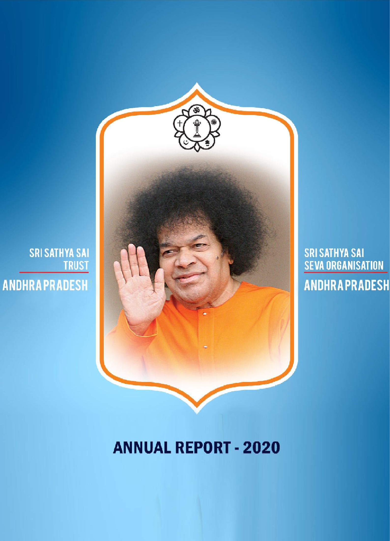

1
1

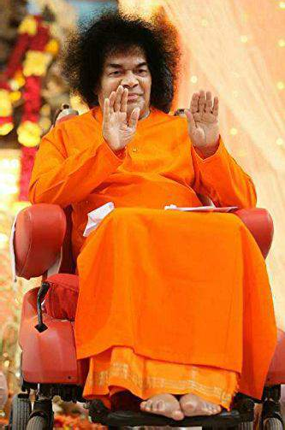

A
humble offering

at the Divine Lotus Feet of
Bhagawan Sri Sathya Sai Baba

2



Om Sri Sai Ram

ANNUAL REPORT - 2020

SRI SATHYA SAI SEVA ORGANISATIONS
&
SRI SATHYA SAI TRUST ANDHRA PRADESH

3
3

Content

Divine Message 05

Sri Sathya Sai Seva Organisations, Objectives 06

Message from the State President 07

Message from the State Trust Convenor 09

Map of Andhra Pradesh 10

SSSSO, AP Statistics 11

List of Office bearers 12

Spiritual activities 13

Educational activities

Sri Sathya Sai Bala Viakas 17

Sri Sathya Sai Vidya Jyothi 24

Sri Sathya Sai Vidya Vahini 28

Service activities

Covid-19 Service activities 29

Prasanthi Nilayam Services 37

Medical Services 38

Mahila Youth Service activities 44

Mahila activities 47

Swatchta Se Divyata Tak - SSSDT 55

DJP (Deena Janodharana Pathakam) 55

DM (Disaster Management) 56

Water Purification Plants 60

SSS Village Integrated Program 61

SRP 62

RVTC(Rural Vocational Training Programmes) 63 RIMS Hospital Seva 70

Youth activities 71

State Trust - Balance Sheet, Income & Expenditure 83
- Conclusion

4

Bhagawan’s Divine Messaage

Selfless love and firm faith

A heart without love is lifeless; Can you call that life
Merely because there is Breath in the body?
It is just a pair of bellows.
EMBODIMENTS of Love! The hall-mark of love is thyaaga (selfless sacrifice). Love seeks nothing from anyone. It bears no ill-will towards anyone. It is utterly selfless and pure. Failing to understand the true nature of love, man yearns for it in various ways. Love has to be cherished with feelings of selflessness and sacrifice. In what is deemed as love in the world--whether it be maternal love, brotherly love, or friendship---there is an element of selfishness. Only God's love is totally free from the taint of selfishness. Divine love reaches out even to the remotest being. It brings together those who are separate. It raises man from animality to divinity. It transforms gradually all forms of worldly love to Divine love. To experience this Divine love, men must be prepared to give up selfishness and self-interest. They must develop purity and steadfastness. With firm faith in the Divine, they must foster the love of God regardless of all obstacles and ordeals.

However, even the feeling of universal brotherliness is not the same as the experience of Ekathvam (oneness). Even in such a fraternal feeling there is an element of self-interest. Those who really wish to promote universal brotherhood should develop the consciousness of the one Spirit dwelling in all beings. Even brothers are often found engaged in mutual bickerings and hatred. What is described as fraternity may not be real and unsullied love. True love should express itself in the awareness of the presence of the Divine in one and all. Names and forms may differ but the indwelling Spirit is the same in all.
One filled with Divine Love will be fearless.
Fill your hearts with love. One will be betraying himself if he entertains evil thoughts, but pretends outwardly to be full of love. No one having Divine love will ever fail to manifest it anywhere at any time. Students, who behave well during their stay in the Institute, should

maintain the same behaviour wherever they may live or work after leaving the Institute. There should be no room for any outside association or circumstances to change their conduct. Love should be firmly implanted in their hearts. One filled with Divine Love will be fearless, will seek nothing from others, and will be spontaneous and selfless in expressing his love. There is no need to pray for gifts from God. God will give of His own accord what is good for any devotee. Did not Shabari and Jataayu get the grace of Raama even without their asking for it? God will decide what to give, when to give, and where. Hence, all actions should be dedicated to God and He should decide what the devotee is fit to receive. When everything is left to God out of pure love and total faith, God will take care of the devotee. People today lack such firm faith. In the path of devotion many ordeals have to be overcome. Great devotees in the past faced such ordeals with faith and fortitude. Ultimately they secured the grace of the Divine and experienced bliss.

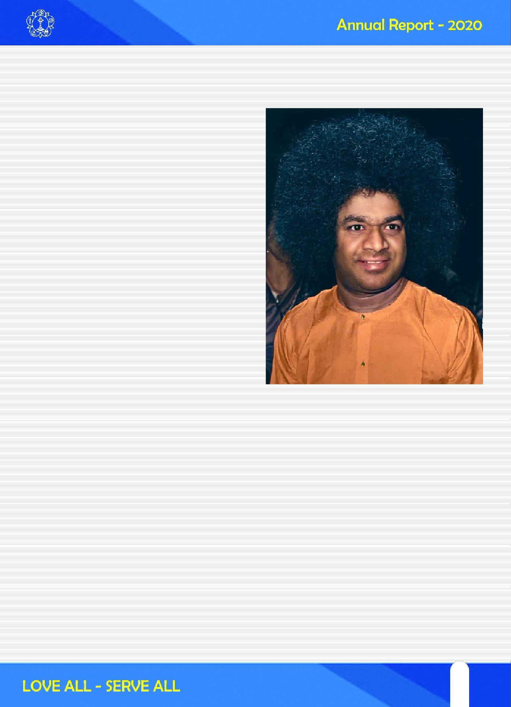

5
5

Dhruva's example

For example, take the case of Dhruva. He was a five- year old boy, who knew little about the affairs of the World. He acted upon the advice of Naaradha and through severe penance was able to have a direct vision of God. His faith enabled him to secure this experience. But, when Vishnu appeared before him and asked him what he wanted, Dhruva said: "Lord! You came to me, knowing where I was doing my penance. Is it conceivable that you could not know what I want?" The Lord said: "I know what for your performed the penance.. When you set out from your home you took a resolve that you will perform penance and secure a boon from the Lord that you should be enabled to sit on the lap of your father. I want to know whether your words and actions are in harmony." Dhruva said: "It is true that I came to perform penance for a small favour, a piece of valueless glass as it were. But, experience of your Form is like a diamond to me. What good fortune is mine that while seeking a glass bead I had found a brilliant diamond. I have no use for that glass piece." The Lord saw the contradiction between Dhruva's original resolution, his penance and

his present desire. The Lord told him that he should stick to his original wish for which he had performed the penance and therefore return to the kingdom with the Lord's Blessings. This emphasizes the need for unity in thought, word and deed.

Recognise the Divine in the entire cosmos

For achieving anything in life, two things are essential: firm faith and pure love. People should not think that pleasure and pain are caused by some external forces. It is not so. They are the result of one's own thoughts. There is no meaning in blaming others. If you develop love of God, that love will banish all sorrow and evil tendencies like attachment, anger and envy. Students should pursue both spiritual education and secular studies.

You have to realise that Nature is also a manifestation of God. Hence, Nature should not be ignored. Nature is the effect and God is the cause. Hence you should recognise the imminence of the Divine in the entire cosmos.

Discourse in Sai Kulwant Mandap on 20-6-1996.

Sri Sathya Sai Seva Organisation
The Sri Sathya Sai Seva Organisation was founded in the 1960s by Bhagawan Sri Sathya Sai Baba to enable its members to undertake service activities as a means to spiritual advancement. The Sathya Sai Organisation derives inspiration, guidance and strength from Bhagawan Baba’s mission and message of propagating the truth of man’s inherent divinity, which is proclaimed and preached by all religions of the world. In consonance with this truth, the Organisation has as its main objective selfless love and service without any distinction of religion, nationality, race, socio-economic status, either for those who work in the Organisation or for those who are served by them. Thus, it transcends all barriers, leading humanity towards the ideal of ‘Fatherhood of God and Brotherhood of Man’. In fact, this spiritual basis enables every one in the Organisation to pursue his own religion better by putting its teachings into practice by way of love and service to the God who dwells in all hearts. That is why the Sai Organisation features in its emblem the symbols of some of the major religions of the world. There is no fee or subscription for membership. .
Objectives of the Organisation
The principal objectives of Sri Sathya Sai Seva Organisation are:
- To help the individual -
  - To be aware of the Divinity that is inherent in him and to conduct himself accordingly;
  - To translate into practice in daily life, divine love and perfection; and therefore
  - To fill one’s life with joy, harmony, beauty, grace, human excellence and lasting happiness;
- To ensure that all human relations are governed by the principles of Sathya (Truth), Dharma (Right Conduct), Shanthi (Peace), Prema (Love) and Ahimsa (Non-violence).
- To make devotees more sincere and dedicated in the practice of their respective religions by understanding properly the true spirit of their religion.

6

State President’s Report and National Service

With the Divine Grace & Blessings of Bhagawan Sri Sathya Sai Baba and with the guidance from Sri Nimish Pandya, All India President, Sri Sathya Sai Seva Organisations Andhra Pradesh has been progressing in the designed path in pursuit of Excellence. We have been receiving substantial guidance, motivation and inspiration from All India Vice President Sri N.Ramani from time to time. With the support from National Coordinators of the organization and totally dedicated efforts of the State, District and Samithi Office bearers. Our Organisation in Andhra Pradesh is exhibiting a trendy performance consolidating its position even at the grass root level.

Our focus has been on Revival and Expansion. Revival of the non performing Bhajan Mandalis and Samithis and Expansion of Organisation in activities and into geographical locations. Spiritual, Service and Educational wings of Sri Sathya Sai Seva Organisation in Andhra Pradesh have started working together with complementary activities aiming at holistic development of the Organisation.

Spiritual Wing has been conducting several online programmes keeping the contemporary needs of the society in an effort to bring back people into the Spiritual Path.

Service wing has extended activities into Mobile Medical Mission in addition to the existing activities reinforced with Disaster Management, About 7000 patient attendants are fed in Govt & RIMS Hospitals every day, Prasanthi Nilayam Sevas and Different Service activities in every District and Samithi. Vocational Training classes are being conducted in RVTC centers with the support of BIRED. To strengthen the sevadal, Under the guidance of National Seva Coordinator Sri S.Koteswara Rao, Sevadal Master Trainers training program at State level (Phase-II), District Level (Phase-III) are completed and also at Samithi Level (Phase- IV) will be completed in the given time.

Prasanthi Nilayam Seva
With the Divine Blessings of Bhagawan Sri Sathya Sai Baba, with the guidance of All India President, Sri Nimish Pandya
Coordinators Sri S.Koteswara
Rao garu & Smt Sasi Bala garu, we are blessed to perform Prasanthi Nilayam Seva for Jan, 2020 to Nov, 2020 with 2119 Gents and 1543 Mahila sevadal.
Service activities during Covid-19:
"Service to Humanity is Service to God". Bhagawan insisted in His Divine discourse that, we must serve as per the need not as per our convenience. With these Divine directions, Sri Sathya Sai Seva Organisations took up service activities as a challenge during the First and Second waves of the Covid-19 pandemic, in all the 14 districts of Andhra Pradesh without any fear or anxiety of the effects of Covid-19 pandemic. Because they have immense belief in Bhagawans Divine assurance (Why fear when I am here). Their unflinching faith is that Bhagawan's Abhaya Hastam will be their protective shield.

Covid-19 pandemic have been very severe which affected people from all walks of life of the society. Therefore the service activities were planned on a large scale with meticulous planning. The Sathya Sai sevadal (both Mahilas, Gents and Sai Youth) rendered the service with pure love, firm determination and great commitment, observing all the precautions given by both Central and State Governments, such as wearing face masks, sanitizing hands, and social distancing.

Tele Medicine/ Medical Helpline Service: A roster for 118 Doctors has been framed to render round the clock services at 38 Help line centers across the state. 10,000 covid patients consulted the Doctors and took medical advise from them.

Supplying Medicines and Steam Inhalers : With the Covid-19 pandemic spreading fast, number of patients suffering from Covid-19,increased by leaps and bounds. Medicines absolutely essential were not available in the markets. Realizing their suffering, essential Medical kits and General Medical Kits and steam inhalers have been supplied to the poor who could not afford to go out of their quarantine for the medicines, in accordance with



7
7

the National level guidelines. Pulse oximeters have been supplied to know the oxygen levels in the Covid-19 patients which is of paramount importance for Covid-19 treatment.

Supplying of Masks, Sanitizers etc.,: To restrict the spread of Covid-19 pandemic masks, sanitizers were absolutely essential. The Mahila Vibhag has taken up stitching of 80,000 Masks and 1200 Liters of sanitiser bottles were distributed to the needy.

Sri Sathya Sai Pranavayu Seva (Supplying Oxygen to Covid Patients) : Due to non availability of oxygen a number of patients lost their lives. Therefore 95 oxygen concentrators have been procured , arranged in time supplied oxygen in a number of critical cases and saved lives.

Community Kitchens and Narayana Seva: In the pandemic situation created by Covid-19 many people were deprived of timely nutritious food. This pitiable situation has been tackled by organising Community kitchens at 37 different centres in Andhra Pradesh and providingh timely, nutritious food to 4,36,148 people at their door step. The Mahila sevadal have taken up the task of preparing and packing the food.

Providing food for quarantined Covid patients and family members. We have identified quarantined Covid patients suffering from non availability of food. Therefore Protein rich, Nutritious food has been supplied including thousands of young children at their door step.

Sri Sathya Sai Annapurna Amrutha Kalasams: Due to Covid-19 pandemic, street vendors, small businessmen, temple priests and tribals lost their livelihood and driven to the state of starvation. To help these people essential groceries such as rice, red gram dal, salt, tamarind and vegetables etc required for their daily needs are given as a set in the form of: 17,210 Sri Sathya Sai Annapurna Amrutha Kalasams with love.

Sri Sathya Sai Youth: Sincerely following the Divine Statement of Bhagwan "Love All - Serve All", Sai Youth of AP have participated relentlessly round the clock in all
the above service activities with great enthusiasm. In addition they have organised Blood, Plasma Donation in emergencies.

Balvikas students and gurus participated in food preparation, packing and distribution activity. Alumni also participated along with Samithi youth wing in this activity. Spiritual activities like Hanuman Chalisa, Gayathri Mantra, Siva nama smarana were done occasionally by the Spiritual wing of the Organisation.

As a part of Special Service activity :
- Necessary items were distributed to street vendors.
- Medicines were supplied to the people in agency areas.
- Sewing machines were given to the Mahilas
- Marriages were are performed.
- Blankets, Sarees, Pant-shirt were distributed to Municipal workers.
- Safety measures for Members of SSSSO and Sevadal in Seva, Awareness Campaigns on Covid Appropriate Behaviours & Vaccination
- Flexies were erected in public places and stickers depicting safety precautions were also pasted on the autos throughout the state.
- Vaccination centers has been started in mandirs.

Offering Gratitude to Bhagawan:
Bhagawan showered His immense Grace on Sevadal members by providing this great opportunity to serve the humanity in this pandamic situation. We offer our grateful pranams at Bhagawan’s Divine Lotus Feet for giving us this opportunity to serve the deprived & needy with commitment and dedication. Each of us felt the Divine presence of Bhagawan during the seva. Offering our humble saluations and pranams at the Divine Lotus feet.

Together, we are marching ahead with integrity, Dedication and Commitment in the path of Excellence.

We pray Bhagawan to be with us, guide us and lead us.

Jai Sai Ram

S.G.Chalam SP, SSSSO, AP



8

State Trust Convenor’s Report

Aum Sri SaiRam

Sri Sathya Sai Seva Organisations, AP(SSSSO, AP) is a spiritual based service Organisation. Bhagawan Baba’s doctrine of “Service to Society with love and care” is applied in letter and spirit by dedicated Sevadal Men and Women. They trust oneness in all human beings, they see God in all beings and serve them. It’s great opportunity for anyone to be part of this divine service for spiritual elevation. Sri Sathya Sai Seva Organisation is spread over more than 120 countries in the world with lakhs of sevadal doing selfless service with utmost devotion, dedication and discipline. Also one wonders to see the free Seva is rendered by the volunteers from various states in India at Prasanthi Nilayam in all spheres of Service activities round the year.

Prasanthi Nilayam (Puttaparthi) being part of Andhra Pradesh, giving wonderful opportunities for each and every Sevadal of the State to render service at the divine abode on all important occasions. The SSSSO, AP has initiated its own website this year which gives all the relevant information of the activities of the Organisation and its members. SSSSO, AP has 341 Samithis, 1111 Bhajan Mandalis, 360 Sathya Sai Mandirs/Service Centres in the 14 districts of Andhra Pradesh. It is a great opportunity to like minded people to join seva at their respective places.

SSSSO, AP conducts innumerable number of Spiritual activities in all its centres, like Bhajans, Nagar Sankeerthans, Festivals to promote

Indian Culture and Spirituality. It has 7 Mobile Medical Vans with all diagnostic facilities, which go to villages to treat poor and needy patients. The patients are also taken to nearby towns for followup surgeries etc., and dropped back at their villages after treatment. In this year 69751 patients were treated. The Organisation is conducting free Nitya Anna Seva in 7 Govt/RIMS Hospitals for 5500 poor patient’s attendants on daily basis.

SSSSO,AP has fully trained Disaster Management Teams who render Seva during Natural calamities, Accidents, Pushkaram seasons etc., The teams also impart training to Security Agencies including Police Trainees whenever the opportunity comes. Youth wing also conducts Rural Vocational Training programmes for unemployed youth in villages and Towns. Mahila Vibhag conducts Mother & Child care programmes, Rural Vocational Training for women.

I wish all the Sevadal a very happy and prosperous life in the SSSSO, AP.

H.J.DORA, I.P.S.(Retd)
Convenor, Sri Sathya Sai Trust, AP



9
9

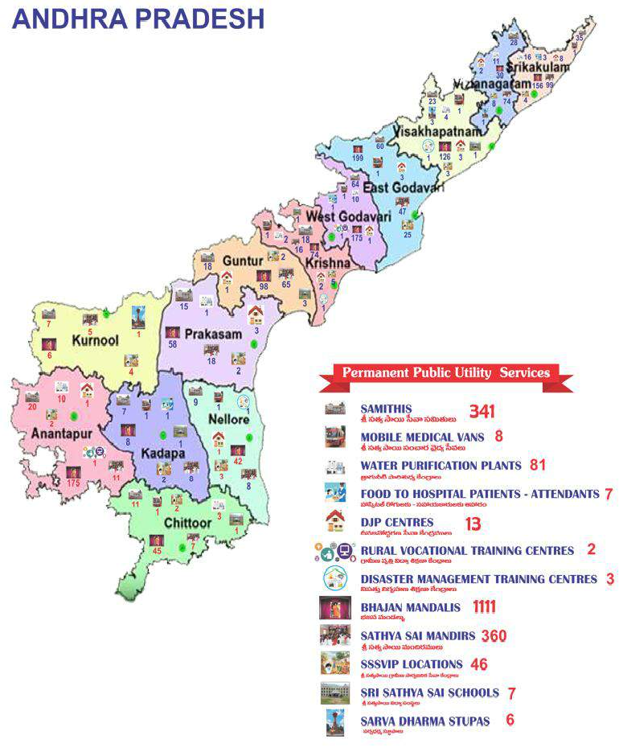

10

Sri Sathya Sai Seva Organisation, Andhra Pradesh at a glance....

1.
2.
3.
4.
5.
6.
7.
8.
9.
10.
11.
12.
13.
14.
15.
16.
17.
18.
19.
20.
21.
22.
23.
24.
No. of Districts 14
Sri Sathya Sai Samithis 341
Sri Sathya Sai Bhajan Mandalis 1111
Sri Sathya Sai Mandirs 360
Sevadal ( Gents) 11964
Sevadal (Mahilas) 10673
Youth (Gents) 5293
Youth (Mahilas) 3243
PS Members 96
RIMS Hospital Service Centers (food Supply) 07
Balvikas Centers 1440
Balvikas Gurus (Group-I, II & III) 1872
Balvikas Children 34,179
DJP Centers 13
DJP Boys 147
Water Purification Plants 69
Water Plants beneficiaries 124200
Sri Sathya Sai Village Integrated Programme - SSSVIP Villages 46
Sri Sathya Sai Vidya Jyothi Programme - SSSVJ Schools 56
Sri Sathya Sai Schools 8
Sri Sathya Sai Vidya Vahini Schools 7
Disaster Management centers 3
Mobile Medical Vans 8
Rural Vocational Training - RVTC Centers 5

11
11

List of Office Bearers

Sri S.G.Chalam State President
Sri H.J.Dora, IPS (Retd.,) State Trust Convenor

Sri R.Lakshman Rao State Vice President

State Coordinators

- Sri V.Subba Rao State Service Coordinator (Gents)
- Mrs K.Kiran Kumari State Service Coordinator (Mahilas)
- Sri B.V.S.T.Sai State Spiritual Coordinator (Gents)
- Kum K Sai Aruna State Spiritual Coordinator (Mahilas)
- Prof V.Sakuntala State Balvikas Coordinator (Mahilas)
- Sri A Sai Pradeep State Youth Coordinator (Gents)
- Smt Sneha Latha State Youth Coordinator (Mahilas)

State Incharges

- Sri M.S.Prakasa Rao Cultural & Bhajan
- Dr G.V.S.Vallinath Sri Sathya Sai Schools
- Dr.K.S.S.Hari Prasad Vedam
- Sri A Ram Prasad Techno Group
- Sri A.Sai Pradeep Sri Sathya Sai Vidya Jyothi
- Sri Dwaram Swamy Radio Sai
- Sri A.B.K.Sarma Medical
- Sri Naga Prasad SSSRVTC (Gents)
- Sri Banti Suresh Disaster Management
- Sri R Sai Kishore IT
- Sri A Sai Kishore PS

12

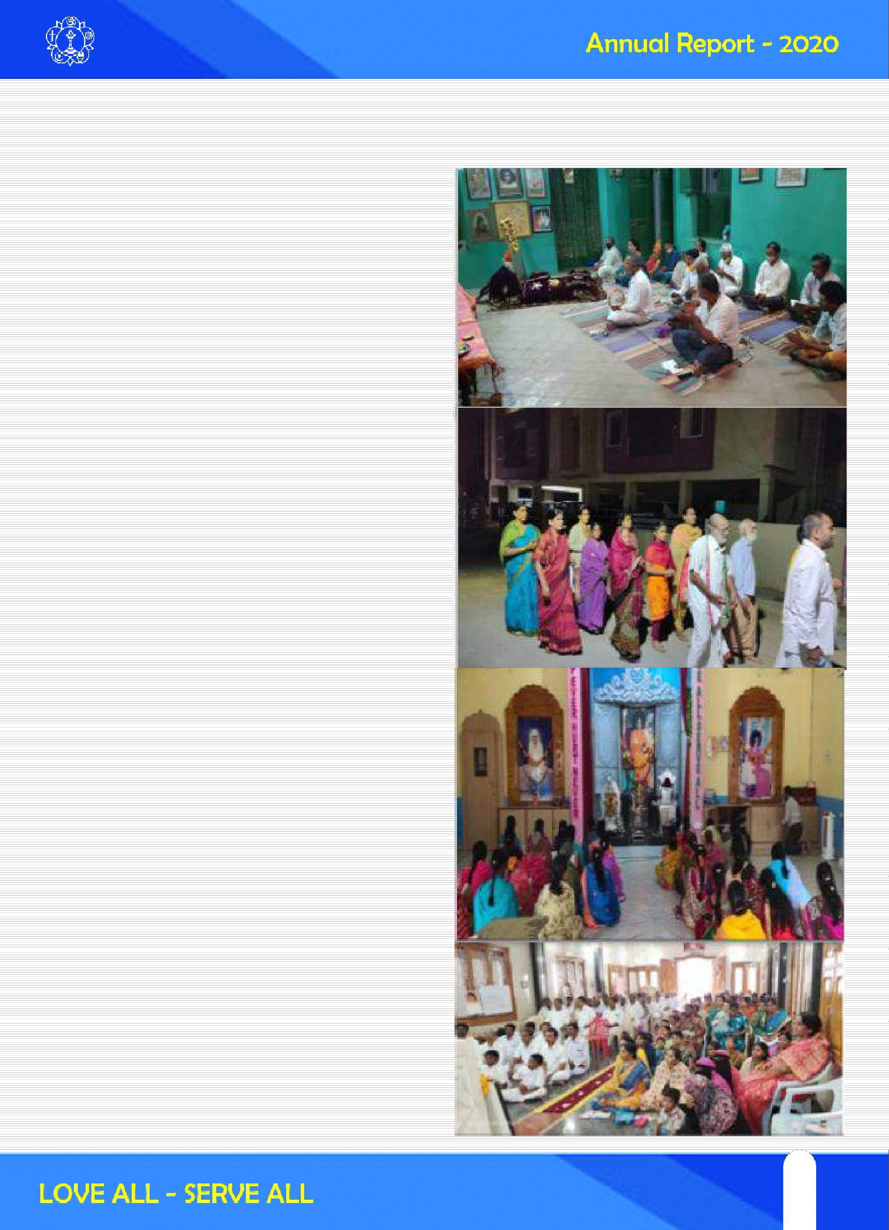

SPIRITUAL ACTIVITIES
With the Blessings of Bhagavan Sri Sathya Sai Baba a number of Spiritual activities were undertaken in the state of Andhra Pradesh. A gist of the activities is presented below:

Nagarasankirtans and Bhajans were conducted by almost all samithis in the months of January, February and March 2020.

Aaradhanautsavam
All the Samithis in the state celebrated Aaradhanautsavam by distribution of clothes etc to the needy, Veda Parayana, Abhishekams, Online Bhajan etc., on the occasion.

Esawramma Day
On May 6th Eswaramma Day was celebrated all over the state in all samithis. Various programmes such as Balavikas students rallies, cultural programmes and bhajans were conducted online. All the programmes on that day were conducted by Balavikas students.

Gurupoornima
Gurupoornima was celebrated on July 5th remembering Viswa guru Bhagavan Sri Sathya Sai Baba. All the samithis celebrated Gurupoornima by conducting special bhajans and by arranging talks on importance of Gurupoornima.

Sri Krishna Janmashtami
On 11th August Celebrated Sri Krishna Janmashtami throughout the state. “Utti” utsavam was celebrated on this day and special bhajans were conducted online.

13
13

Vinayaka Chaturdhi
VinayakaChaturdhi was celebrated on August 22nd by all the samithis. Samithis celebrate this festival in very simple manner due to Covid-19.

Varalakshmi Vratam
Mahilasevadal members celebrated Varalakshmi vratam on 31st July in all the samithis. In many places online varalakshmivratams were conducted by
involving all the ladies from their houses itself.

Avatar Declaration day
Avatar Declaration day was celebrated in many districts by following covid guidelines.

Dasara Navratri
Dasara Navaratri was celebrated for nine days in the month of October. Dasara is celebrated as a symbol of victory over evil. All the samithis in state celebrated Dasara by installing idol of goddess Durga and performing poojas for nine days. Bhajans, cultural programmes and special talks on importance of Dasara Navaratri were arranged by many samitis.

Deepavali
Festival of lights, Deepavali was celebrated samithis throughout the state on November 14th. Sitaramapuram Smaiti, Vijayawada, celebrated Deepa Lakshmi Pooja on a grand scale and many mahilas participated. Some samitis celebrated Kartika deepotsavam in the month of Kartik starting from Deepavali

Bhagavan Sri Sathya Sai Baba Vari Janmadinotsavam
Bhagavna Baba’s 94th Birthday was celebrated by all samitis and Bhjana Mandalis and performed many online activities during the entire month.

Mukkoti Ekadasi
Mukkoti Ekadasi was celebrated on December 25th. On this day samitis arranged “Uttara Dwara Darsanam” of Swami and special Bhajans and talks were arranged.

Christmas
On December 25th Christmas was celebrated by samithis to mark the Birthday of Jesus Christ. Special online Bhajans and talks by a church father were arranged by many samithis in the state.

Samkranthi
Makrasamkranthi festival indicating shifting of the Sun to Makara raasi was celebrated for three days starting from 14th January.

Maha Shivaratri
Maha Shivaratri is an important festival and was celebrated by all samithis. Devotees from all over the state visit nearby temples for darshan after taking holy dip in nearby river. Sevadal from various samithis rendered seva both at river ghats and temples such as Simhachalam, Kankadurga temple, Vijayawada, Kotappakonda, Guntur

14

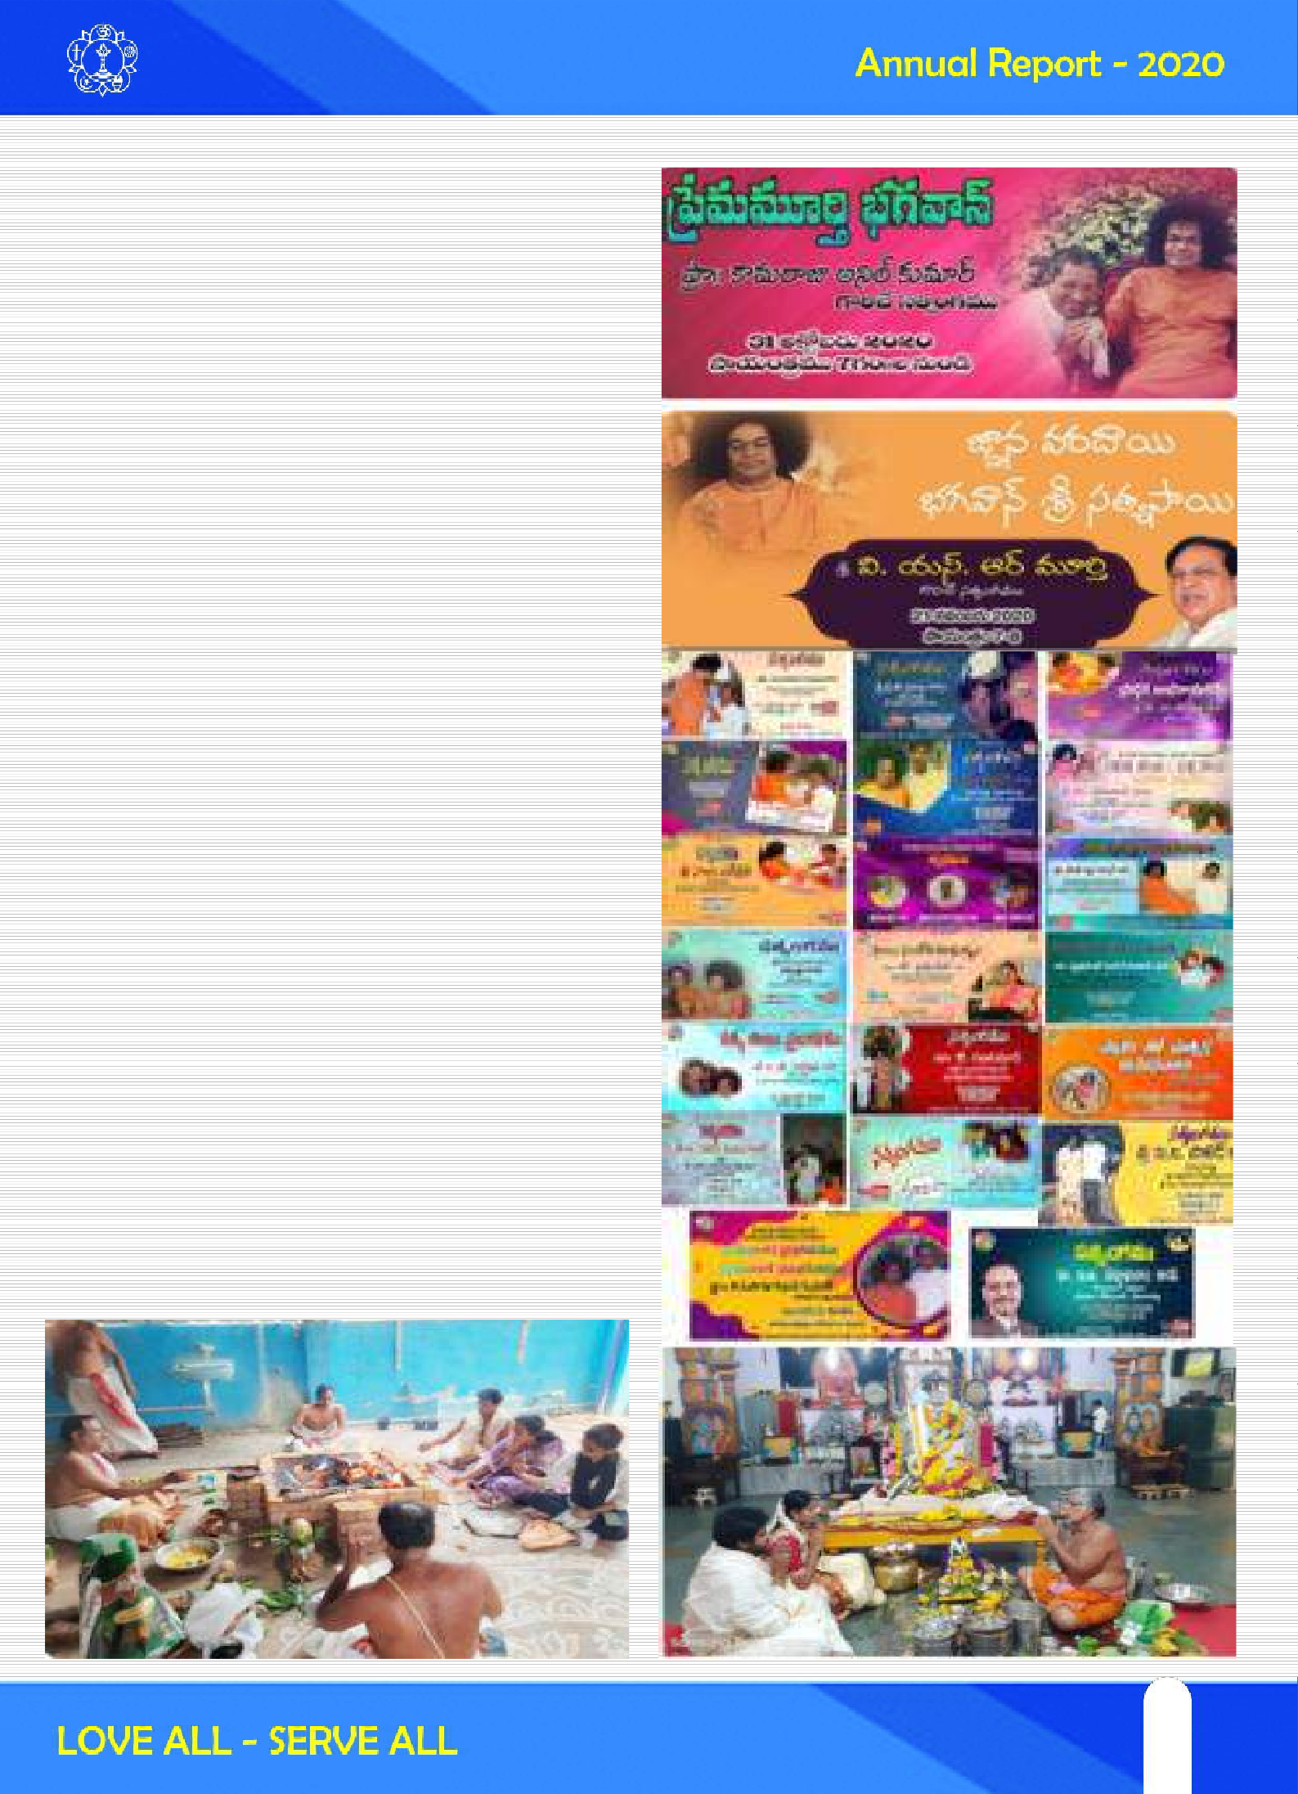
district and many other places in the state. Also medical camps are arranged at these place to render medical services to the devotees visiting temple.

Online Satsangs and Study circles were conducted in almost all the districts of the state on different topics such as Nine Point Of Conduct, Nava Vidha Bhakti Margam and Prema Moorthi Bhagavan.

Shodashopachara pooja training
Online Shodashopachara pooja training was conducted for mahilas at state level.

Training Classes:
Online Vishnu Sahsranama Parayanam, Vedam classes and Bhajan training sessions were organized in various districts.

Special Activities:
District level online 95 days Bhajans, online Samoohika Sri Sathya Sai Vratams and Special poojas like Sahasra Sai Gayatri yagnam were performed as part of Swami's 95 th Birthday celebrations.

15
15

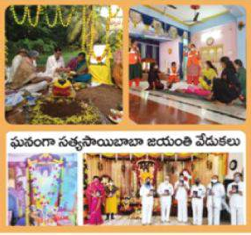

Details of the activities performed:
Activity | Viziana garam | East God  avari | West God  avari | Kris hna | Gun tur | Praka sam | Nel lore | Kad apa | Chit tor | Ana nta  pur
Devotional Singing/  Bhajans held | 28520 | 4680 | 10224 | 6000 | Onl Ine  Bha jans | 5178 | 1262 | 100 | 92 | 1079
Seven  household Bhajans | 1159 |  | 210 |  |  |  |  |  | 55 | 75
Nagar Sankirtan | 954 | 1440 | 10000 |  |  | 70 | 105 | 20 | 51 | 46
StudyCircle  s | 435 |  | 4 | 500 | 238 | 4 | 5 | 5 | 17 | 210
Sadhana  Camp | 115 |  | 4 | 100 | 32 |  |  | 1 | 3 | 10

16

Brief report of Balvikas Activities For the year of 2020
SRI SATHYA SAI BALVIKAS YEARLY REPORT STATE: A NDHRAPRA DESH YE AR: 2020

STATISTICAL DATA

CEN TRES School BalVikas
Urban Domestic Bal V ikas Rural Domestic BalVikas
G URUS Gu ru s Male
Gu ru s Female
BOYS-Sch ool Bal Vikas
BOYS-Urban Domestic BalVikas
G roup I
153
428
320
226
837
5302
3717
Group II
43
223
124
120
438
1038
1321
G roup III
17
98
34
59
192
231
425
Pre- Sev adal
07
18
05
-
-
95
378

STUDENT S

Value Additions :
BOYS-Rural Domestic BalaV ikas GIRLS-School Bal Vik as
GIRLS-U rban Domestic Bal Vikas GIRLS-Rural Domestic BalV ikas
2974
5725
4550
3583
730
1108
1268
973
204
225
554
248
93
122
296
165

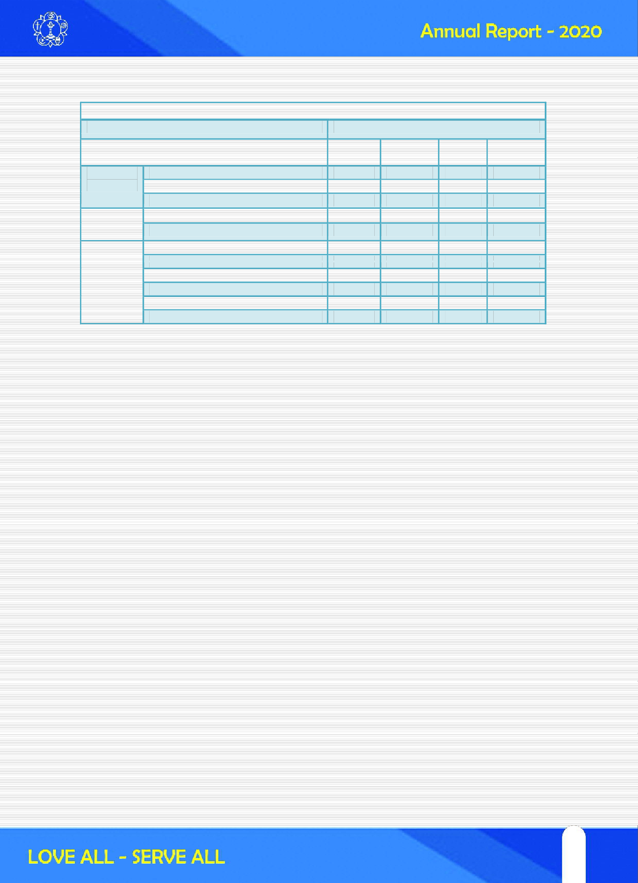
- Number of Online Classes Conducted : 35,280
- Number of Online Training programs
  - Group-I : No.of Training Programs : 131
  - No. of. Gurus participated : Male - 246 Female - 637
  - Group-II: No.of Training Programs : 67
  - No.of Gurus participated : Male - 133 Female – 521
  - Group-III: No.of Training Programs : 29
  - No.of Gurus participated : Male - 21 Female- 105
- No.of Alumni enrolled in SSSSO : Male -181 Female: 364
- No.of New Bal Vikas Centres Commenced: 39

Online Vedam & Bhajan Classes : A Team of 95 Balvikas Gurus, Alumni and Students are being trained in Vedam and Bhajans from 13 Districts of Andhrapradesh. These trainings were Conducted by using Online Applications like Zoom meet, Cisco Web meetings , Free conference etc., Around 1250 from Vedam and 1250 from Bhajans will be prepared thoroughly on upcoming 2 Months.

Certificate Course : A New Programme “BALVIKAS CERTIFCATE COURSE “ is being conducted in Vizag where training classes are held on Saturday afternoon for 4 hrs. The Syllabus has been divided groupwise into 8 classes. Certificated will be issued at the end of the course.

Talent hunting : Talent hunting programme is being done where a contest is being conducted in speaking skills, singing, instrumental, vedam, drawing etc, In Each week is for one event and children are required to send videos to particular inchargers.

Quiz Competitions: Online Quiz competitions are conducted to Gurus and Students on Swamy’s life history , Tapovanam, Ramayana etc., separately.

17
17

Interaction with parents : Interation of Gurus with parents being done at all districts. Every day one Creative Activity ( Task with value) Would be given for Students to be done at their homes. Some models I have given. It was more enjoyable task for children.
Mass Prayers : Collective Prayers for well being of the world and for speedy recovery of the CORONA HAVOC are beding done daily from 30th March to 9th April 2020 where gurus, Balvikas children and parents are chanting as per given below.

Sai Literature : A Satsung have been conducting everyday from 3-00 PM to 4-30 PM on Swamy Vahinis. All the district incharges has been participated in this through online apps. Every day one chapter is being discussed.

Global Akhanda Gayathri Mantra Japam
(13-06-2020 from 08-30 P.M to 14-06-2020
08-30 P.M)
With Divine blessings of our Beloved Bhagwan, A Program of Global Akhanda Gayathri Mantra Japam has been conducted by Sri Sathya Sai Seva Organisations, Andhrapradesh for the world peace.
On behalf of this Balvikas wing took a part from 14-06-2020, 06-00 A.M to 08-00 A.M as
per the schedule given to various districts. A brief report is given below.
- 06-00 A.M to 06-30 A.M. – Srikakulam, Vizianagaram, Nellore Districts
- 06-30 A.M to 07-00 A.M – Vizag, Paderu, Guntur, Kurnool Districts
- 07-00 A.M to 07-30 A.M. – East Godavari, West Godavari, Chittoor Districts
- 07-30 A.M to 08-00 A.M.– Ananthapuramu, Prakasham, Kadapa, Krishna Districts

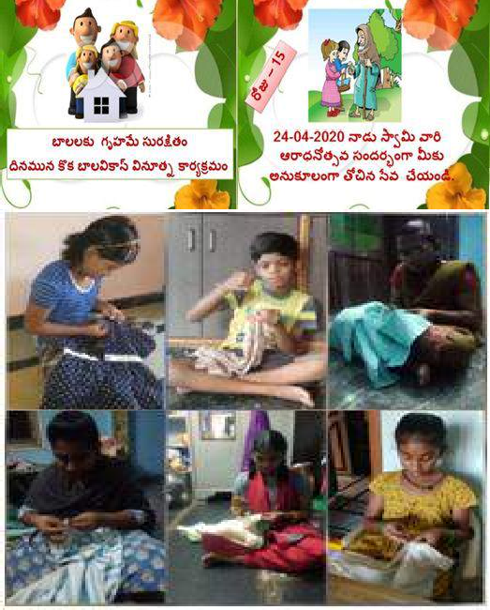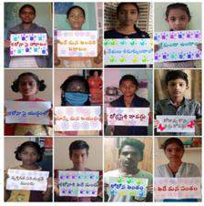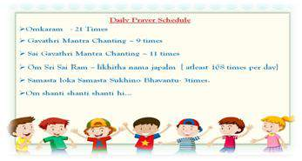

18

OM SRI SAI RAM
Sri Satya Sai Seva Organisations, Andhrapradesh
Global Akhanda Gayatri mantra Chanting (14-06-2020)

S.N0 1
2
3
4
5
6
7
8
9
10
11
12
13
14

District

Ananthapuram Kadapa
Kurnool
Chittoor Nellore
Prakasam Guntur Krishna
East Godavari West Godavari Vishakhapatnam
Vizayanagaram
Srikakulum Paderu
Total
No. Of Balvikas children Boys
202
67
29
126
102
87
312
226
180
115
126
171
132
0
1875
No. Of Balvikas children Girls
294
101
26
123
88
90
396
153
246
300
157
216
200
0
2390
No.Of Female Gurus
397
38
14
80
25
41
97
105
74
70
60
66
21
0
1088
No.Of Male Gurus
141
6
3
11
17
12
50
25
17
21
21
20
20
0
364

No.Of Parents

123
24
12
74
65
10
52
66
60
50
103
41
24
0
704
Total Number of participants
1157
236
84
414
297
240
907
575
577
556
467
514
397
0
6421

450

400

350

300

250

200

150

100

50

No. Of Balvikas chi ldren Boys No. Of Balvikas chi ldren Girls No.Of Fem ale Gurus
No.Of Male Gurus No.Of Parents

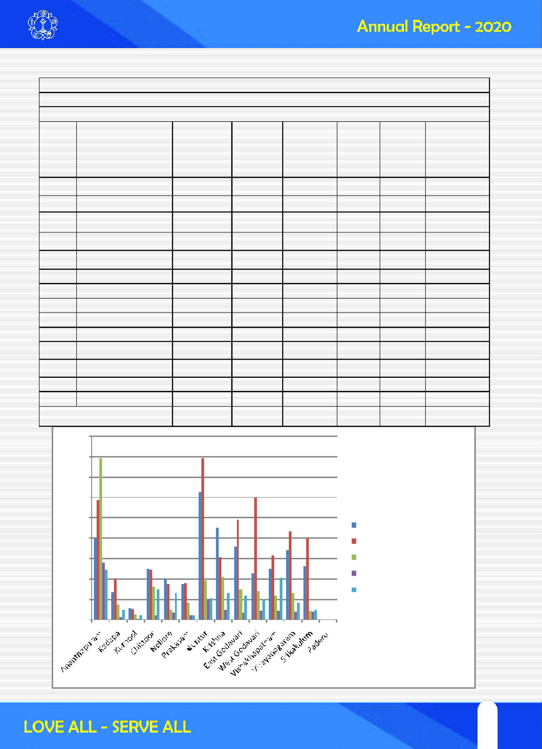
0

19
19

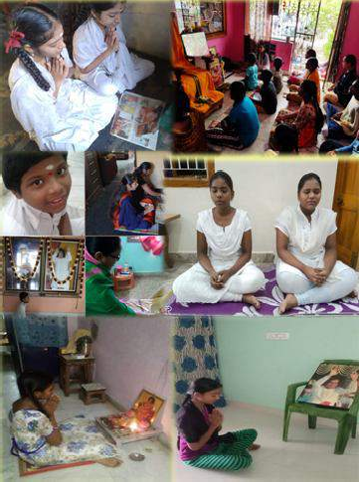

20

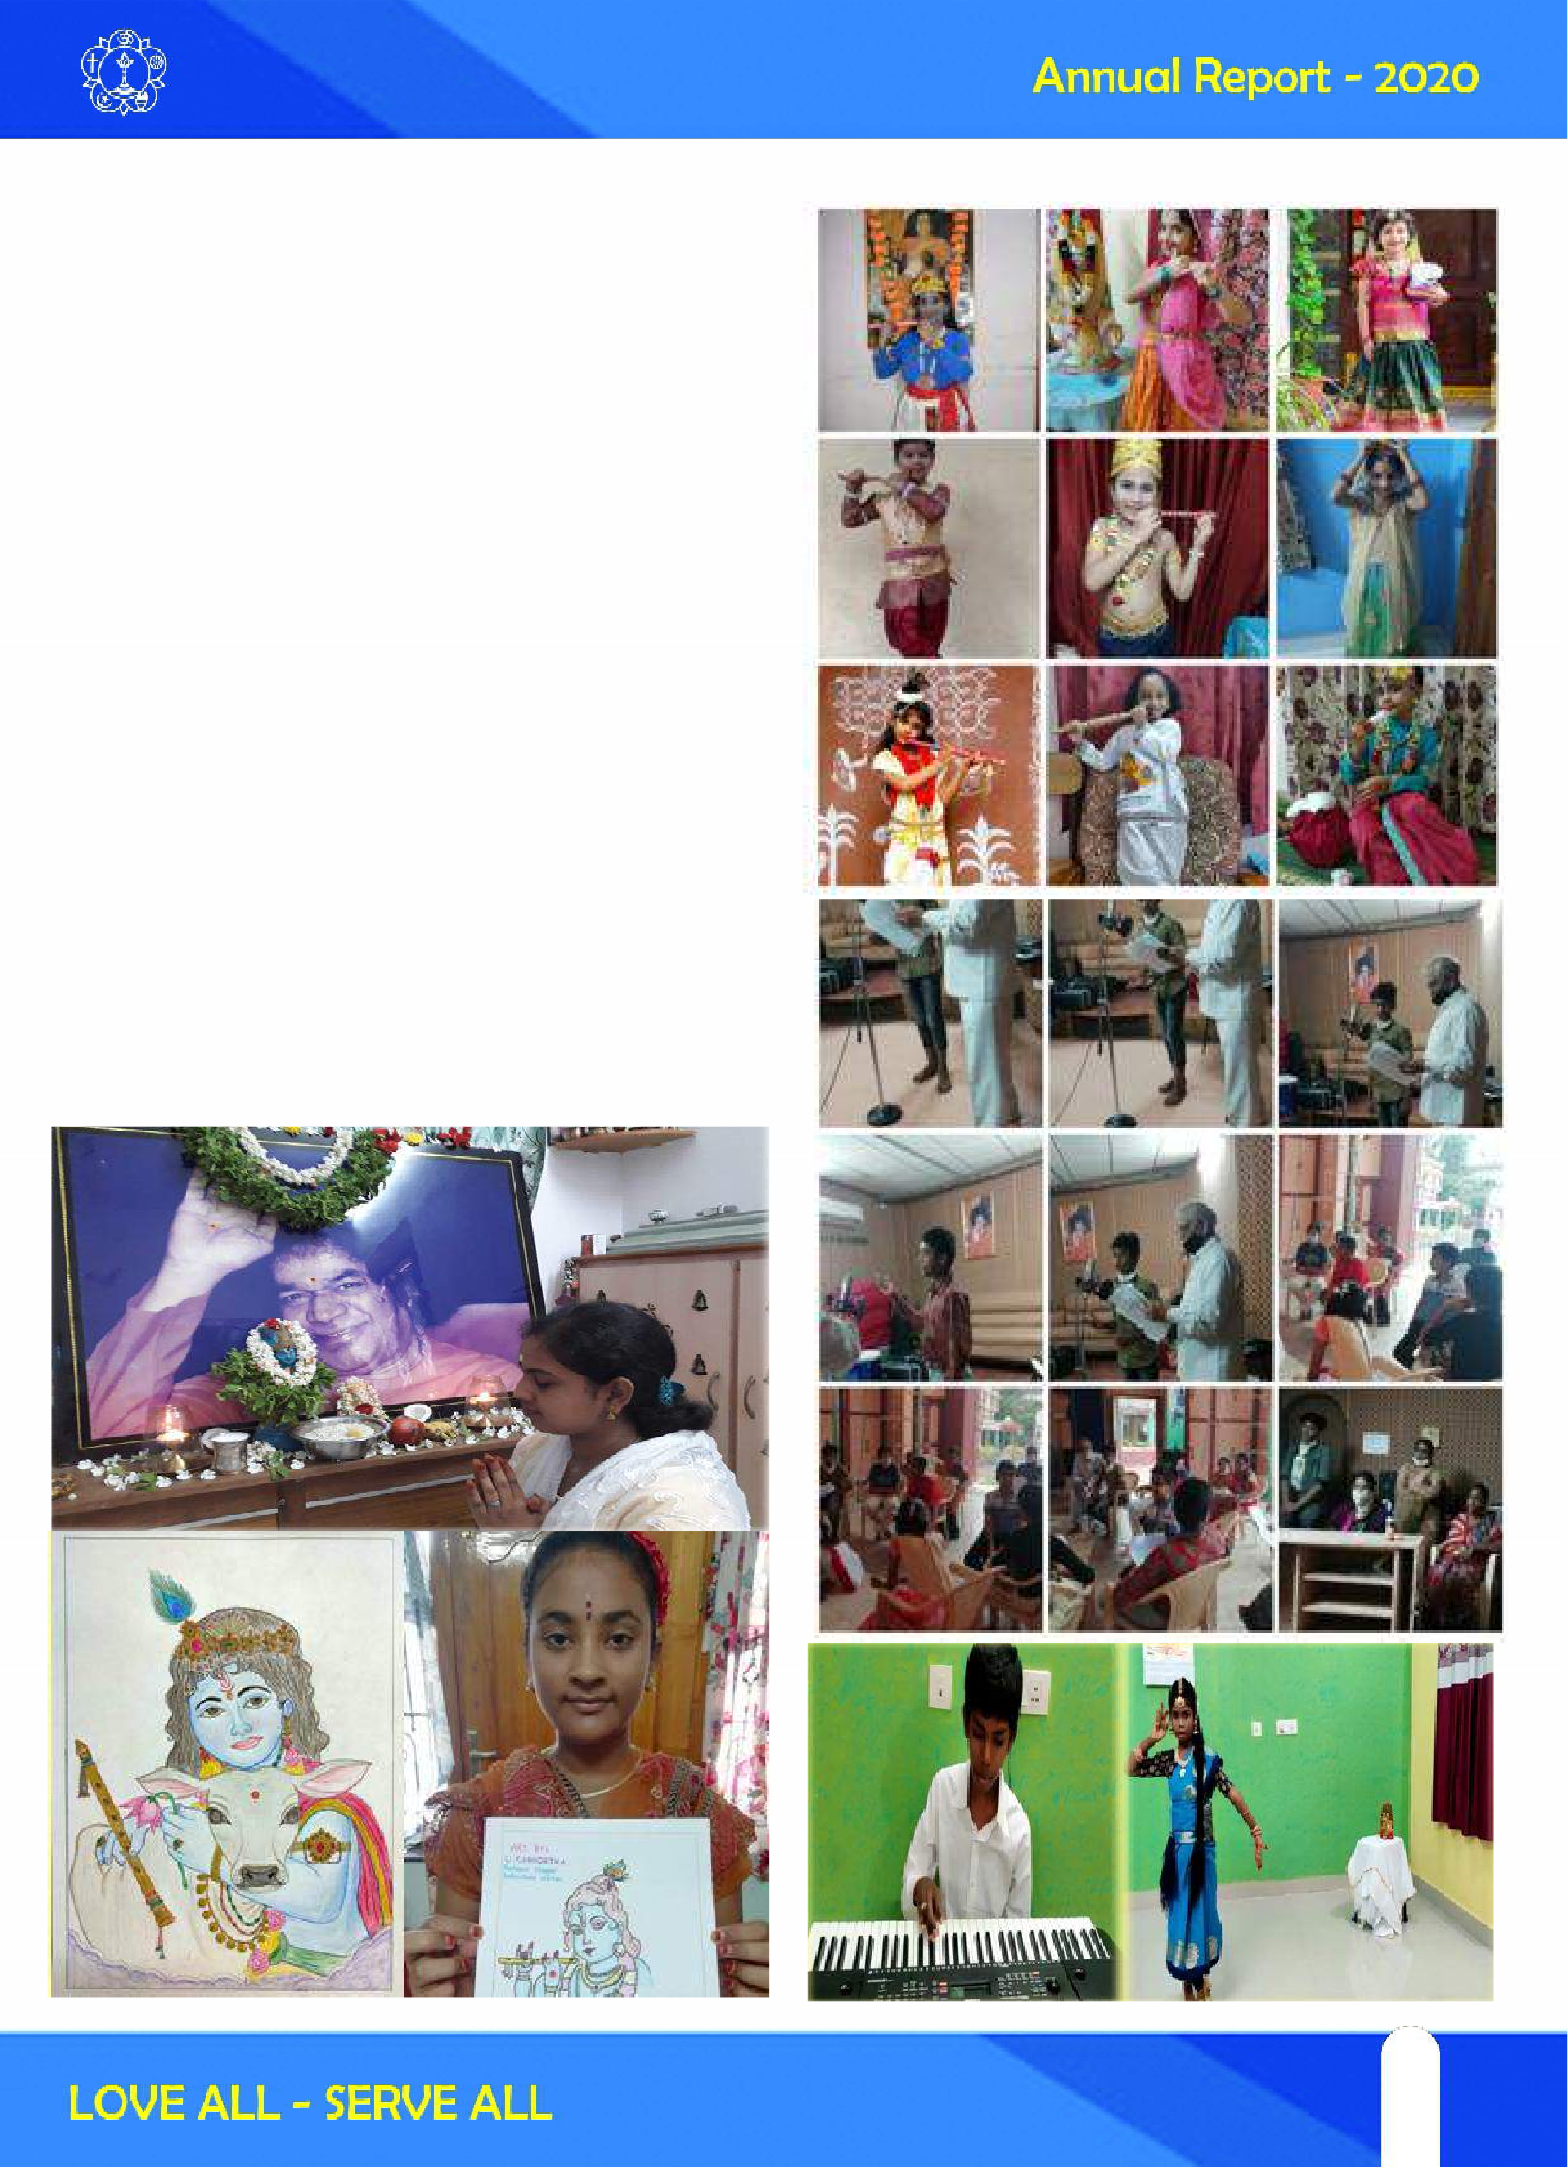
Sri Krishnastami Celebrations (11-08-2020) As a part of Sri Krishna Jayanthi ( Krishnastami Celebrations), the Andhra Pradesh State Balvikas Students and gurus were celebrated with different activities.

- By Involving Parents all the Gurus and Children were recited a Mantra “ Om Sri Sathya Sai Krishnayanamaha “.This mantra Swamy was given to Dr. Gadia for the peace of world.
- A fancy dress competition was conducted to the children through Online. All the children were dressed in Krishna as well as Radha.
- Painting competition was also took place to extract the talent of the children.
- A drama “ Danam” Was live telecasted by the students of Vishakhpatnam Balvikas.
- Some children offered Singing songs/ bhajans and dance performance as a token of their love towards Lord Sai Krishna.

21
21

Sarannaavaratri Celebrations (17-10-2020 to 25-10-2020)
On the Occasion of Sarannavaraatri festival Balvikas Students initiating a programme entitled “Sri Sathya Sai Bala Sudha Sravanthi” by presenting various topics through online.
Date | Veda Chanting & Participating  Districts | Topic & Participating Districts
17-10-2020  Saturday | Srisuktham | Significance of Navaraatri Festival
17-10-2020  Saturday | Vishakhapatnam Dist | Vishakhapatnam Dist
18-10-2020  Sunday | Neela Suktham | Significance of Navaraatri Festival
18-10-2020  Sunday | Nellore Dist | Vishakhapatnam Dist
19-10-2020  Monday | Sivopasana Mantras | Ideal Women
19-10-2020  Monday | Prakasham Dist | Guntur Dist
20-10-2020  Tuesday | Sarvadevataa Gayathri | Glory of Sri Sathyasai Avatar
20-10-2020  Tuesday | Ananthapuram Dist | Ananthapuram & Kadapa Dist.
21-10-2020  Wednesday | Narayanopanishath  Kadapa Dist | Bhakta Prahlada, Dhruva and  Markadndeya -Chittor Dist
21-10-2020  Wednesday | Narayanopanishath  Kadapa Dist | Bala Aruni, Nachiketudu  Vizianagarm Dist
22-10-2020  Thursday | Medha Suktham | Glory of Sri Rama
22-10-2020  Thursday | Guntur Dist | East Godavari, Kadapa Dist
23-10-2020  Friday | Sri Rudram | Sri Krishna Madhuryam
23-10-2020  Friday | Vizianagarm Dist | Krishna , Kadapa Dist
24-10-2020  Saturday | Durga Suktham | Sri Sathya Sai Prema Pravaham
24-10-2020  Saturday | West Godavari Dist | Srikakulam Dist
25-10-2020  Sunday | Mantrapurshpam | Sri Sathya Sai Sangeetha Kadambam
25-10-2020  Sunday | Chittoor Dist | AndhraPradesh State Balvikas Children

22

Ganesh Chaturthi Celebrations (22-08-2020) As a part of Ganesh Chaturthi Celebrations the Andhra Pradesh State Balvikas Students and gurus were celebrated with different activities. Children prepared Lord Ganesha Statues with Turmeric and Mud.

Children and Gurus Worshipped Lord Ganesha with grass and leaves by Chanting “Om Gham Gham Gham Gham Sri Sai Ganapathayenamaha”. Some of the Children drawn the image of Lord Ganesha with Crayons and Sketches.

Spoken English Classes for Balvikas Children from Aug’2020
Sri Satya Sai Youth Wing – Mahila Vibhag, Andhrapradesh has been conducting Spoken English classes for Balvikas Children of various districts as a part of service.

95th Birthday Celebrations of SWAMI (18-11-2020 to 23-11-2020)
One more programme entitled “Sri Sathya Sai Viswa Janeena Prema Vahini “was done by Balvikas Children of AP, Showing their gratitude towards our beloved Bhagwan on the occasion of 95th Birthday. They are presented the events of divine avatar in different aspects through online.

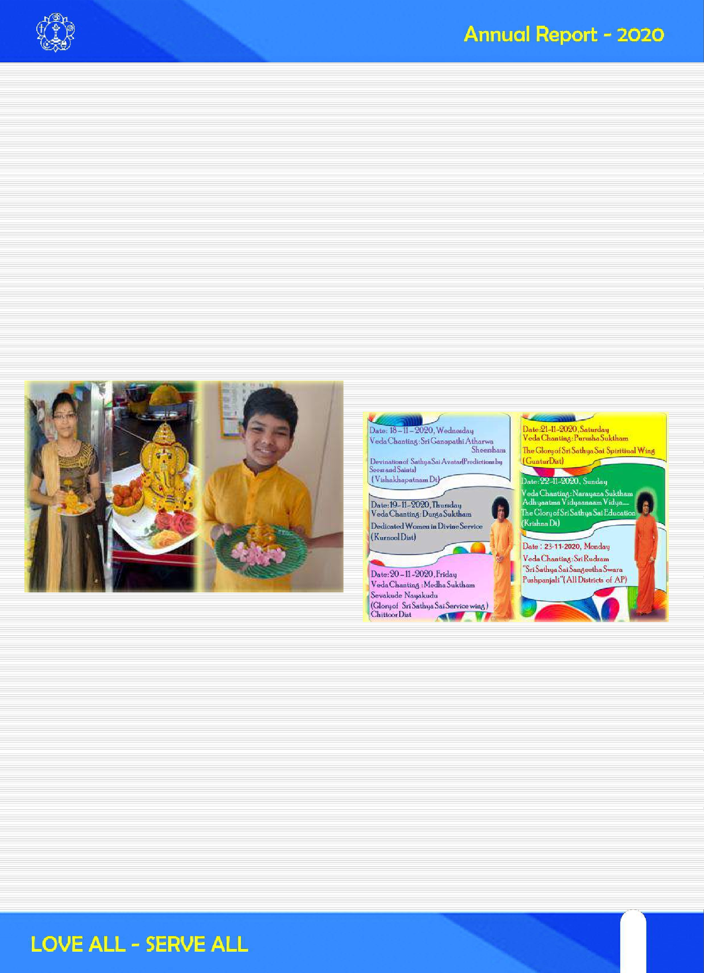

Online Balvikas GURUS Parthi yatra Celebrations (27-12-2020 & 28-12-2020)
A programme entitled “Sarvaswamaina Swamiki Sahrudya Samarpana “was done by Balvikas Gurus of AP, Showing their gratitude towards our beloved Bhagwan for the succeed of Previous year Golden Jubilee Balvikas Swarnotsava Sankalpa Yatra. Balvikas Gurus from Various districts of Andhra Pradesh Performed in different aspects of importance of Balvikas through online.

Online Gurus Training for Balvikas Gurus from Aug’2020 - Traning Camps was started for Balvikas Gurus through online by Senior State Faculty members on Group-1 & 2 Syllabus on 2nd and 4th Saturday, Sunday of every month. It is most helpful for the gurus who were enrolled recently. Some of the districts also conducting trainings for respective gurus.

Offering this report at HIS Lotus feet and Praying Swamy to shower his choicest blessings those who participated on one and all. -Team Balvikas of AP State.

23
23

Introduction:
SRI SATHYA SAI VIDYA JYOTHI (SSSVJ)

Inspiring children by Empowering Schools

The vision of SSSVJ program is to inspire children by empowering schools. The aim of the project is to take up existing semi- operational, makeshift, dilapidated schools, and turn them into reasonably equipped, operational and well-structured temples of learning. Since a school is more than just a brick and mortar structure, the program will take a more holistic view of the entire ecosystem. Multiple stakeholders like the parent, the teacher, the school staff, the student, the villager, the volunteer and even the government department is approached, interviewed, involved and leveraged on a need basis, in constructively shaping the learning environment for the child. Physical activity, cultural programs, value-oriented discussions, Grama Sabhas, sports activities are all leveraged to inspire the child and equip the school. The target of this program is to take up 900 schools, PAN-India and an initiative of Sri Sathya Sai SevaOrganisations-India.

Following are the methodical steps for implementing SSSVJ project.

Decide the team (linked toSamithi):
Each school adopted under SSSVJ program must be adopted through one specific Samithi. More than one Samithi’s can come together and adopt a school under SSSVJ program. However, one of the Samithi’s from the group shall play a leading role in implementation of SSSVJ. There cannot be a school without a Samithi being responsible for it. The Samithi convener becomes the centre point of responsibility. He shall convene a meeting of all the office bearers
and constitute a team consisting of himself, service coordinator (or his nominee), Bal Vikas coordinator (or her nominee), Mahila coordinator (or her nominees) and the Youth coordinator. These 5-member team shall be responsible for all the decision makingprocess.

Identify the deservingschool:
The next step in the program is identifying the deserving school. The national team has already circulated a detailed survey process. Get few members from the Samithi especially youth to carry out the Survey of schools in the vicinity/nearby village and chose the deserving school. The survey process has been created keeping in mind the various dimensions; hence follow them sincerely. Complete the formalities of engaging (Energise phase) with the school management and local education offices of the government explaining the program and its benefits and seek the necessary permissions to adopt the school under SSSVJ program. Let us inspire them such that they become part of the program implementation.

- Create the plan (school’s needsbased): Third step is creating a plan for the school. The plan shall be strictly based on needs of the school and available resources. The 5-member team of the Samithi may delegate the work to group of youth to create a plan consisting (a) scope of sevas based on resources available (b) calendar of implementation and (c) estimated budget. Ensure we follow Energise, Empower, Equip and Evolve phases sequentially. At some point Empower and Equip shall overlap each other and go concurrent.

24

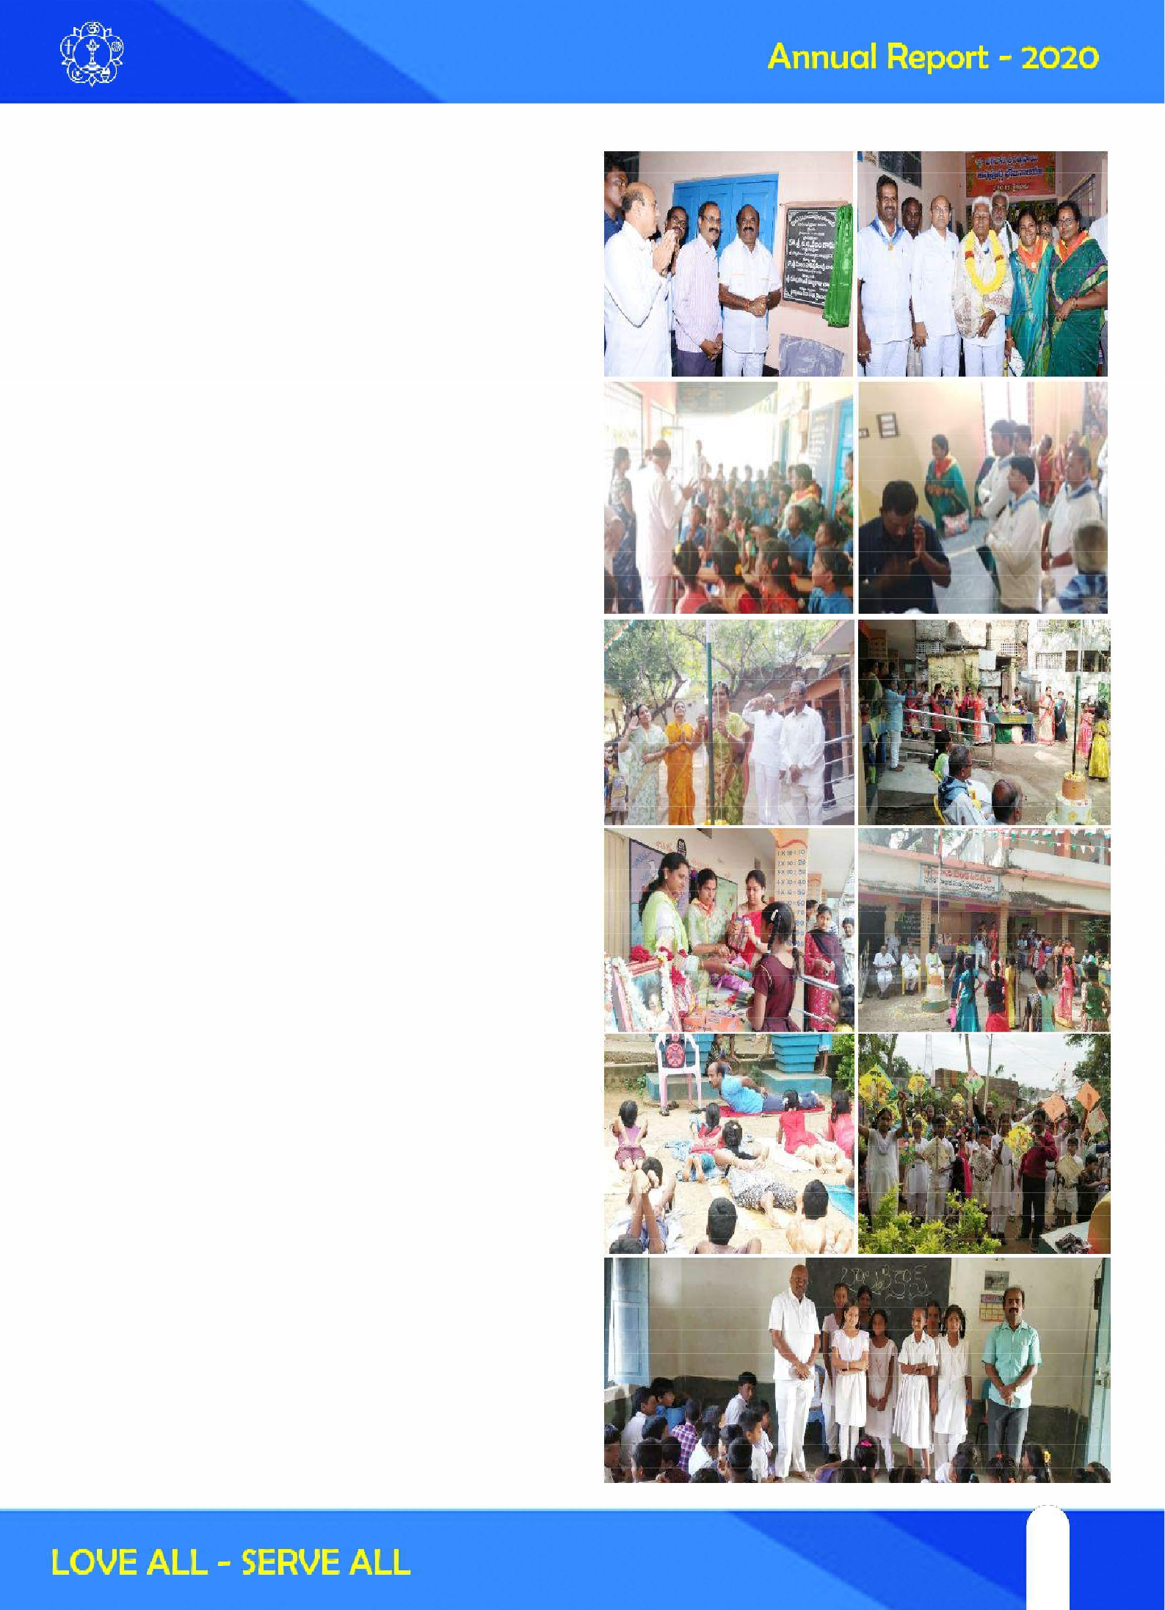

Identifyresources:
Resources for the project consist of manpower resources and monetary resources. Monetary resources shall be handled only by the Samithi convener through Samithi/district/state offices. However, the primary manpower resources shall be from the Samithi active members, Seva Dal and youth.

SSSVJ is a program for all members of the Samithi to participate; however, the youth shall play a larger role under the guidance of Samithi office bearers. The youth shall conduct youth outreach program in nearby colleges andneighbourhood to rope in new young volunteers as secondary resources. They need not be members of the organization but have to strictly abide by the discipline of the organization. The third and important manpower resource is specialists such as Doctors, Counsellors, Speakers, Educators, Infrastructure specialists, Children specialists etc. The youth shall take the efforts to identify and source these resources under the guidance of Samithi senior members. The beauty of this program is, there is most appropriate role for each and every member matching his/her capabilities. Let us inspire all the above three resources to take part in SSSVJ program. This itself is part of Energise phase of the program.

Assignresponsibilities:
As there are multiple sevas to execute, identified resources may be assigned to smaller groups based on the beneficiary that is being served. For example, children centric sevas, teacher centric sevas, etc. are all
beneficiary focused sevas. It is very important that the sevas are delegated to smaller groups

25
25

/ individuals and responsibilities are clearly stated. Creation of sub-teams and delegation are the key for smooth implementation. Periodically all the team members should meet at Samithi to exchange the progress, challenges and way forward. At the start of the program itself we should strive to create a team of youth from the village to help us in implementing the program. They shall be guided and made part of all the sevas such that within one year they gain experience and become the implementing team for subsequent years.

Monitor progress anddelivery:
Start the program as per the calendar prepared and guidelines given hereunder. Each of the activity is termed as seva as it would not only entail just doing the activity but shall be done with Love and effort to bring out and highlight the values at each step. Smoother implementation of the program needs a great teamwork and His grace. Let us pray for the same.

- Inform, exchange and share–experiences: We are here to transform self to transform the world. Exchanging and Sharing have to happen at three levels. At first level let us share the experience with fellow team members. After every seva, meet as a team and exchange/ share the learning. This will not only internalize the learning for each one of us, but will also motivate others. At second level, let us share the experience with people whom we know but not yet part of the team. This shall motivate them and enhance the team size. At third level, let us inform, exchange and share the experiences with national team through SSSVJ blog. This shall motivate and create the platform for exchange of best practices among
various SSSVJ teams across the nation. Each data and seva should be converted into a story and key learning/innovation/new ideas should be highlighted. Make narrative of every transformational success achieved with photographs to be uploaded in the SSSVJ blog for others to read and benefit from them. Who knows- Some team from a remote corner of the country may find a solution from what you did already. Why reinvest the wheel when someone has already done it.

Learn whileimplementing:
This program is dynamic and shall evolve at every stage of implementation. There is no present template for this program. What is given in this document is wishful thinking. Let us apply your own ideas and innovate. But we should ensure we don‘t cross the organizational discipline and code of conduct. Ours is a spirituality based seva organization and we are here for self-transformation.

We are not a substitute for the Government. Let us have the attitude of learning while implementing.

Offer to Bhagawan!
He is the one, who sows the thought; He is the one, who makes us think and plan; He is the one, who executes it. Yet He gives us the credit for all good work. As part of self- transformation exercise let us offer every seva, every plan, every detailing at His lotus feet. Let Him guide us, motivate us and inspire us at every step!

26

A glimpse of the Project in the State of Andhra Pradesh is depicted below DESCRIPTION
No. of Sai Districts in the State 14
No. of Samithies in the State 341
No. of SSSVJ Schools adopted as on date 56
District Level Reach % 100%
Samithi Level Reach % 36%
Activity Level Reach in % 75%

LIST OF SSSVJ THINK TANK TEAM MEMBERS
S.No Name Districts Coordinating Mobile No.

- K. Sai Pradeep

- A. Siva Kumar

- I. Anil Kumar

- U. Sudheer Kumar
- P. Lakshmi Rangaiah
- B. Sreeramulu
State Coordinator Krishna Dt.
Srikakulam Vizianagaram Visakhapatnam
East Godavari West Godavari Guntur, Prakasam
Chittor, Kadapa Kurnool, Anantapur
8099127990

7075306682

9848383834

9963393263
9494948561
8885156956

- K. Damu Pratap
Nellore
9440540278

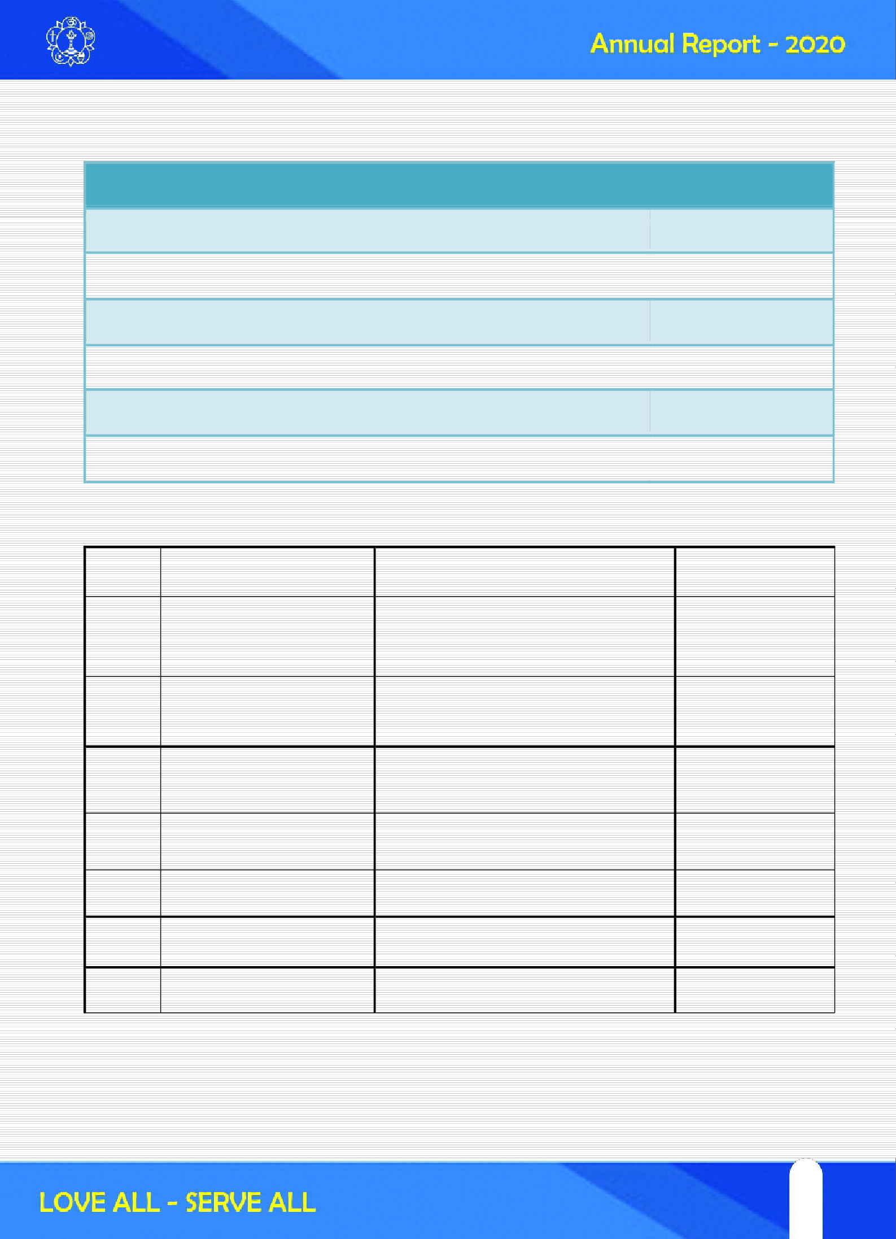

27
27

Sri Sathya Sai Vidya Vahini program in Andhra Pradesh
Sri Sathya Sai Vidya Vahini is an open-ended project to harness technology as the key enabler to replicate on a national scale, the success of the model of Integral Education, followed at the University and Schools founded by Bhagawan, where Value education is integrated into academics. The program was launched by Bhagawan on His 85th birthday, 23 November 2010, and has been implemented in schools bearing name of Sri Sathya Sai in India as approved by Sri Sathya Sai Central Trust. The pilot project has started with content creation integrating values in to the curriculum with seven jewel pedagogy in lesson plans; training teachers in lesson plan transaction using five teaching techniques; supporting teachers with teaching aids in activity based learning skills.

In AP the program has been implemented in 7 schools.

Mentor Schools in Sri Sathya Sai Vidya Vahini Program.
1) Sri Sathya Sai Vidya Vihar, Visakhapatnam, 2) Sri Sathya Sai Gurukulam, Rajahmundry

List of Supported schools, Sri Sathya Sai Vidya Vahini Program
1) Sri Sathya Sai Vidya Vihar, Bommidala Nagar, Guntur, 2) Sri Sathya Sai Vidya Vihar, ZP Compound, Guntur, 3) Sri Sathya Sai Vidya Vihar, Railpet, Guntur, 4) Sri Sathya Sai Vidya Vihar, Macherla, 5) Sri Sathya Sai Samagra Vidya Kendram, Ongole

The Director, Sri Sathya Sai Vidya Vahini program Mrs.Karuna Munshi along with AP Vidya Vahini team has visited supported schools to review the content and lesson plan transaction in the classrooms of respective schools. With the aim to increase the usage of content and teaching aids, the visit to schools have been encouraging on the level of participation of teachers and management of schools.

Sri Sathya Sai Vidya Vihar school at Macherla had the good fortune of Sri R J Ratnakar, Trustee, Sri Sathya Sai Central Trust, inaugurating the spacious dining hall at the school premises. The facility will give 400 students to partake their lunch at one place. During the visit, Sri Ratnakar garu and visiting team of State President Sri Chalam garu addressed the gathering of parents and teachers of the school.

Deloitte Impact day 2018 had 9000 employees of Deloitte, contributing to Sri Sathya Sai Vidya Vahini program by supporting 18 different teaching aids that are useful to teachers across 63 schools in India. They have effectively contributed to about 50,000 man hours as a corporate social responsibility initiative. This is the 6th successive year of Deloitte participation with the program.

A teacher training workshop was organized at Sri Sathya Sai Vidya Vihar, Visakhapatnam on 29th May 2018 to empower teachers of Sri Sathya Sai Schools on content development and curation. A total of 45 teachers participated from 12 schools. Master trainers from Mumbai and Bangalore have shared their knowledge with teachers on transaction of Vidya Vahini lesson plans with the help of teaching aids.

28

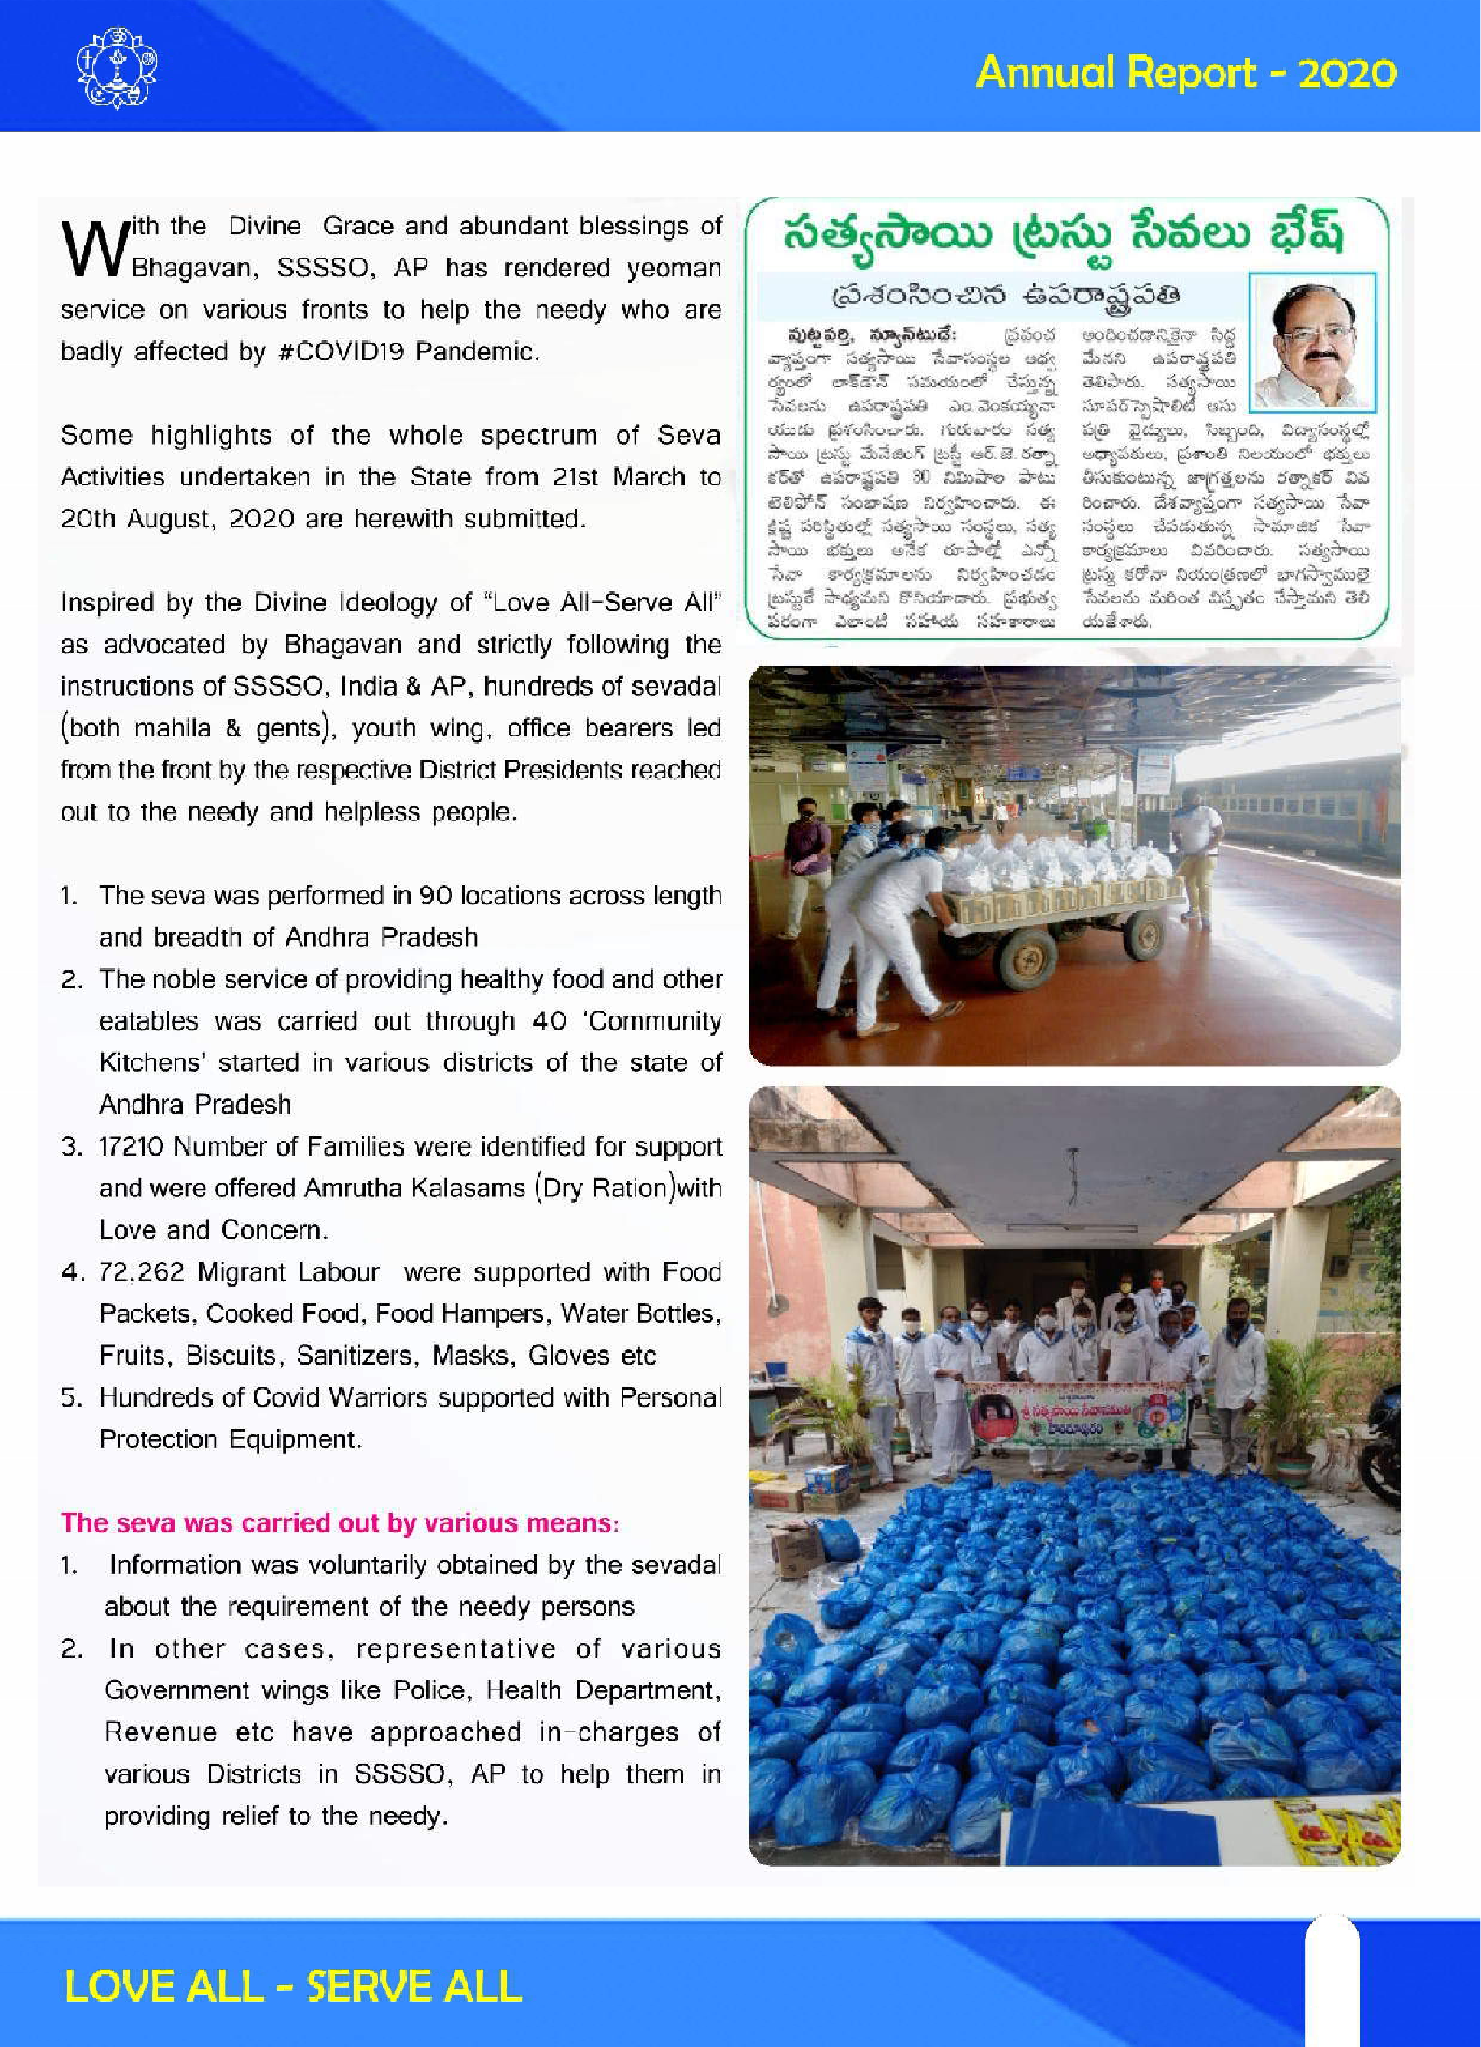

29
29

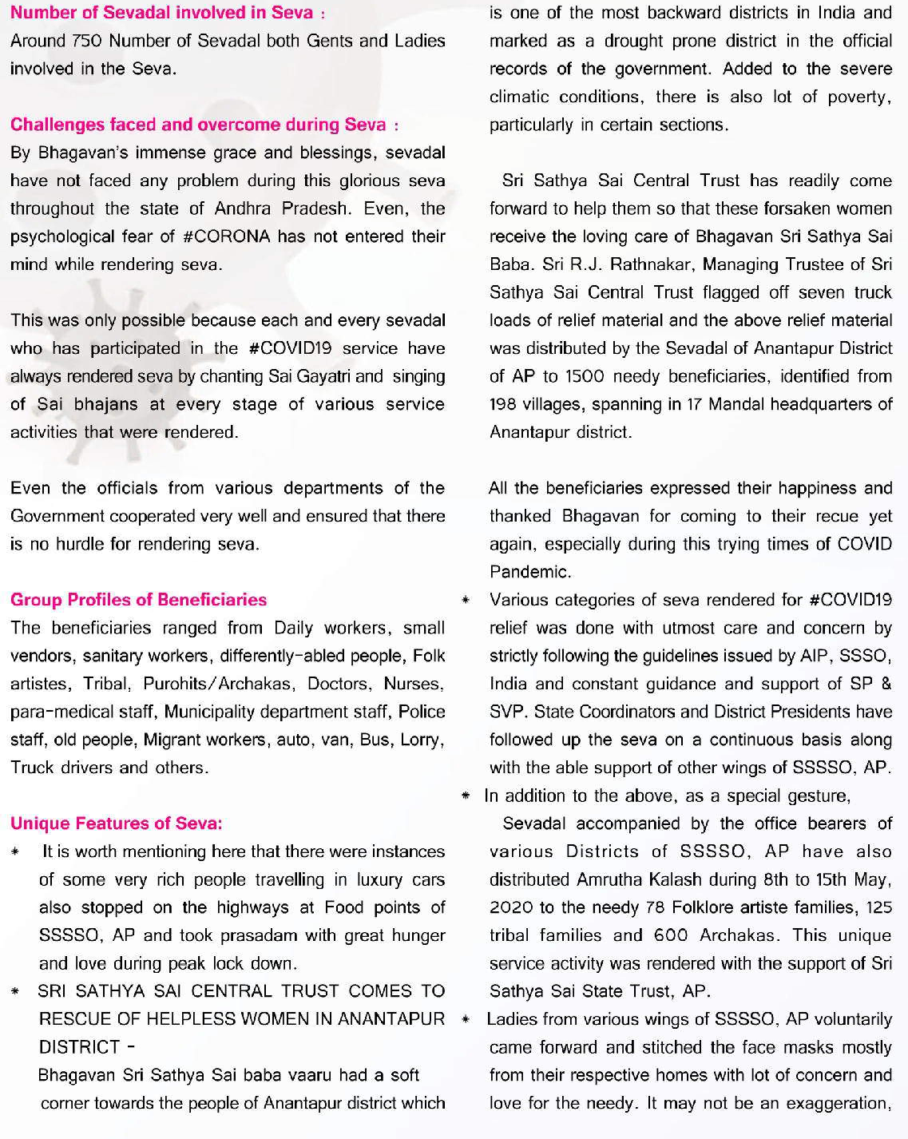

30

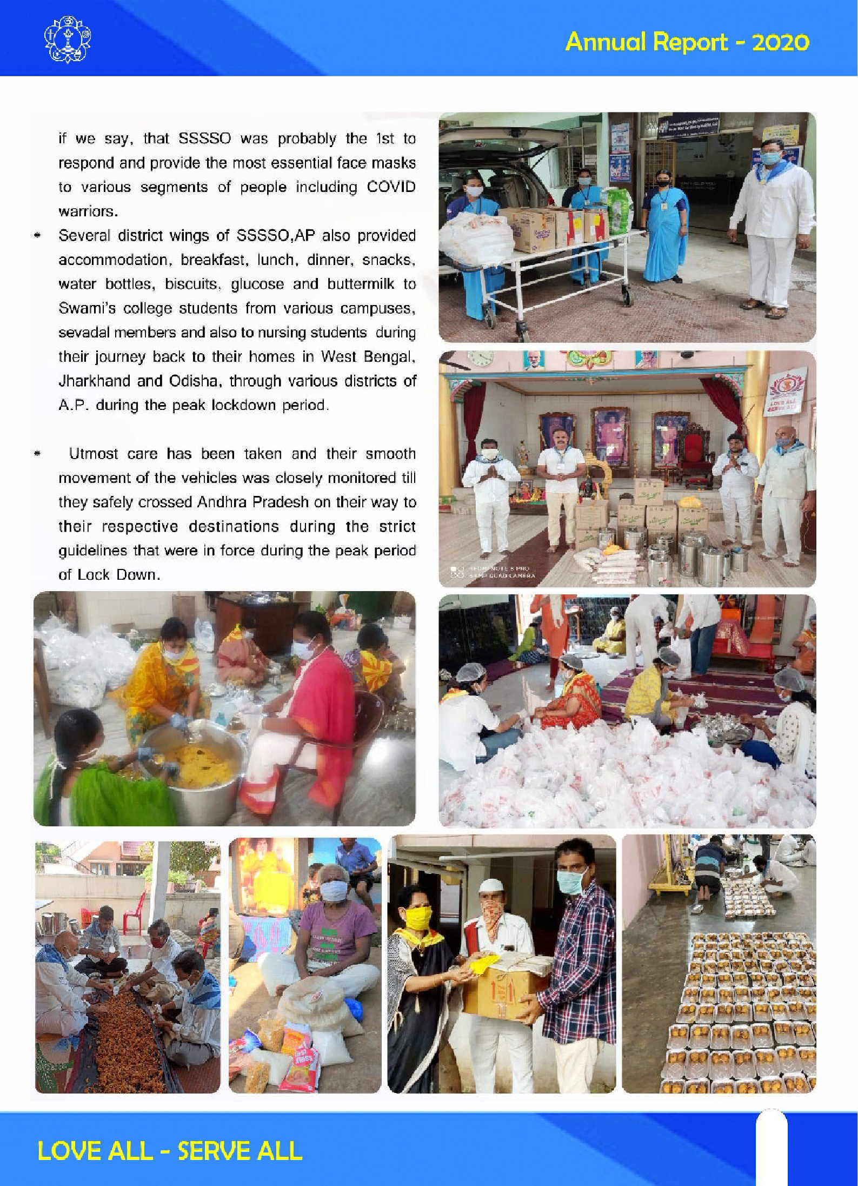

31
31

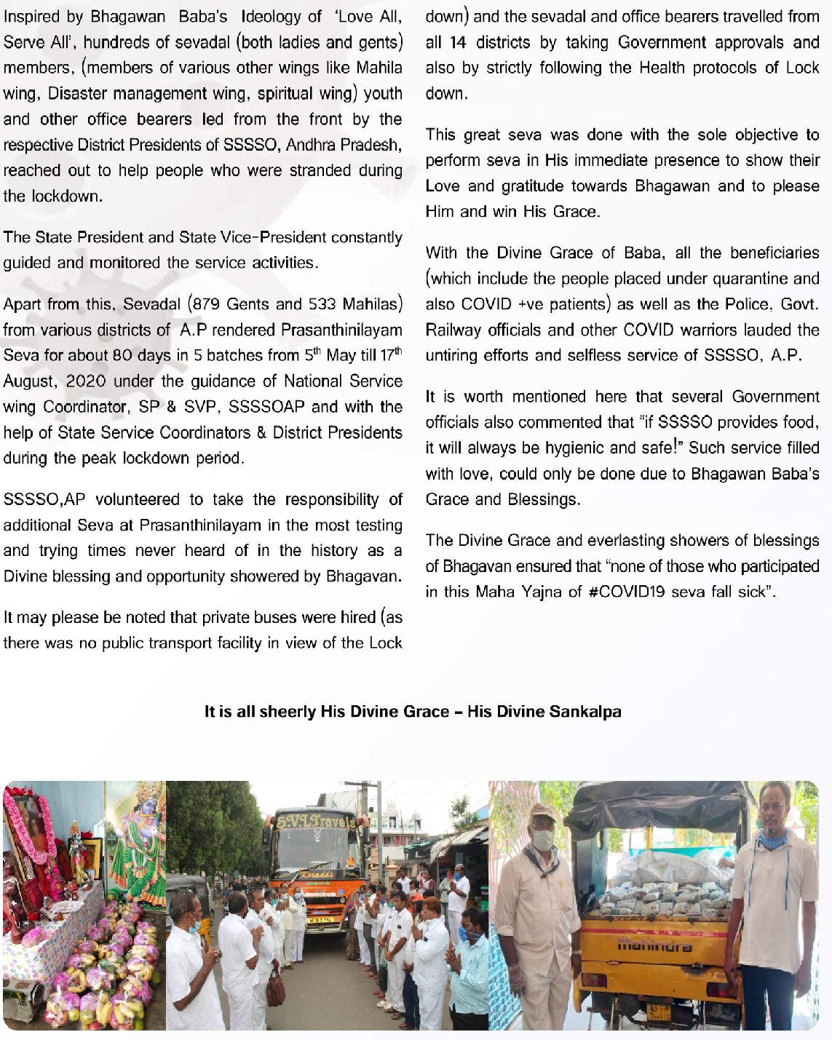

32

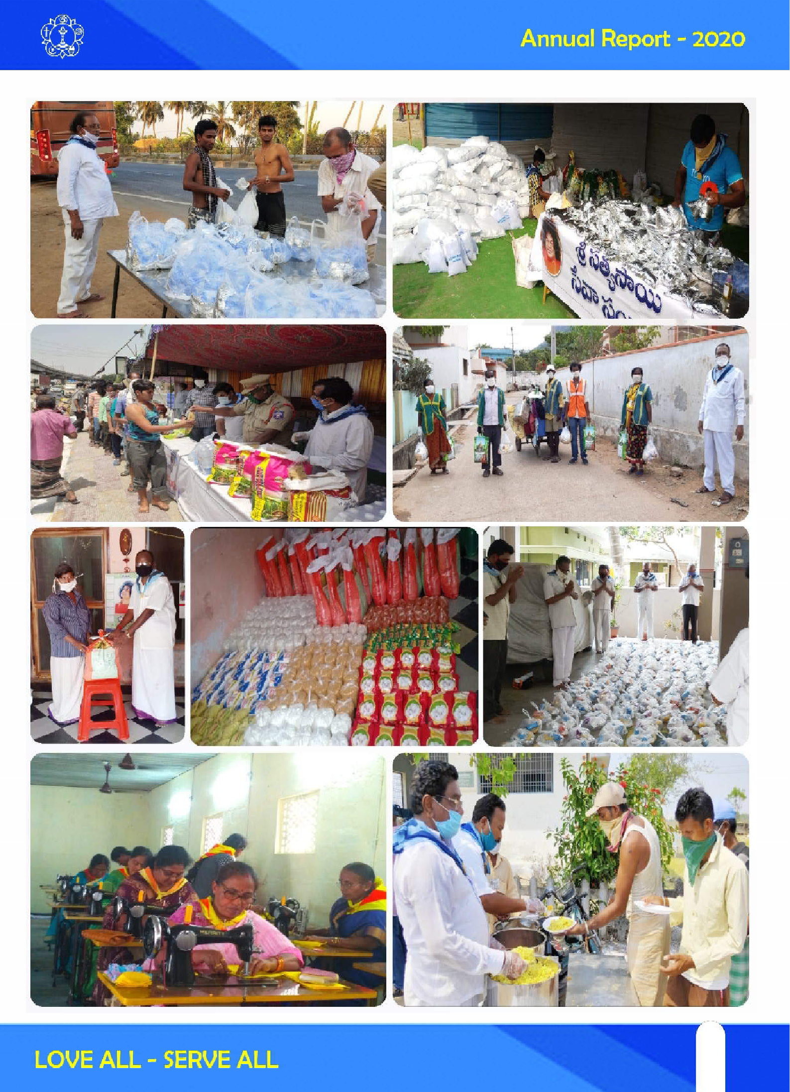

33
33

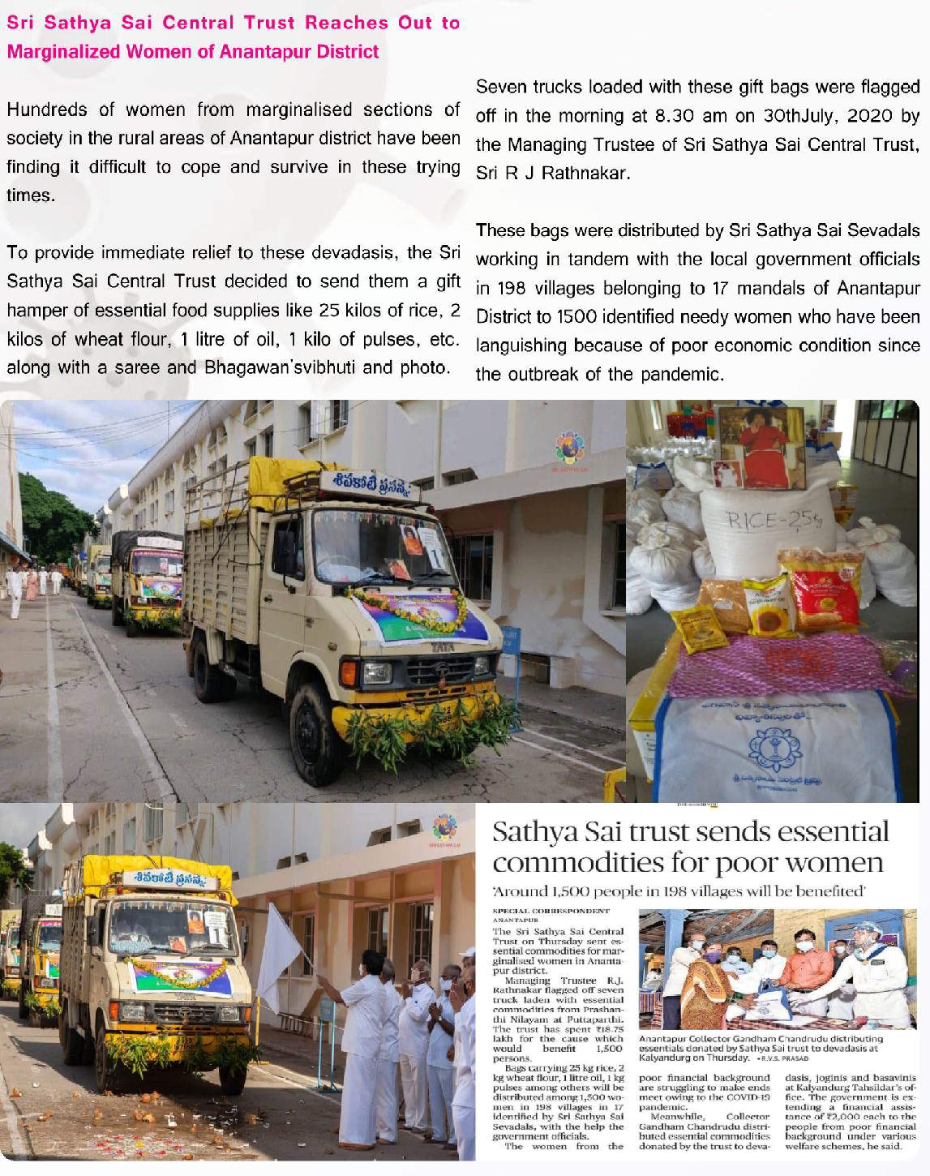

34

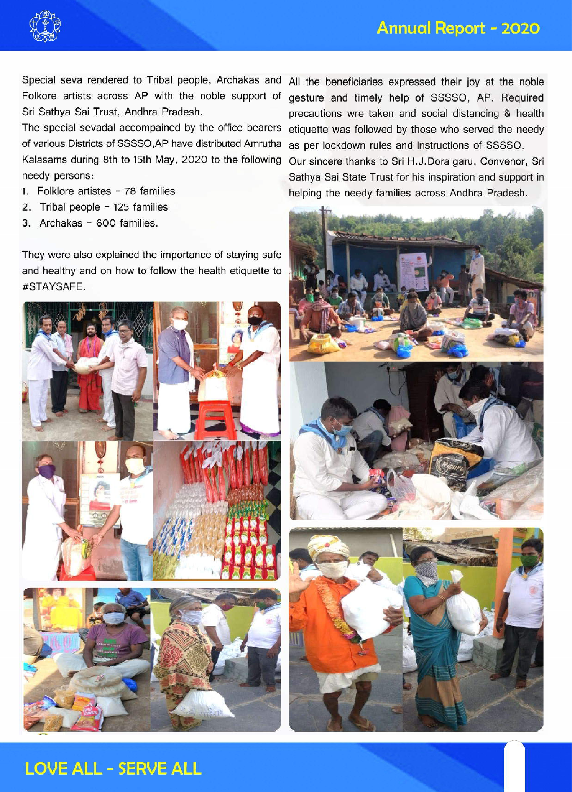

35
35

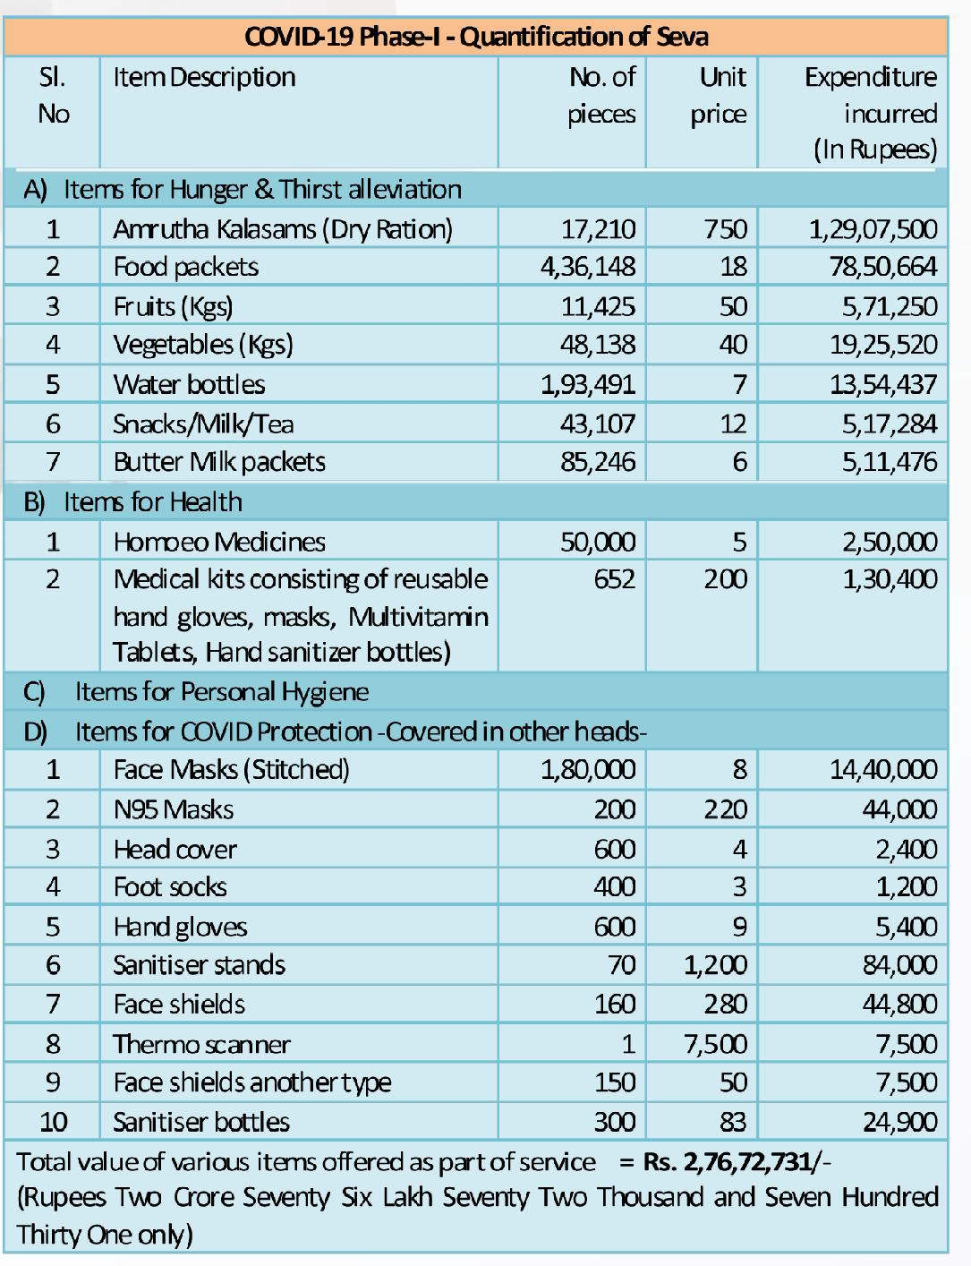

36

SERVICE WING - Prasanthi Nilayam Services
Sevadal of Andhra Pradesh perform seva at Prasanthi Nilayam every year in January, April and November. It has been a great opportunity for sevadal of AP to be involved on 3 major occasions in the year. All the works in connection with the Sports and Cultural Meet (11th January) like cleaning of the Stadium, Prasadam and drinking water distribution, decoration in Sai Kulwant Hall and Rathosavam are carried out by sevadal. Additional batches of Sevadal are deputed on the occasion of Ardhana Mahotsavam (24th April), Bhagawan’s Birthday(23rd November), Sivaratri(Feb-March) and Ugadi(March-April).

Further AP render service by deputing 6 sevadal to SRB of Super Specialty Hospital on continuous basis every week.

PRIOD | GENTS | MAILAS | TOTAL
31.12.2019 - 08.01.2020 | 780 | 700 | 1480
Special Batch  08.01.2020 - 12.01.2020 | 200 | 138 | 338
Special Batch - Covid-19
05.05.2020 - 07.07.2020 | 751 | 455 | 1206
02.08.2020 - 18.08.2020 | 165 | 090 | 255
15.11.2020 - 30.11.2020 | 223 | 160 | 383

Total
2119

1543
3662



Major Service Activities
- Nitya Narayana Seva
(RIMS, Cooked food, Carriages etc.,)
- Sri Sathya Sai Vidya Jyothi
- Sri Sathya Sai Village Integrated Program
- Mobile Hospital Services
- Medical Camps
- Swatchta Se Divya ta Tak
- Chalivendrams
- EAMCET Buttermilk
- Oldage Homes
- DJP Centers & Summer camp
- RO Plants

37
37

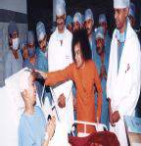SRI SATHYA SAI MEDICAL HEALTH SERVICES, ANDHRA PRADESH

“Doctors are like the fragrant flowers and Bhagawan is the invisible thread which binds them together in to a beautiful garlandF – BABA
Keeping in mind the above Divine Directions, Sri Sathya Seva Organisations have rendered their medical services in various branches including veterinary services.

Sri Sathya Sai Mobile Health Services in AP has taken up healthcare to the rural doorsteps by
  - Conducting medical camps with its team of doctors and paramedical staff with multi specialties which includes cardiology, Neurology, orthopedic, Gynecology, Dermatology, ENT, Ophthalmology, Dental etc., every month.
  - Creating basic awareness on Maintaining good health and the preventive measures to be taken to protect oneself from diseases by demonstrations and video shows on basic health and hygiene covering food habits, personal hygiene and cleanliness of self and surroundings. They are also educated on the ill effects of bad habits such as drinking, smoking and chewing tobacco.

During the camps diagnostic services were provided and also identified critical and chronic cases brought to the nearest city/ town for further investigations, procedures and surgeries. The patients were taken care till they are recovered fully and sent them back to their respective Villages. With the Divine Blessings of Bhagawan Sri Sri Sri Sathya Sai Baba varu, Sri Sathya Sai Mobile Health Services project has completed EIGHT years of service to the poor and needy people.

Water in rural Andhra Pradesh and Telangana is very high in fluoride (2 to 4 ppm against the permissible level of 1.5 ppm) which causes Fluorosis, a crippling and painful disease affecting teeth and bones. Villagers are taught a simple method of reducing fluoride content using Alum to make their drinking water safe.

Educating the rural people on the importance of Spirituality in holistic health:
The medical community is increasingly becoming aware of the link between spirituality and healing. Villagers are taught to spiritualize their lives which will not only keep them away from vices but will also bring harmony to their homes and community.

38

Au m Sri Sa i Ra m
Sri Sathy a Sai Sev a Organiza tions , India

Na me of t he Sta te: ANDH RA PR ADESH
RECO RD OF MEDICAL ACTIVITIES PERFORM ED BY AP S TATE SSSS Org. DURING THE PE RIOD
1-1 -2 01 0 to 3 1-1 2 -20 2 0
1 . T YPE OF ACT IVITY: MOBILE MEDICAL C AM PS

Ty pe of Act iv ity | Ty pe of Cam p – | No of Camps h eld | No. of Be nef ic | No. of  doc tors wh o | No . of  doctors who | Numbe r of Pa ram e dic | Numbe r of Sev a dals
 | (Gene ral / Dia betes / | du ring th e y e ar | iarie s | part ic ipate d with | pa rticipa ted with | als who part ic ipat e | who  partic ipated
 | Eye , e tc ) |  |  | unde rgra duat e | postgradu ate qua li fic at io n | d
 |  |  |  | qualifica tion
Mobile Me dica l | GENERAL, EYE, | 5 2 | 7 36 3 | 5 3 | 55 | 7 2 | 57 2
Camps  con duct ed | OR THO , GYNIC,
by SSSS Org . | PEDIATRI C ETC .
Krishna Dist ric t
 | DEN TAL | 2 | 76 | 2 | 2 | 5 | 2 1
 | EYE | 2 8 | 2 80 2 | 3 2 | 35 | 3 8 | 12 1
 | Cardia c | 1 | 27 7 | 4 | 5 | 6 | 3 2
Tota l |  | 8 3 | 105 18 | 9 1 | 97 | 12 1 | 74 6

RE C O RD O F ME DICAL AC TIV IT IES PE RFO RM ED BY AP S T AT E S SS S O rg . DURING T HE P E RIOD
1- 1-2 0 10 to 31 -1 2- 20 20
T YP E O F ACT IV IT Y : F RE E CL INICS
N u m ber o f Se va da ls
F ree C lin ic s ru n | No . o f | No . of | N o. o f | No . o f do ct o rs | Nu mb er o f
b y S S SS O | clin ics | Be n e ficia | d oc to rs w h o | wh o | P aram e d ic

(e g . , S ai K ripa
c linics )

- .S ri S a th y a Sa i Clin ics
AL L O P AT HY
he ld in
t h e ye a r
rie s
p a rticip a te d
w it h
un d e rg rad u a
p a r ticip a te d w ith p o s tg ra d u at e
qu a l if ica tion
te
q ua l if ic at io n
18 5 | 17 82 3 | 3 61 | 3 16 | 45 3 | 1 56 2
50 | 6 25 | 76 | 5 2 | 16 6 | 21 7
26 | 3 73 | 24 | - | - | 26
26 1 | 18 82 1 | 4 61 | 3 68 | 61 9 | 1 80 5

als w h o
p a rt icip at e d
w h o
p a rticipa ted


- . S ri S at h ya Sa i Clin ics –
HO ME O P AT HY
- . S ri S at h ya Sa i Clin ics
V IB RO NIC S

To ta l

39
39

TYPE OF ACTIVITY: SINGLE DOC TOR CLINICS

Name of doctors | Under  -  gradu ate | Post- graduat e | Nature of services provided Eg.,  Consultati on,  Surgery, Scan and  others | No. of such  services provided | Date (dd/mm/yy) | No. of Beneficia  ries
DR G V S RAO |  |  |  |  | Monthly once - 4 Weekly Once - 16 Daily once - 60 Weekly once - 24  Fortnight ly once - 16  Monthly once - 6 Bimonthly - 4
DR VANI
DR Y RAJARAM
DR Y SESHU KUMAR
DR K KANAKA DURGA
DR V SOMESWARA RAO
DR P KONDA RAJU  DR HANUMANTHA RAO CHOWDARY  DR NAGESWARA RAO | 168 | 126 | Consultati ons and medicines | 204 |  | 3780
DR B NARASIMHA RAO
DR N JANARDHANA RAO
DR K SUKUMAR
DR K HARITHA
DR K NIRANJAN BABU
DR G ANNA POORNA
DR R DURGA DAS
DR BALA KRISHNA
DR Y V RAO

VETERINARY CAMPS

Veterinary Camps | Name of doctor (s ) | Under- graduate | Post- graduate | Nature of services provided  Eg., Consultation, Immunisation Deworming and  others | No. of Beneficiaries (Animals)
5 | Dr. Rayapu Reddy  Dr Sudhakar  Dr Punniaha | 10 | 6 | Consultation, Immunization Deworming and others | 2566

40

IN STITUT IONAL/HO SPIT AL S/NU RSING HOMES

N ame of clinic

SRI
Venkate swara Nursing Ho me Visah ka Eye Ho spitals
Gayatri vidya parish ad
Ho spitals
GITAM Ho sp itals Dr. DURG A DAS
clinic
Paramahamsa yoganand a Eye ho spitals
Alluri Seetha rama raju
Acadam y o f
M edical Sciences Ush a Cardiac Cen tre
Nature of services p rovided
Eg., Consultation,
Surgery, Scan and others

CONSULT AT ION GENER AL
SURGE RY
EYE SU RGERY
ECG,ECH O,DENTA L E XTR ACTIO NS & ROO T CANAL E tc.,
N o. of su ch
services
pro vided

301
No . of
B eneficiaries

301
No. of doctors w ho part icipated
w ith
u ndergraduate qualif ication (Cumulative

16
N o. of doctors who participated
with
po stgraduate q ualification ( Cumulative

34

A c tivitie s C o n d u cte d (V i rtu ally) d u r in g
C o v id 19
p a n d em ic

T E L E
M E D IC IN E S ER VIC E S
CO VI D PO S IT IV E CA S E S:
T h es e p a tien ts t es ted C O V ID -1 9 P o sit iv e. A s ad v i se d b y d o c to r s t h ey ar e t r ea ted t h r o u g h
te le p h o n ic c o n v er s atio n a n d m o n i to r in g b y o u r Se va d al. A l l a r e s u cc es sf u l ly rec o ve r ed .

G e n era l C a s es
T h r o u g h te lep h o n ic co n s u l ta tio n an d a d vis e b y o u r d o ct o r s an d m o n i t o r in g o f o u r s ev a d al

T r ib al p eo p le w e r e b r o u g h t to viza g an d su rg er ies
g o t d o n e fo r co lo r b o n e f r ac tu re, th ig h b o n e fra ctu re an d a s e ve re w o u n d .



41
41

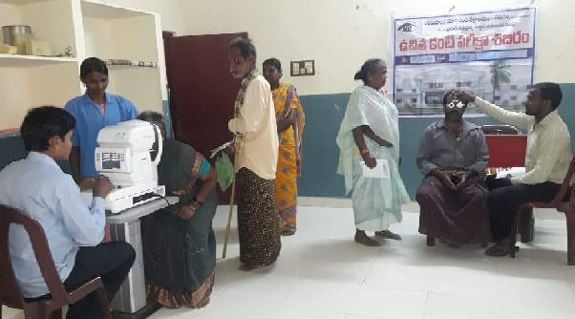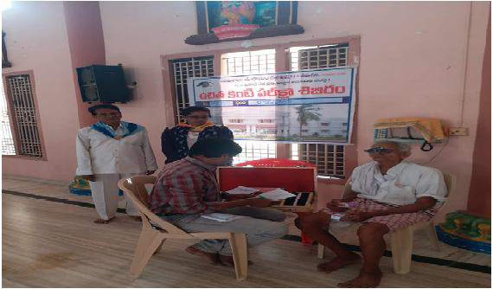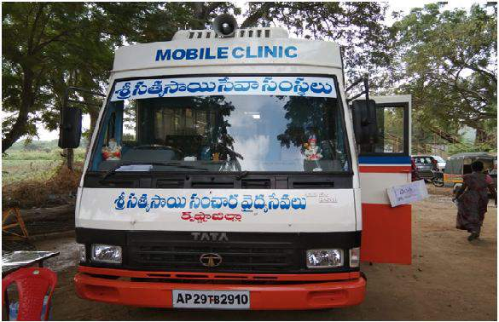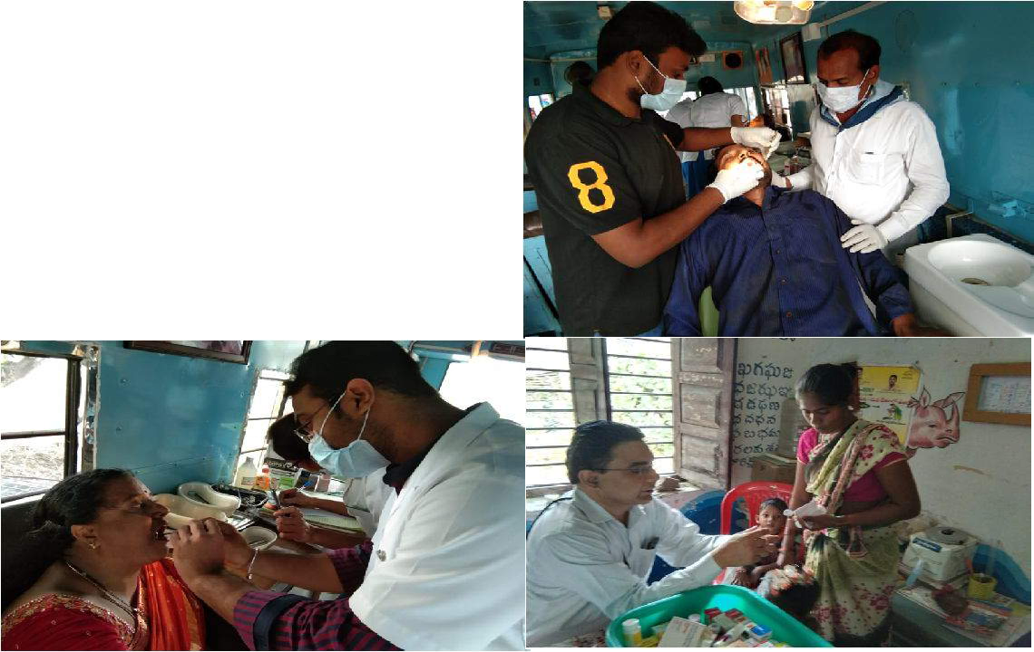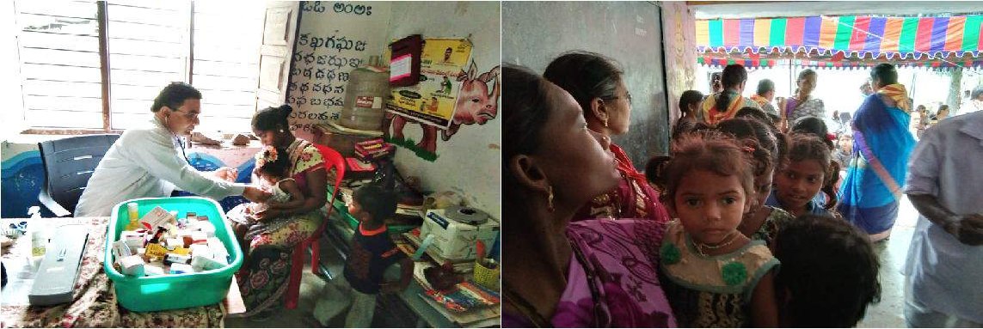

42

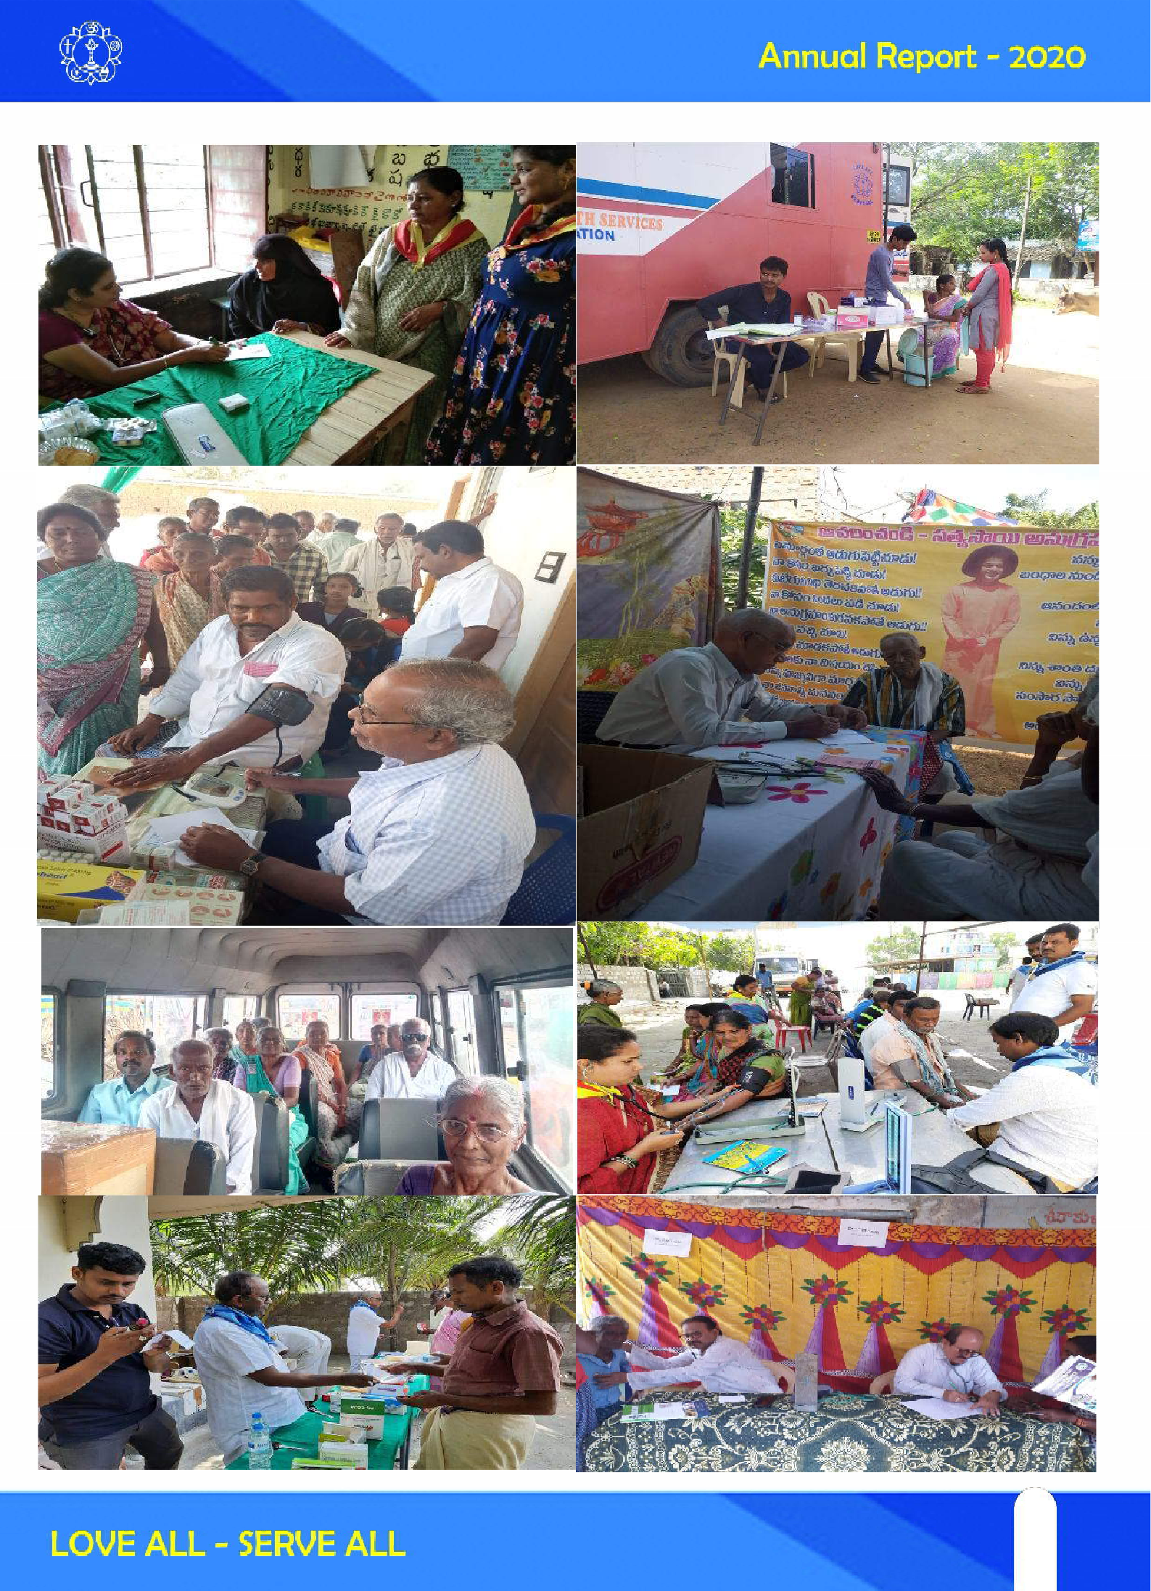

43
43

Mahila Youth Participation in AP, SSSSO India
The future of the country depends on the skill and the sincerity of the youth. Therefore, the necessary enthusiasm and encouragement must be generated among the youth. All my hopes are based on the students, the youth.
They are very dear to me. - Sri Sathya Sai Baba, World Youth Conference, 1997

Mahila Youth Wing of Andhra Pradesh has taken an wonderful initiative to relish Bhagawan's miracles and teachings. So far SAI SAKHA successfully completed 53 sessions and still counting on. Every Sunday Hundred’s of participants were attending the program.

Spoken English Classes for Mahila Leaders of all Districts
Spoken english classes were conducted by the Mahila Youth Wing of Andhra Pradesh to all the mahila leaders. Around 100 members were enrolled in this program.

Online orientation by Ms. Madhu Kapani, Department of Education, SSSIHL
- Every week district youth incharges are invited to address the active youth of the organization
- State meeting with the president - Mr. Chalam Garu
- State meeting with the Mrs. Kiran Garu

Online Spoken English Classes for Balvikas Students More than 1000 balvikas students were participated in this online spoken english classes.Classes are scheduled weekly as per the teacher's convenience. All districts balvikas students enrolled in this initiative except paderu and nellore.

Spoken English Classes for Gurus
This initiative is mainly for balvikas gurus from vijayanagaram and visakhapatnam districts. Around 80- 100 members enrolled for this program

Training Teachers to Teach English
This initiative is mainly for gurus who are teaching online spoken english classes for mahilas and balvikas students.

This program is mainly to enhance further knowledge and to learn the teaching skills.

Singing Competition for Youth Started on 25th August 2020

We have received 160 names across the state and 14
members were selected for the final round. Awaiting for results.

one day Online Training session about youtube live

Alumni of SSSIHL participated actively in online spoken english classes. Young and adult members participated actively

Al the youth did ground work by collecting names and preparing lists and sending invitations

Youth actively participated in all activities irrespective of their districts under the guidance of mahila incharge.

NATIONAL LEADERSHIP PROGRAM (NLP)
Through this program, the Sai Organisation wishes to spread Bhagawan Sri Sathya Sai Baba's message, and create an awareness amongst the emerging youth lead- ers about their responsibilities to their own-self and the Nation.

Sri Sathya Sai National leadership programme for self transformation is a national level, web based, online program. Microsoft teams is the platform used for this purpose. The program is conducted on Saturdays and Sundays, six months to complete.

Approximately 178 participants were selected, divided into Mahila -team 1, gents -team 2&3.

SAI SADHANA
Initiated By Mahila Youth Wing of Andhra Pradesh (From June 20 )

On Every Sunday from Initially it was from 2-3pm. Now it was Conducted from 4-5 pm Mahila And Youth in each district have actively Participated in the Quiz Competition.
Quiz Was Conducted On “Tapovanam” Chapters which make them read swami sahityam. And Around 80-100 participants were attending the program.

44

Bhagavatha Vahini parayanam
With divine grace and blessings of Bhagawan we will start Bhagavatha Vahini parayanam from 1 feb 2021.

This Vahini is Baba's retelling of The Srimad Bhagavatam, a Hindu scripture about the divine incarnations of Vishnu, concentrating on the Avatar of Krishna through the story of King Parikshith, grandson of the Pandavas - the heroes of the great epic The Mahabharata.

Only one chapter parayanam on every alternate monday.

Expecting all the members to participate in this Divine Book Sadhana.

And no of pages are also less. We can comfortably com- plete this parayanam.

Youth from many Districts have actively taken part in this.

NAMASMARANA
With divine grace and blessings of Bhagawan we will start
* 21 times Aum Sri Sai Ram chanting and one bhajan daily* from 4 Feb 2021

Expecting all the members to participate in this Sadhana. Interested members can Ping to the concerned mahila youth coordinators.

As it takes very less time We can comfortably continue this sadhana.

YOUTH PARTICIPATION IN SPIRITUAL WING
For well being of mankind, several spiritual programs as given below, have been organized by following suggestions & directions of State Spiritual wing in which Youth have taken Active Part :

Thanks to the technology availability, which helped organizing all spiritual programs virtually (google meet). Devotees irrespective of their location able to attend various programs staying in their home.

Online Youth bhajans - From 7-7:45 Pm On every Sunday
Satsangs - 20 mins - 1 hr
Study Circles
Parayana ( Eswaramba, Tapovanam, Shirdi Sai Satcharitra, Guru Charitra, Satya Sai chalisa).

Sai Gayatri chanting / Tandularchana etc.
All these programs are aimed at (1) collective prayers to Swamy for coming to rescue of suffering people and to save mankind by eradicating Covid completely.

SAI SIKSHANA SADA RAKSHANA
Mahila & Youth Wing of Andhra Pradesh has taken a wonderful initiative to relish Bhagawan's teachings. So far SAI SIKSHANA SADA RAKSHANA successfully com- pleted 39 sessions and still counting on. Every Thursday many participants were attending the program.

PRASANTHI NILAYAM SEVA
Youth are taking part in Prasanthi Nilayam Services Even During the Pandemic times.

Youth are helping in the media activities organized by all the three wings.

YOUTH PARTICIPATION IN SEVA WING
Mahila Day Programme
Every Month On mahila Day Youth have Actively Partici- pated in Seva Activities and also in Spiritual Program Conducted on the Occasion of Mahila Day. They have Participated & given their Support in “IT” related Works Under the Guidance and support by Mahila, Balvikas & Spiritual Wings.

YOUTH PARTICIPATION IN BALVIKAS WING
Some of the Youth are taking Balvikas Online Classes.

EASWARAMMA DAY - 2021
Youth have taken a active Part in Easwaramma Day Cel- ebrations. They Conducted various Competitions such as elocution,bhajan singing, letter to mother, vedam etc. for 5-10 th class Balvikas Students on online.

SUMMER SHOWERS - 2021
Education Wing of SSSSO,AP Has Conducted Summer Showers an Unique Program Designed with Speeches on Different Topics From Eminent Personalities for Balvikas Gurus,Children, & Parents.

45
45

On the 1st Day on the Eve of Hanumath Jayanthi Cultural Programs have been Streamed, In which Youth Members - Balvikas Youth Alumni taken part in Hanumath Jayanthi Celebrations.

COVID SPECIAL SERVICES
Telemedicine Services : Sai Sanjeevani TeleMedicine Services have been started on 13.5.2021. Totally 25 calls received and all were arranged Doctor consultation. All the patients have recovered and discharged.

Food Preparation & Distribution : Community Kitchens started functioning prepared food by following hygienic methods and with devotion. Food packets prepared, kept at Swamy’s feet and then distributed to needy people. Attractive posters have been prepared and made available to the notice of to the notice of Covid sufferers. Mobile Nos. were prominently given in the poster so that that it will facilitate affected people or their rep- resentatives to seek food on medical support.

Amrutha Kalasam Distribution : Covid pandemic made many people like private school/college teaching staff, small temple priests, street vendors etc jobless. Continu-
ously months-together they have no earnings. Several Samitis identified such people and arranged Amrutha kalasams to meet their 20 to 30 days requirement.

Heartfelt gratitude to each and everyone Who Partici- pated in all the seva activities and made them successful.

We offer humble pranams to our divine god who gave us this wonderful opportunity to serve the humanity.

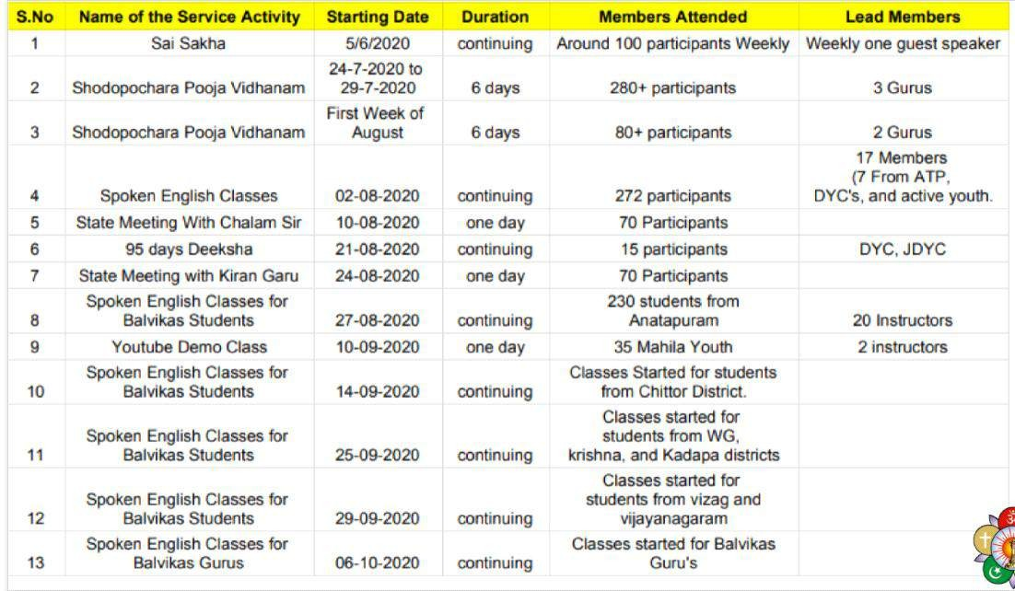

46

Mahila Participation in SSSSO, AP
A Woman Looks with Her Heart, Feels with Her Eyes and Woman's Love is in Action!! - Baba

With the immense Grace and Love of our Beloved Sai Maatha, Offering a brief Report On Seva Sadhana from Jan to Dec 2020 by Mahila Vibhag of AP(Avathara Pradesh) at His divine lotus feet.

Mother and Child care Seva Sadhana on 9th of Every Month

Mother and Child care seva mainly focuses on poor mothers who lack health awareness and nutritious food. It’s being done at Primary Health Care Centres and Government hospitals on 9th of every month by most of the Districts - Distribution of Food packets/Saiprotein/Fruits/ Sarees/ Baby kits to pregnant women, patients, young mothers, new born babies, attendees and creating awareness on Covid precautions, health & hygiene. 10 Districts are participating in this initiative and around 7800 members were benefited from this activity.

- Mahila Day Celebrations on 19th of Every Month

Mahila Day is celebrated on 19th of every month by mahila devotees of Sri Sathya Sai Seva Organiations of AP. Various service activities includes distribution of Upadhi items, Amrutha Kalasams/Sarees/Blankets/Umbrellas, Mandir/Samithi cleaning ,Felicitation to elders who excelled in their field etc. And also visit & conduct Bhajans at Orphanage/leprosy/Old age homes along with the distribution of Swamis prasadam.

As part of Bhagawans birthday celebrations in the month of November 2020 Mahila day was celebrated on 19th by distributing 1008 kits at the abode of our divine Lord, Puttaparthi and 9500 kits in all districts of Avathara Pradesh with love and gratitude to COVID19 FRONTLINE WAR RIORS – Doctors,Nurses,Paramedical staff, Sanitation workers, police,,railways workers etc. Each kit contains Sari/Bedsheet/Gents dress, Nose Masks, Sanitizer, Sweet, Swami's Photo, Vibhuthi.

Started celebrating Mahila Day through virtual media from December 2020 onwards. Programme starts at 5am with Omkaram, Suprabhatham, Jyothi dhyanam followed by Chanting & Seva activities during the day and evening session on Sri Sathya Sai Vahinis. Mahilas of all wings and youth collectively plan conduct and participate in this blissful programme.

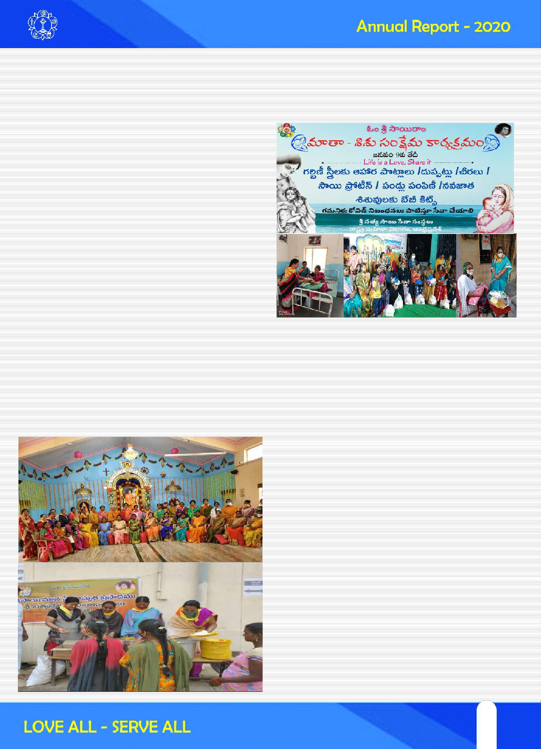

47
47

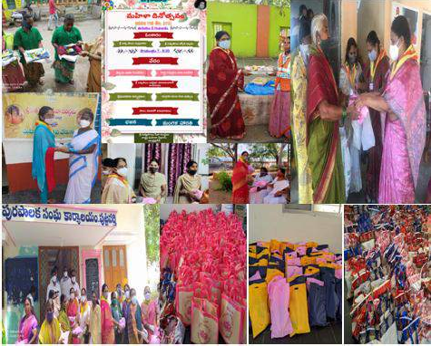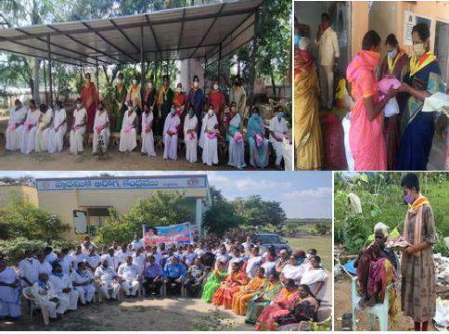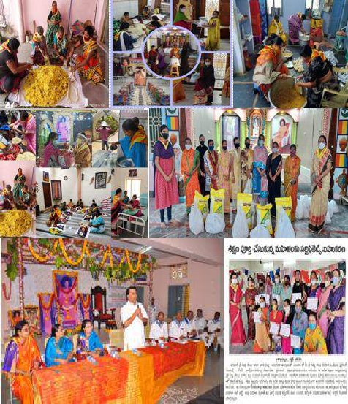

48

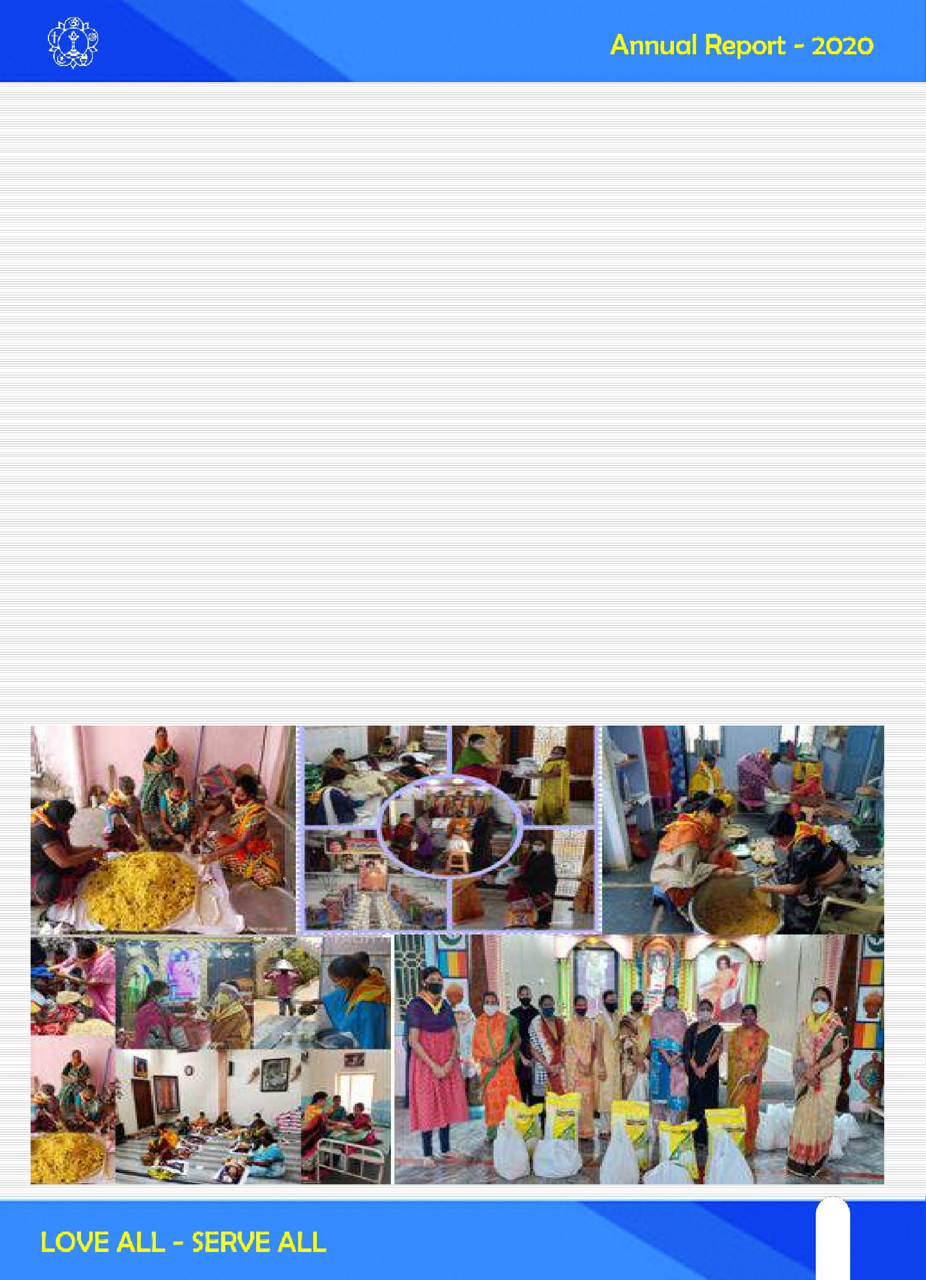
- Women Empowerment
Swami says that women who are empowered have the power to bring positive change in the society. Conducted 40 days training for vocational skills on Tailoring and Jardosi work for 121 ladies. Distributed 18 Upadhi items (Sewing machines, Wet Grinder, Maggam ) to the needy Mahilas. Free tuitions on various subjects, spoken English classes etc are part of regular seva. And also installed one sanitary pad wending machine in one of the colleges and distributed 3 cycles to the girl students. Sanitier/Phynol Preparation classes were conducted online & Offline.
- COVID 19 Special Seva
Love for Swami removes the fear of even a deadly pandemic like Corona. Nothing could stop the Sevadal from serving their Bhagawan in difficult times like this, have served Swami in all the different ways they could. Sevadal rendered seva virtually/physically together as one family i.e. Sai family and everyone's thoughts were filled with Swami.

Mahilas took active part in preparation & packing of food packets in the community kitchens. Helped in distributing Amrutha Kalasams, Sai Protein, Food Hampers, Milk/ Butter Milk/Juice, Bread/Fruits, Food Packets to the needy Narayanas at their homes, hospitals, HIV Centres, Orphanage Centres, Leprosy homes, Pujaris, Private school teachers and many other contract workers, Migrant workers who are in need.

Took active part in distribution of Sarees/Bedsheets/Writing Pads to Sanitary workers, masonry workers/ centring workers, Push cart vendors, Narayanas sleeping on road side, Old age homes, Orphanage homes etc And also distributed kits to the 125 teachers who lost their livelihood due to the pandemic. Each kit contains 1000 rupees worth of grocery, vibhuthi, and Swami's Photo.

Created awareness on Covid appropriate behaviours, necessity of Covid vaccine through Google meetings, Phone calls, Hoardings, Auto stickers, Leaflets and in all online spiritual & training programs. And provided support in Tele medicine/Help line/Call centres, distributed Covid seva support home kits, essential medical kits, Homeo medicines. Provided counselling support to Covid patients, families of Covid patients, SSSSO Members and Sevadal.

49
49

- Mass Chanting (Namasmarana)
Individual and collective prayers such as 95 days Deekshalu, Tapovanam Parayanam, Chanting of Sai Gayathri, Samasthalokha Sukhinobhavanthu, Varalakshmi Vrathalu, and Satsangs were conducted for self-transformation and well being of the world. Around 1500 members participated in each activity including Mahila Incharges and active sevadals.

Mass chantings like Maha Mrityunjaya Mantra, Samastha Loka Sukhino Bhavantu, Rama Raksha Mantram, Sai Gayathri were chanted at 9am from 9th to 19th of every month , for 3 months – Praying Swami to remove the suffering of humanity forever and bring peace and bliss upon the whole mankind. All coord at State, Dist, Samithi level participated in Aaradhonathavam- Sadhana by chanting of Sai Gayathri daily from 9 to 9:15pm.

- Prashanthi Nilayam Seva
Sevadals from all 14 districts including a remote area like Paderu have come to serve Swami in Prashanthi Nilayam Seva Sadhana.

1522 Mahilas participated for 121 days in 2020 (Jan, Mar, Apr, May, Jun, Aug, Nov)

Created Awareness on Seva Sadhana, COVID19 Guidelines, and SMS (Sanitation, Mask & Social Distance)

Sevadals actively participated in regular service at various seva sadhana points and sastang, special services like flower seva and rangoli seva for Rathosthavam. Healthy food, comfortable accommodation, and medical care were provided by Ashram for every sevadal.

During CoVID-19, Sevadal extra time was utilized by involving them in Bhajan Singing Training, Awareness on Balavikas, Disaster Management Camp, Craft making, Yoga classes, Interpersonal skills training etc.

- Nose Masks Preparation and Distribution
More than one lakh nose masks were prepared in the critical time during first lockdown phase in Mar and Apr 2020 with lots of love, faith in Swami and with great dedication. It was really challenging seva for Mahila Vibhag and another one lac masks were prepared till Dec 2020. Total 200000 nose masks were prepared & distributed in the year 2020.

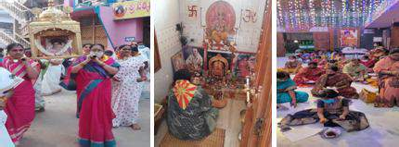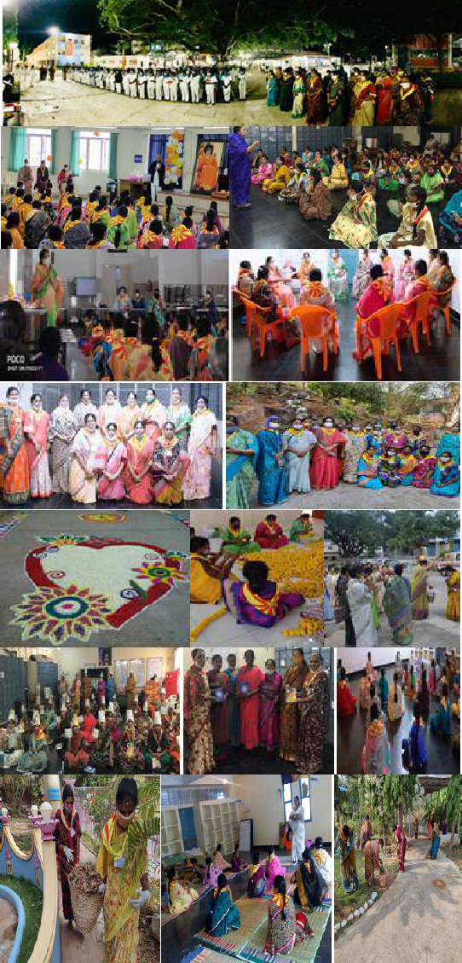

50

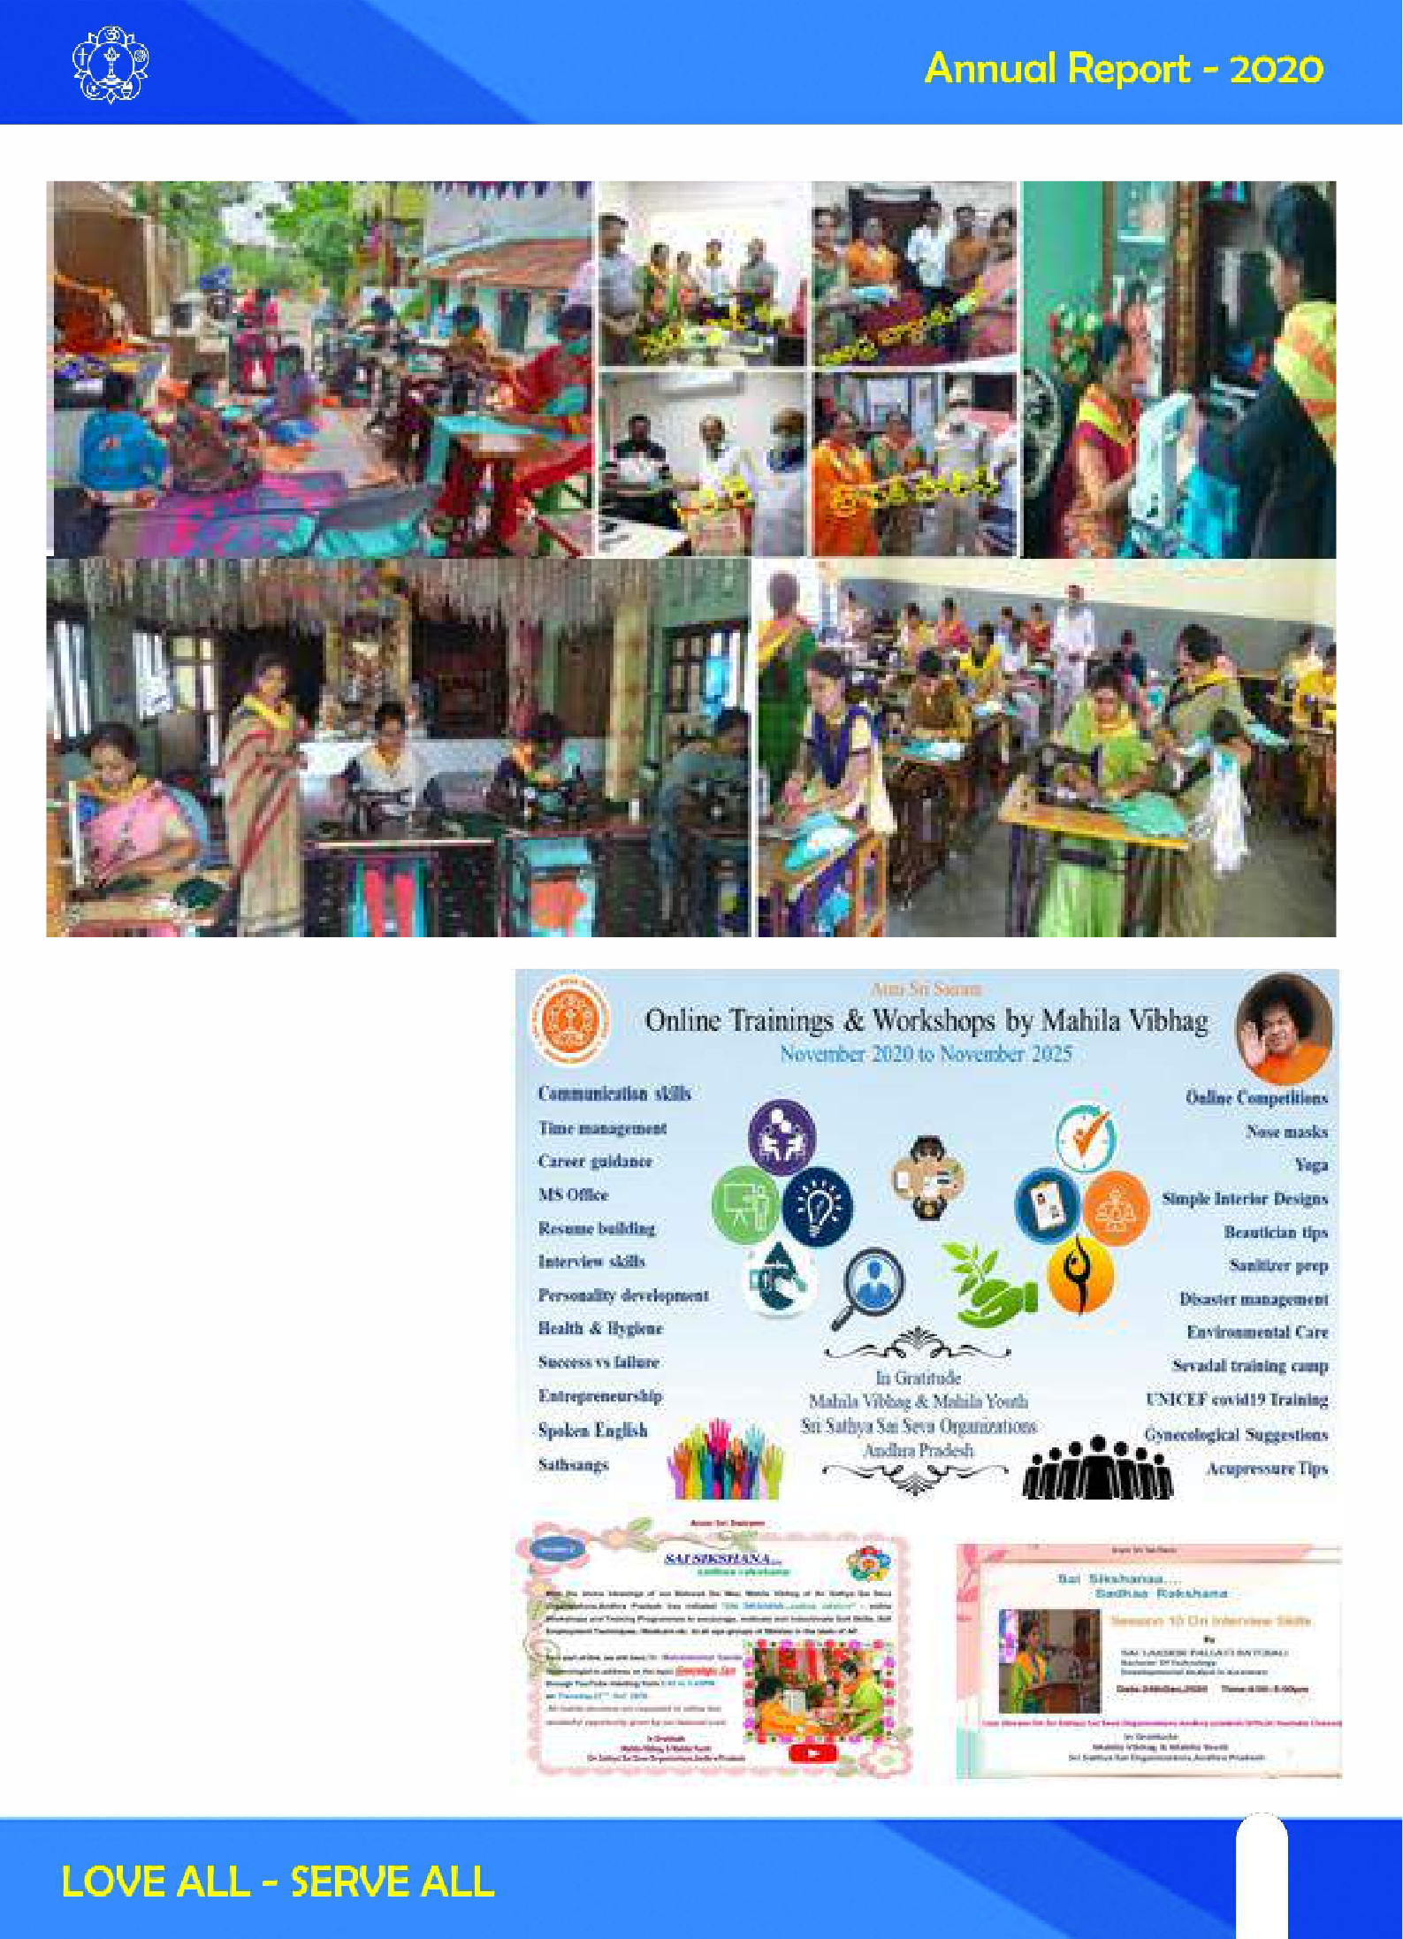

- Sai Sikshana...Sadhaa Rakshana...

With the divine blessings of our Beloved Sai Matha, Mahila Vibhag of Sri Sathya Sai Seva Organizations, Andhra Pradesh has initiated “SAI SIKSHANA...SADHAA RAKSHNA”...

A series of online Workshops and Training Programmes to encourage, motivate, and indoctrinate Soft Skills, Self Employment Techniques, Medicare, etc., to all the age groups of Mahilas in the state of Andhra Pradesh. 11 sessions were done on various topics from 19th Oct 2020 till Dec 2020.

The main objective of this programme is to expand ones learning, knowledge, skills and effective utilization of one’s available time due to this pandemic.

There is overwhelming response - more than 1000 views per session.

51
51

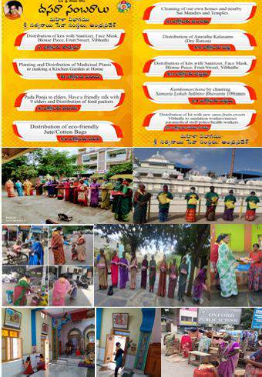
Sai Sikshana ….Sadhaa Rakshana
An Initiative By Mahila Vibhag Through Official YouTube Channel of
Sri Sathya Sai Seva Organisations Andhra Pradesh
Session# | Topic | Speaker | Youtube Link
1 | Gynecological Care -1 | Smt Dr.Mahalakshmi Sanda | https://youtu.be/HabJ0LWo 6dQ
2 | Gyneocological Care - 2 | Smt Dr.Mahalakshmi Sanda | https://youtu.be/F9 uIi_M-1vc
3 | Kitchen Gardening | Smt V. Gowri Kavitha Smt S.Mano Ranjini | https://youtu.be/BNmCcF14GCI
4 | Time management | Ms K.Sai Susmitha | https://youtu.be/93n8ogkzrHI
5 | Sanitizer Preparation | Smt Harini | https://youtu.be/ObGcbfoe-Tk
6 | Disaster Management | Smt Sai Kumari Gopinath | https://youtu.be/ZUomR8W0haw
7 | Resume Preparation | Ms Sindhu .C | https://youtu.be/TFzi6orj IVE
8 | Interior Designing | Smt Sai Sujath Devi | https://youtu.be/Zazf_D-lZp 4
9 | Sure Success | Smt Dr. Bennuru Lavanya | https://youtu.be/Iu Asr4TrxRc
10 | Interview Skills | Ms Batchali Sai Pallavi | https://youtu.be/BNtc0HaFV3o
11 | Microsoft Office-1 | Smt Akula Pallavi | https://youtu.be/6V7udW_edZI

- Dasara Sambaralu
“Dasara is the festival that celebrates the victory of the forces of good over the foes
that resist the progress of man towards the light”. -Baba With the blessings of our dear Lord Sri Sathya Sai Baba, on the auspicious occasion of Holy Navaratri, Mahila vibhag planned a series of seva activities for nine days for bestowing Health, Peace, Harmony, and Blissfulness across the globe.
- 1300 kits (Each kit with Saree, Sanitizer, Mask, Vibuthi,
Swamis Photo) were distributed across the state

- 2000 Eco-friendly Jute/Cotton bags were distributed

- 900 Medicinal saplings were distributed and planted in Homes/Samithis/Hospital premises.

- 1530 Amrutha Kalasams were distributed in the state

Mahilas were actively participated and cleaned 54 mandirs during Dasara period.

*Each one call Ten* program was planned to share love with elders by calling them over phone and spending valuable time with them and also helping the needy ones.

52

- Sankranti Sambaralu
Celebrated new year Sankranti sambaralu by conducting Rangoli competitions and Slokas/Songs/ Poems sung by bhagawan, around 1300 mahilas participated. Mathru puja by the c hildren and Medicinal/Flower plantation drive was done.

- Other Unique Seva Activities
- Helping Hand
Marriage Seva is performed for one couple by providing all house hold things along with Mangalasuthram and provisions for one month.

Adopted one pregnant lady, provided support for her delivery in Aug giving Amrutha kalasam monyhly till the date.

Financial support (Rs 3,05,000) - To to the covid patients for their check up/tests/medicines/surgery, tuition fee for students, prasadam & decoration for festivals in Prashanthi Nilayam, Narayana seva etc.

- Seva to Cyclone Victims
Service to cyclone victims were taken up by couple of districts with love and dedication.

- Swami's Photo Caption Contest
950 members participated in Swami's Photo Caption Contest for 6 Photos. The contest will take place every Thursday from10:00 am to 4:00 pm and winners will be announced on Sunday.

- Sanathana Sarathi Subscriptions
Made 550 new Sanathana Sarathi subscriptions.
- Participation in other wings seva
Participated in Sadhana camps, Parayanas, study circles conducted by Spiritual wing of SSSSO.
Participated in Eswaramma day celebrations, Tandularchana, Summer Showers programmes conducted by Education wing of SSSSO.
- Reports are shared through Website:www.ssssoap.org Mobile App: ssssoapofficial
Official YouTube Channel: SSSSOAP Facebook:https://m.facebook.com/SSSSOAP/ Twitter:https://twitter.com/SSSSOAP1/ Instagram:https://www.instagram.com/ssssoaporg/

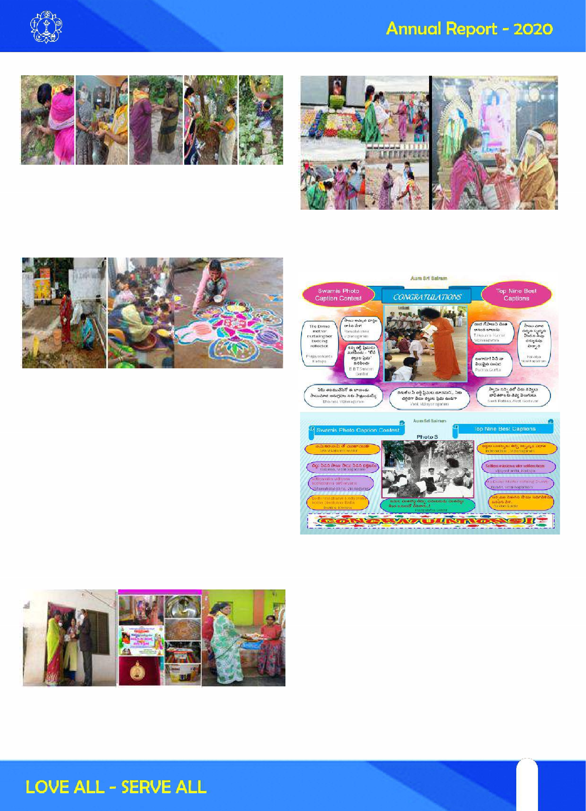

53
53

Mahila Seva Vibhag Report :: Jan - Dec 2020
S.No | Activity |  | Number | Number of Beneficiaries |  | Num ber o f  M ahila Sevadal invo lved
1 | Stitching/D istr ibution of Nose Masks |  | 200000 | 2 00000 |  | 600
2 | P reparat ion/Distribution of Sanitizers |  | 703 | 703 |  | 31
3 | C oun sell ing Supp ort to Co vid P atients |  | 434 | 322 |  | 78
4 | C oun sell ing Supp ort to Fam ili es o f Covid Patient s |  | 151 | 597 |  | 104
5 | M o ther & Child Care(Food Packets/bread, fruits, Ju ice) to pregnant wo men & B aby Kits D istr ibution |  | 7800 | 7800 |  | 130
6 | D istri but ion of W rit in g Pads t o the need y |  | 99 | 99 |  | 4
7 | Visit to Orp hanage Ho mes/Old age Hom e and distribut ion of t he n eedy items, Bedsh eet s etc |  | 12 | 600 |  | 48
8 | St ickering (Sam is M essage alo ng with Sami s Photo) o n  Aut ur ikashaws |  | 2 | 108 |  | 10
9 | M andir/Samit hi Cleaning |  | 13 | 13 |  | 65
10 | 19th Mah ila Day Nov 2020  K its to Co vid Fron t Li ne W arriors(Eac h k it - Sari/Bed sh eet/Gents d ress, Nose M asks, Sanitizer, Sweet, Swam i's Ph oto , Vib huthi |  | 10508 | 10508 |  | 250
11 | Sai Protien Food Dist ribution |  | 1020 | 1020 |  | 64
12 | H omeo Medic ine Distr ibu tion |  | 540 | 540 |  | 2
13 | U pad hi It ems Sewing machi nes/Grinder |  | 18 | 18 |  | 35
14 | P ick les prep aratio n i n kgs & D istr ibution |  | 600 |  |  | 60
15 | Self-employment Training on Tai loring and Zardosi |  | 121
16 | N umber of Mahil as parti cipat ed in PN Seva  (Jan (8),M ar(10),Ap r(10)M ay(31), Jun (3 0),Aug(17),Nov(15)) |  | 1522 | 119 Days
17 | Sanathana Sarath i Subscription |  | 550
18 | S ai Sikshana Sad haa Rakhana online program me |  | 11  Session s | 1000 v iews/ session
19 | Sw am is Ph oto C aption Co ntest |  | 6 Sessio ns | 950 P artic ipant s
20 | D asara Sambaralu  Seri es of seva activ ities conduct ed for n ine d ays for besto wing H eal th, Peace, Harmon y, and Blissfu lness across th e glo be.  Distr ibuted 1300 kits (Each kit with Saree,, San itizer ,M ask, Vi but hi,Swam is Ph oto ),  2000 Eco-f riend ly Jute/C ott on bags, 1530 Amrut ha Kalasams and 900 M ed icin al saplin gs were distribut ed and plant ed i n Ho mes/Samithi s/Hospit al premises.C leaned 54 mandirs du rin g Dasara peri od.
21 | Sankranti Sambaralu  C elebrated n ew year Sankranti sambaralu by conductin g Rangoli compet itions and Slokas/Songs/P oem s sung by  b hagawan, aro und 1300 mahilas parti cipat ed . Mathru p uja b y t he ch ild ren and M ed icin al/Flo wer plant at ion dri ve was d one.
22 | F in anci al Sup port | Am ou nt in R s
 | To Patien ts | 20000
 | To Student s/N eedy Mahilas | 10000
 | C ondu cted 1 marriages in Sai mand ir provid ing all hou se hold t hin gs | 50000
 | Installed Sanitary pads wendi ng machin e at o ne co llege & 3 C ycl es were distribu ted | 25000
 | P rasadam an d Deco ration c ont rib utio n fo r the festivals in  P rashanthi N ilayam | 200000

54

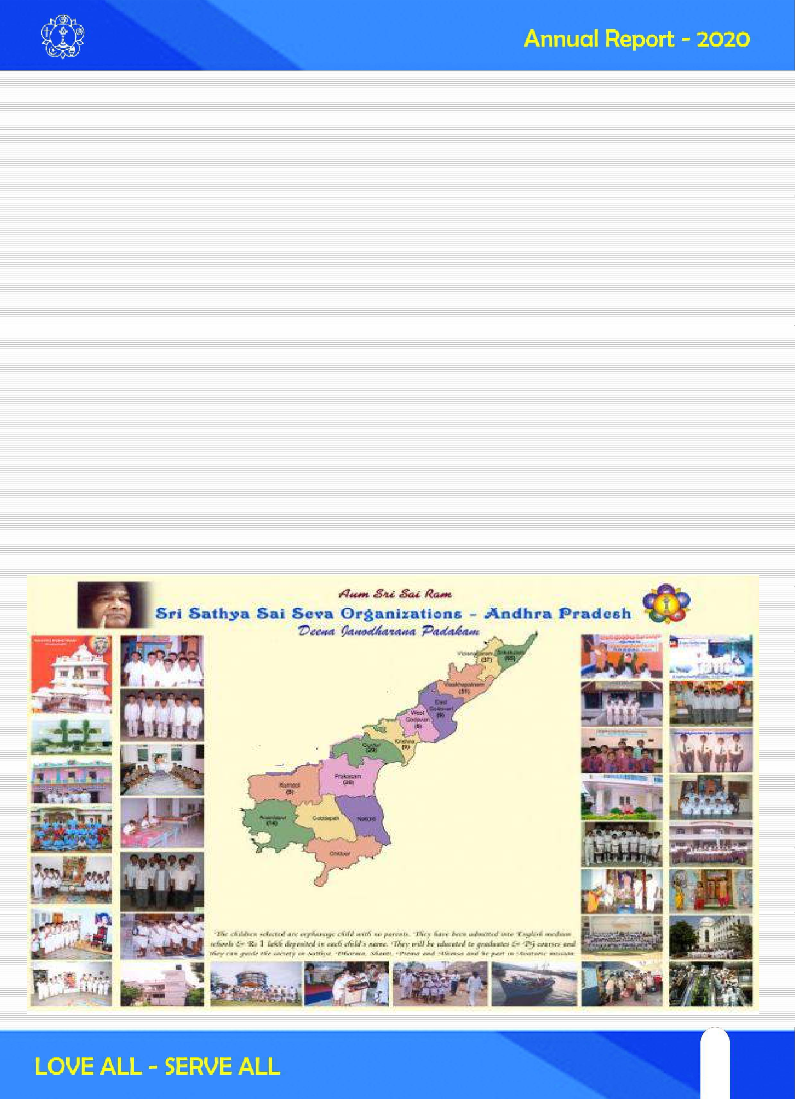

“Swatchata Se Divyatha Tak” Programme (SSDT)
This programme was taken up by all District Organisations during the period 2nd October (Gandhi Jayanthi) to 20th October (Avatar Declaration day). A number of activities aimed at cleansing the premises, mind and spirit have been planned and communicated to various samithis. In many places, devotees and the public also have taken part after getting attracted by the selfless efforts involved in making the programme successful. Prominent personalities were also present on the occasion. Balvikas gurus, Balvikas students & their parents, Sathya Sai Schools, Youth, Disaster Management team and all office bearers have invariably attended this activity on holidays. Total No of Man hours : 42053 Hrs.

DEENAJANODHARANA PATHAKAM (DJP)

One of the important activities of Sri Sathya Sai Seva Orgnisation is the adoption of orphan boys who have no parents of having a single parent and bringing them up in an ideal manner. Boys in the age group of 6 to 9 are selected from SSSVIP villages after proper enquiry/assessment and then inducted into the DJP scheme. They are accommodated in Sri Sathya Sai Mandirs or residences of willing devotees. The boys are constantly under the care of Seva Samithi members and apart from good education, they receive training in the practice of spiritual and moral values, good habits and character. This has been going on in 10 districts at 14 centres in Andhra Pradesh where 147 children are admitted and groomed.

55
55

Sri Sathya Sai Disaster Management

Grace of Bhagavan Sri SathyaSai Baba, Activities of Disaster Management wing for Andhra Pradesh started from the State meeting held at PrasanthiNilayam on 10th October 2018. Our thankful pranams at the lotus Feet of Swamy for guiding and guarding to implement the action plan discussed in the state meeting. We also thank all the office bearers and members of the SSSSO for their support and love towards execution of the action plan.

Brief about “Disaster Management”

Designing of Disaster Management Wing was started in reference to the Swamy’s words while doing relief activity to Gujarat earth quake in 2001. Swamy said “We are able to relief activity… It would be better if we do rescue activity also.” Sri Syamal Sur designed and started the training camps to develop the Disaster Management wing as Swamy’s desired.

We can never predict a disasters / accident. Natural calamities like Earth quakes, floods, cyclones…. Etc are not only the disasters… a simple incident may lead to loss of life if we ignore. Hence it is everybody’s responsibility to save our society, family and self. So we intend everyone to undergo this DM training module designed and exacting throughout the nation.

AIM : To create awareness on Disaster Management among all the members of SSSSO and as well general public and make everyone ready to face disaster situations with the skills of disaster management. We pray Bhagawan Baba to enable us to execute this mission successfully. During this period we are able to give awareness
to the office bearers and members of the organisation in the following districts i.e. Srikakulam, Vizianagaram, East Godavari, Krishna, Prakasam, Chittoor, Kadapa and Kurnool. Members attended were understood the importance of the DM training and everybody is suggested to organise many more camps to reach all the public.

Apart from the camps for SSSSO, we have organised (1) One Day training at P.E.T. Training College, Proddutur, Kadapa District, (2) 2 days training at Police Training College, Anantapuram for newly recruited DSPs (25 No.s), (3) One Day awareness camp for the students of Sri Prakash Degree College, Tuni, East Godavari. We are thankful to the district administration of SSSSO for their cooperation to execute DM trainings in various institutions.
Prior to this period the team DM, SSSSO is got an opportunity to train 750 RSIs at PTC, Anantapuram.
The existing team (27 members) in Andhra Pradesh is Srikakulam (1), Visakhapatnam(12), East Godavari (1), Krishna (5), Chittoor(3), Kadapa (2) and Anantapuram (2) is ready to render their services as trainers and as well sevadal. The team is equipped with ropes, life jackets, fire extinguishers, life ring buoys, cutters etc.
For the convenience to organise more training sessions, we have made the state as two zones
  - Trainers from Srikakulam, Visakhapatnam & East Godavari will train Srikakulam to West Godavari (2) Trainers from Krishna, Prakasam, Chittoor, Kadapa, Ananthapur will train remain part of AP.

56

As per the guidelines of our State President, SSSSO the DM Trainers Team planning to have Certified Frist Aid training and Diploma Course in DM very soon.

Sl .
No.
Date District Participents& Venue Male Female Faculty

25 & 26
Jan. 2020
West Godavari SathyaSaiSevaKendram,
Rama Krishna puram, Eluru
90 0 11

2 31-01-20
01-02-20
ATP Police Training college, A nantapuramu
136 10 5

3 08-02-20
09-02-20
NLR SathyaSaiM andir, Nellore 35 0 6

4 16-02-20 KRI SathyaSaiM andir, Railway Samithi, Vijayawada
15 12 3



Total Camps : 4 Male : 276 Female : 22 Total : 298
Sevadal members participated from various districts for 2 days DM Training Programm.
- Srikakulam – 6
- Vizianagaram - 21
- Visakhapatnam – 6
- East Godavari – 14
- West Godavari – 34
- Krishna - 9
- Prakasam - 3
- Nellore – 7 + 20 students
- Anantapuram - 4
- Two Day DM Trainings conducted : 2Nos. for Sevadal Members
- Two (2) Special First Aid and Rescue Training were conducted for trainee Sub Inspectors at Police Training College, Ananatapuram
57
57

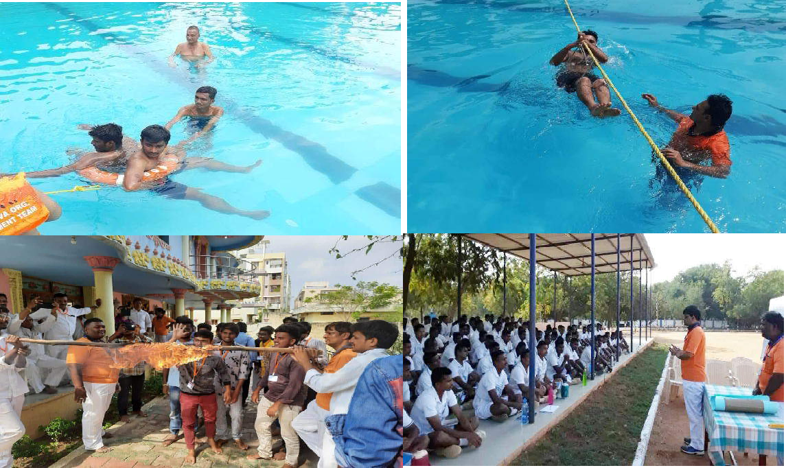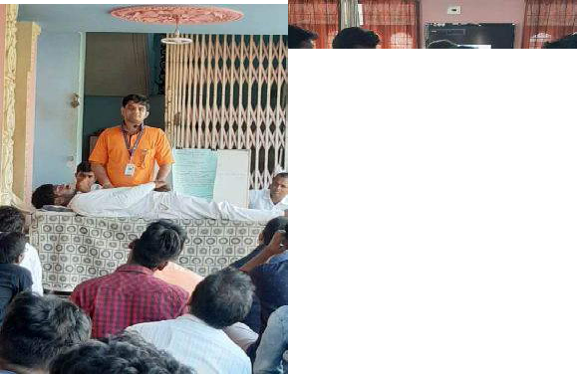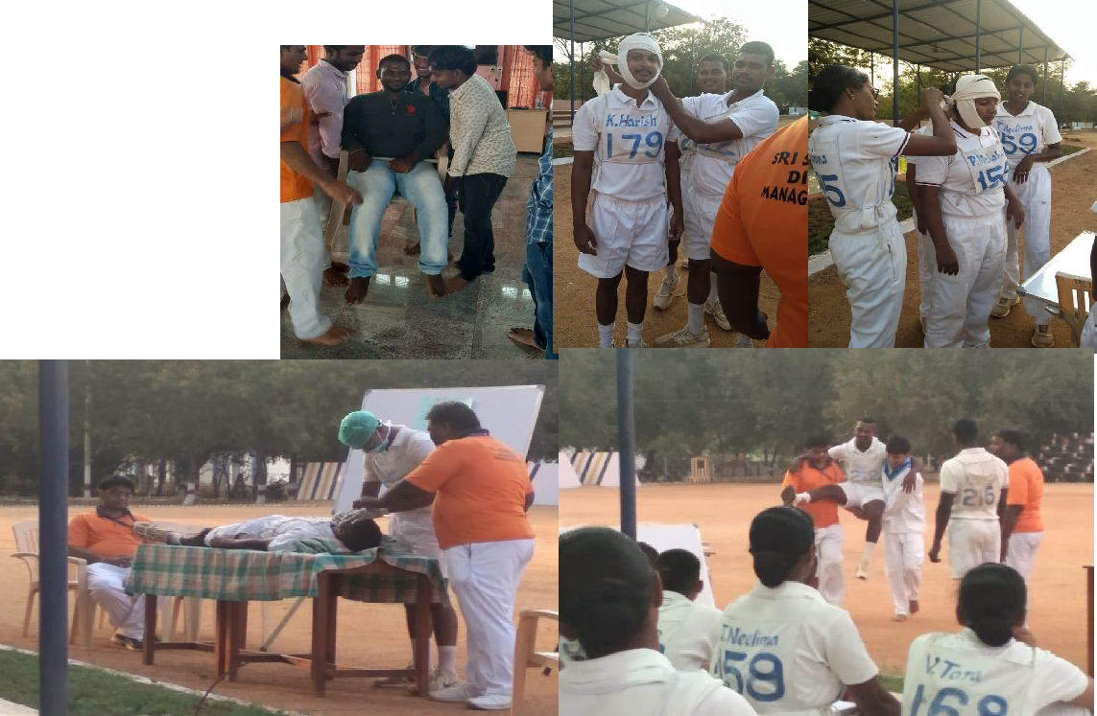

58

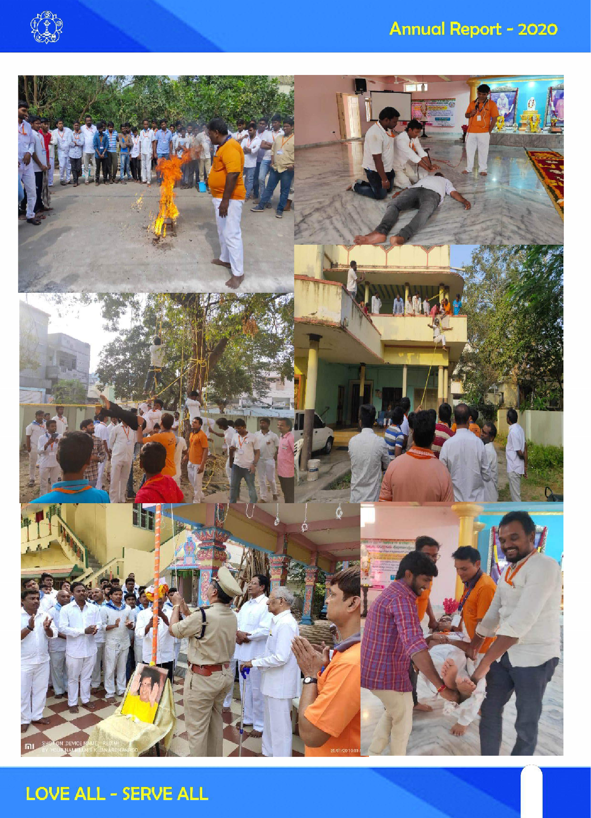

59
59

Sri Sathya Sai Water Purification Plants (SSS Premamrutha Dhara Plants)
With the inspiration and guidance from Bhagawan Sri Sathya Sai Baba, the Technology group of Sri Sathya Sai Seva Organisations (SSSSO) have established over 100 Water Purification facilities in various rural areas. The health hazards on account of fluoride contamination of drinking water was recognised and some
of the worstâ€ affected villages have been selected by the Organisation to provide safe and pure water
to thousands of people. With the initiative of the Technology group, SSSSO has provided necessary infrastructure to house and install purification plants with the latest facilities, ensured nonstop supply of drinking water and periodic checks for the smooth functioning of the systems. Water is provided at a nominal cost of Rs.2 per 20 litres against ATW smart cards. The funds are used to cover not only the operational and maintenance costs of the plant, but certain other welfare activities of the village as well. A local committee manages the functioning of the Plant in all respects. Details of production usage plant- performance are electronically recorded. Visible and appreciable changes have been observed in the health condition of the rural folk in all areas where such systems have been in operation.
SNo VILLAGE BENEFICIARIES

ANANTAPUR DISTRICT
1 Pothukunta | 1500
2 Pamdurthi | 1500
3 Cherlopalli | 1500
4 Narepalli | 1500
5 Marlapalli | 1000
- Kathiavaripalli 1000
- Subbarayanipalli 1000
- Karvallapalli 1000
- Diguvagangapalli 1000 10 Yerravankapalli 1500
- Pathabhatlapalli 1500
- Masakavanipalli 1500
- Mamillakuntapalli 1500
- T.Kuntapalli 1600
- Kokkantivaripalli 1800
- Mamillakuntapalli 1600
- Donnikota 1800
- Gopipalli 1600
- SSSIHL-Parthi 1000

CHITTOOR DISTRICT
- Bhagyanagaram 1500
- Akkurthi 1500
- Gudelagudu 1500
EAST GODAVARI DISTRICT
- Mulakala lanka 1500

KRISHNA DISTRICT
- Satravapalli 18000
- Borraputhula 1500
KURNOOL DISTRICT
- Borivelli 2000
PRAKASAM DISTRICT
- Chautupalem 2000
SRIKAKULAM DISTRICT
- Ramakrishnapuram1600
29 Matamkanchali | 1500 | 56 Palangaram | 1500
30 Chandipugutta | 1500 | 57 Vantharam | 1600
31 Silagram | 1600 | 58 Uddavolu | 1500
32 Dokulapadu | 1500 | 59 Ravivalasa | 1600
33 Rushikonda | 1600

34 Sanyasipugutta 1600
35 Paragapagutta | 1500 | 60 Pothepalli | 5000
36 Gokarnapuram | 1600 | 61 Gollagudem | 1200
37 Palakonda | 1400 | 62 Ponukollu | 1500

38 Vatapagu | 1600 | 63 Penakannametta 1600
39 Kallepalli | 1500 | 64 Puliramannagudem1500
40 Udayapuram | 1800 | 65 Ankannagudem 1500
41 Kotturu | 2000 | 66 Buttuyagudem 1200
42 SKLM mandir | 1600 | 67 Kommugudem 1400
43 Rim Hospital | 1800 | 68 Ommivanipalem 1500

- Fisherman village 1200

VISAKHAPATNAM DISTRICT
- Vechalam 1500
- Toruvolu 1600
- Kanamam 1500
- Ramavaram 1600
VIZIANAGARAM DISTRICT
- Bhandi 1600
- Jarajapupeta 1600
- Nellimarla 1500
- Duvvam 1500
- Gajapathinagaram1500
- Pedabondapalli 1600
- Ramabhadrapuram1700

WEST GODADAVARI DISTRICT

69 Eluru-Hospital 1600
TOTAL BENEFICIARIES : 124200

60

SRI SATHYA SAI VILLAGE INTEGRATED PROGRAMME (SSSVIP)

The jewel in the crown of all these is the Sri Sathya Sai Village integrated programme (SSSVIP). This is a rare opportunity of serving the rural poor through a systematic and integrated approach in the areas of medicare, sociocare, educare, agricare, individual care, employment care and spiritual care.

Bhagawan's message on SSSVIP “On the holy occasion of Sarvajit Ugadi 2007, we are launching a new scheme for rural development, under the name, “Village works”. Every house in every village shall be kept clean. The houses are to be kept neat and clean both inside and outside. The children in these homes are also to be groomed into clean and healthy children. We propose to cover every village under this scheme. Hence, we must undertake this rural development project immediately. The elders as well as children, the poor and rich, should all work united for the success of this project. It is seva (selfless service) that unites people. Both the villages and towns should join and work together in a spirit of unity….

Since 2013, the Seven-care concept of SSSVIP was launched in 56 needy villages of the Andhra Pradesh including the 25 Girijan hamlets of East Godavari where Sri Sathya Sai Drinking water project is in place. The following cares have been initiated for overall development:
1. EDUCARE 2. MEDICARE
3. SPIRITUAL CARE 4. EMPLOYMENT CARE
5. AGRICARE 6. SOCIO CARE
7. INDIVIDUAL CARE

These aspects are latent in the manifold activities taken up by the Organisation in the rural areas.
Educare : Classes by Bala Vikas Gurus are undertaken to provide comprehensive education in human values to the rural children. Distribution of notebooks, school bags, footwear etc. are done in almost all districts. In Krishna and Chittoor districts, separate programmes were conducted with emphasis on health and hygiene.

Medicare : In 8 districts of Andhra Pradesh, the Mobile Medical vans equipped with state of the art medical devices are rendering sustained health services by visiting SSSVIP and other villages and conducting camps there. Hundreds of sick people are benefited during each visit of the Medical Van in every district. SSSSO also takes care of follow-up cases in designated hospitals thus providing the much needed helping hand to the needy patients.

Spiritual Care : Activities like Bhajans, Nagarsankirthan, Pallaki processions, Spiritual talks, Tandularchana, celebration of festivals, conducting free marriages for the poor etc. form the core of spiritual activities. Small plays are enacted to drive home the ideas and teachings of Bhagawan Baba.

Agricare: Sri Sathya Sai Seva Organisation has been instrumental in taking the services of eminent Agriculture scientists for the benefit of farmers in SSSVIP villages. The farmers have been educated about the precautions to be taken before seeding as well the aer-care and remedial measures to be adopted in the case of attack by pests and insects. In some districts were also supplied high-yielding varieties of seeds.

61
61

Socio care: Establishing Water purification Plants, construction of sanitary toilets, providing solar lights, Tree Plantation and rainwater harvesting etc. are some of the activities taken up under socio care.

SSSSO offered training to unemployed youth through tuitions and short term courses to enable them to to get gainful job placements. Similar Skill enhancement training programmes were taken up in a few districts for mahilas also in Computer basics, Tailoring, Dress-making, Fashion design etc. Individual Care : Help in the form of clothes, school needs for children, supply of Sai Protein food, 'Amrutha Kalasams' (a kit of provisions for a month's sustenance) etc. are extended to selected poor families. Model Villages also being developed in Andhra Pradesh where all the seven cares would be taken up.
The areas of activity were formulated with an aim of bringing about holistic transformation of individual lives and community living, by attacking the root cause of the persistent problems. This SSSVIP programme could aptly be termed the “SIlent(Sai Lent) revolution” In each state, the service wing identifies the needy communities of the society and conducts activities accordingly.

Rendering selfless service or seva is best described in Swami’s words “Seva eppudu kashtapadi cheya vaddu, ishtapadi cheyali”, meaning ‘Never render service as an exertion, but do it with linking’. Seva should be done with a feeling of empathy and not superficial pity.

SAI REHABILIATION PROGRAMME – SRP

Sri Rehabilitation Programme we started in Andhra Pradesh during February 2008 and completed 10 years of service. It is unique initiative of Bhagawan’s Super Speciality Hospitals in Puttaparthi and Bangalore, seeks to continue, sustain and boost the hospital-patient relationship.

Elsewhere, once the bills are paid and the patient is discharged, the hospital has hardly any connection with the patient. But those operated in Swamy’s hospitals are never completely discharged, they are only handed over to another local doctor.

Post-surgery recuperative care and continuing doctor consultations for a period of six months and regular medication and diagnostic tests, and lifestyle changes, are vital for cardiac patients as most patients as most patients are poor and illiterates. Hence unlikely to understand this and to do this, Qualified Doctors in 14 districts are actively participating in the Divine activity voluntarily.

62

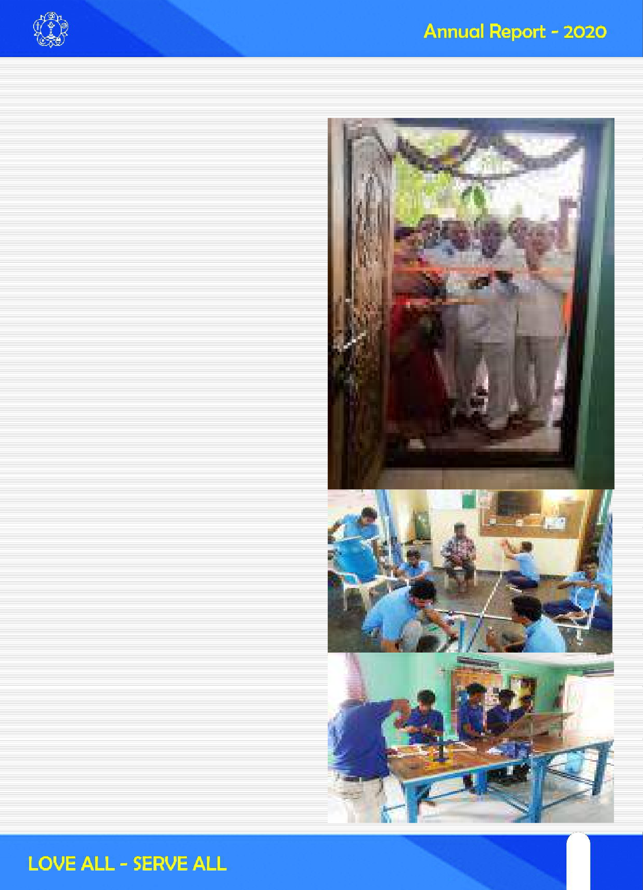
Sri Satya Sai Rural Vocational Training Centres (SSS RVTC)

What is RVTC:
Rural Vocational Training Centre is a by-product of the deep concern and selfless thought of Sri Sathya Sai Organisations, India aiming at improving the economic conditions of the unemployed youth in a particular village and to create areas of self-employment. Also it streamlines the youth by helping them to focus and hone their skills, rather than on unwarranted pursuits. Skill training is offered totally free of cost along with free boarding and lodging at selected few centres where the youth do not have access to the centre from their village. Skill trainings are catered according to the needs of the neighbourhood of that particular village by RVTC team.

Mission Objective:
- To train unemployed youth from Sri Sathya Sai Village Integrated Program(SSS VIP) villages and its neighbourhood in multi skills that are required in the rural areas.
- To help the trained youth to set up small service centers in their villages, enabling them to gain economic independence.
- To avert migration of village youth to towns and cities.
- To inculcate ethics and values in youth.

Why this focus on Youth:
Of the 1300 million Indian Population, 40% are in the age group of 13-35 years, defined as youth in the National Youth Policy(520 million) and, in this age group, the unemployment rate is 13% (67 million) and will grow to 15.5% (80 million) within a year. This rise in youth unemployment is not only because of the direct economic costs, but also due to the social impact of joblessness

63
63

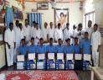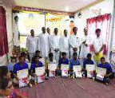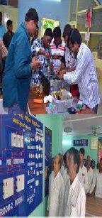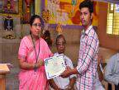manifested by increased crime, mental health problems, violence, drug taking and social exclusion are indicators of degenerating society. To establish a harmonious society for peaceful coexistence, which is Sri Sathya Sai Baba’s Sankalpam, SSSSO has undertaken well known activities like Vidya Seva, Vaidya Seva, Water projects, Balvikas etc. Of all these, Balvikas, Swami’s pet project, prepares the children who would certainly transform this society when they grow up (may be 15-20 years later). The SSSVIP programs, like Medicare(Vadya Seva), Narayana Seva (Annadhanam), protein distribution, housing etc serve the needs for the immediate present. The gap in between of these two i.e. of 15-25 years, when the current youth play a very important part in the competitive society, has to be filled with opportunities for these disadvantaged youth. The SSS RVTC Program (Sri Sathya Sai Rural Vocational Training Center), started in the year 2014, exactly addresses this problem. Though some of these activities have been going on even prior to 2014, this has been systematized in 2014 and so far, 9400 youth were trained with 26 Centers serving across India.

Salient features of SSS RVTC:
  - The training is totally free of cost to the trainee
  - Provides Seva opportunity to members of SSSSO.
  - The duration of the training is 3 to 6 months
  - The skills are selected according to the requirement/need of the village.
  - In some centers, free boarding and lodging is provided for trainees. Districts, which do not have RVTC, can send youth from villages to these centers for training.
  - Free tool kits and uniforms are provided to trainees
  - TVS MOTORS is very much involved with RVTC.

64

Whenever requested, they provide training to the students in two wheeler repair and service at their service centers
- Integral to training curriculum is Sarva dharma principles, ethics, values and yoga.
- Project work: At the end of training, the trainees are sent to Prasanthi Nilayam to work in the Maintenance section. Normally it coincides with a particular State’s Prasanthi Seva
- The RVTC mission was declared as a National initiative in April 2014. Following this directive, a number of Centers (26 as on date) were started across India and are functioning well. A brief summary of the performance of these centers is presented herein to understand the extent of the achievement of the well thought out objectives and sustainability perspective. SSS RVTC in Andhra Pradesh:
Sri Sathya Sai Rural Vocational Training Centres (SSS RVTC) have been set up by SSSSO as one of the three National projects throughout the country. In Andhra Pradesh, they are established at Anantapur (Tadipatri) and West Godavari (Pothepalli).
SSS RVTC has so far trained about 100 youth in various skills like Domestic electrical wiring,
Plumbing, Pump set repair, AC repair, Tailoring and Maggam works, Tractor repair ,Mobile phone servicing etc.
The trainees have been provided with complete set of Tool kits so that they can earn their livelihood in their respective locations serving the surrounding villages.
New programmes to empower rural youth have been undertaken by providing free vocational training in those trades which are in great demand at village level. These trades are selected based on the information obtained from village survey, district employment office and job placement potential.
Youth wing of SSSSO have initiated several programs like RPL (Reprogramming Lives), Higher Education Projects and Youth conventions to empower the unemployed.

Women Empowerment:
In association with BIRED (Bankers' Institute of Rural and Entrepreneurship Development), several skill development programmes have been undertaken in Advance Tailoring, Maggam and Zardoshi , Beautician Courses etc. in most of the districts of Andhra Pradesh.

Details of Training Programs

Rural Vocational Training Centre's - 01-01-2020 to 31-12-2020
NO . OF TRAINEES

SL NO

1
COURSE

Electrical Wiring, Home
appliances repair, Plumbing
No. of Batches

2
Trainees Per Batch

29

Total

58
Distr ict

ANANTAPUR
PLACE

TADIPATRI

3 Electrical Wiring, Winding 1 26
26 W GODAVARI
TANUKU


TOTAL: 3 55 84

65
65

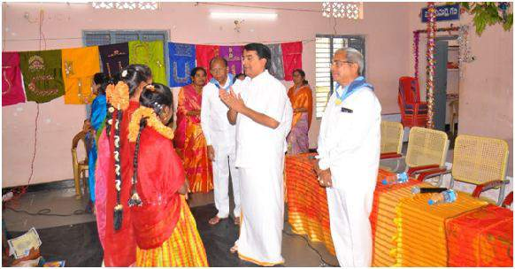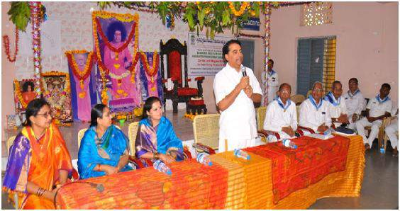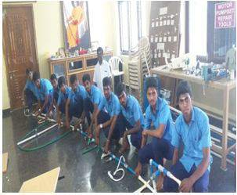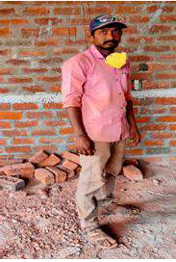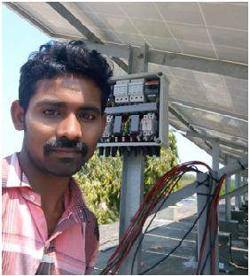
Vocational Training Programs from01-01-2020to 31-12-2020
SL NO | COURSE | NO. OFTRAINEES |  |  | FROM | TO | District | PLACE
SL NO | COURSE | Gents | Mahila | Total |  | TO | District | PLACE
1 | MAGGAM |  | 57 | 57 | 03-12-2019 | 20-01-2020 | SRIKAKULAM | KOTABOMMALI
2 | TAILORING |  | 63 | 63 | 16-12-2019 | 02-01-2020 | KRISHNA | KAIKALURU
3 | MAGGAM |  | 54 | 54 | 30-01-2020 | 13-03-2020 | ANANTAPUR | KOTHACHERUVU
4 | ELECTRICIAN | 27 |  | 27 | 13-02-2020 | 28-03-2020 | KADAPA | PRODDATUR
 | TOTAL: | 27 | 174 | 201

Sri R J Ratnakar garu, Managing Trustee, Central Trust, interacted with Trainees at valedictory function of Maggam & Zardosi training at Kothachervu

RVTC, Tadipatri 14th Batch Trainees
G Rama Krishna Trained in our RVTC Srikakulam 4th Batch and now doing house wiring contracts and earning 20,000/- per month

Mr. Ellapa Raju, Kaikaluru trained at our RVTC, Tanuku in Electrical Wiring and Winding course. After having thorough knowledge and confidence in this field diversified in to installation of Solar Panels. Now he employed another 2 persons with a salary of Rs.8000/- per each and he is earning Rs. 20,000 – 25,000/- after paying salaries. Besides, in Tanuku he is undertaking subcontracts in Hyderabad as well.

He expressed his satisfaction and gratitude for swami.
66

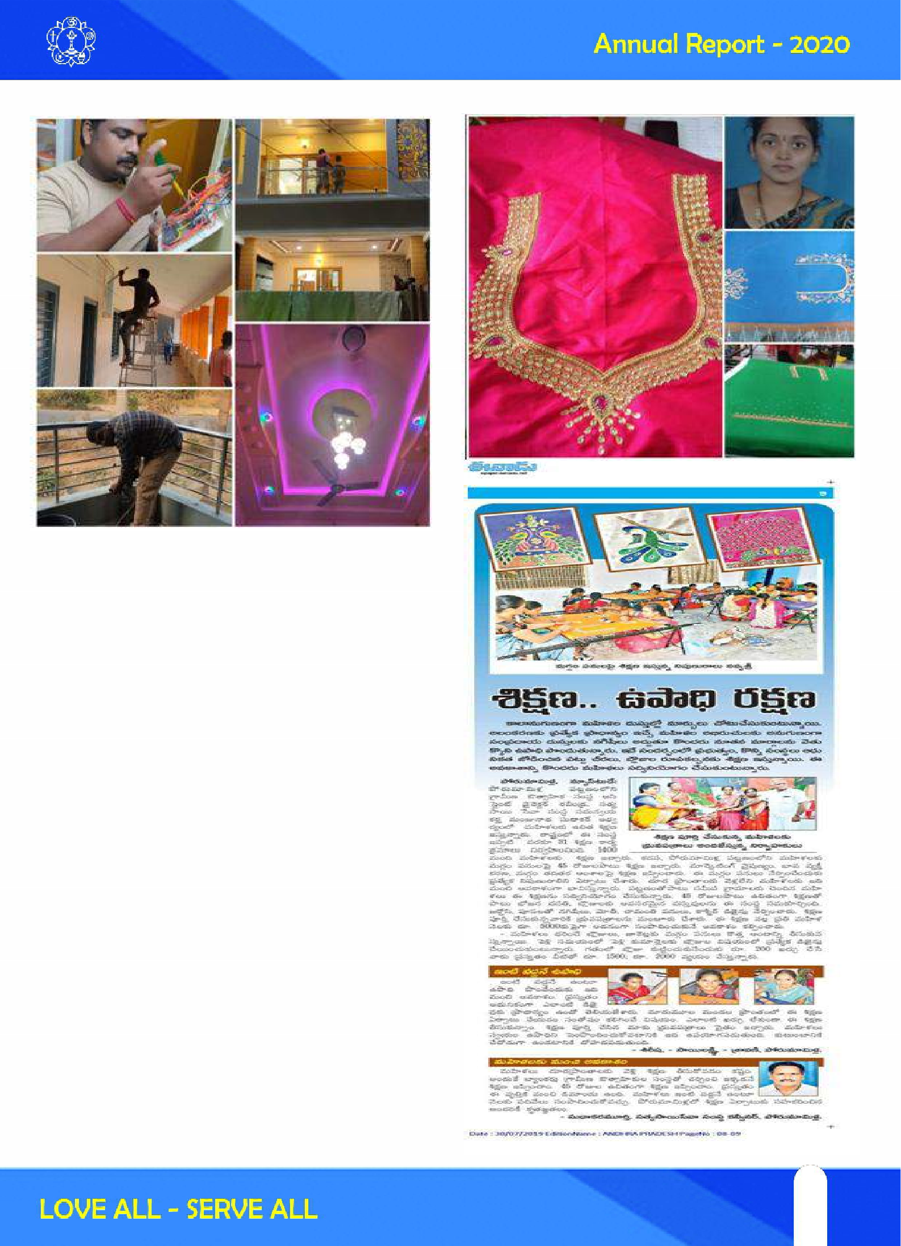

Mr. R Veeraswamy, Relangi village, W G Dist trained at our RVTC, Tanuku in Electrical Wiring and Winding course. After having thorough knowl- edge and confidence in this field diversified in to Plumbing and core cutting and doing housing wir- ing contract. Now he has reached to a height of employing 18 persons under him with a salary of 10,000 – 18,000 per person and earning 40,000 to 50,000 per months after meeting all expenses. Recently he got elected as Ward Member unani- mously in panchayat elections

He expressed his full satisfaction in quality of our training and felt very much happy for our Love & Care. Also he is attending Seva Programs of our Tanuku Samithi.
Mrs. K Swetha Sree, Porumamilla, Kadapa Dist trained at our Porumamilla Vocational training centre in Maggam & Zardosi and now working in her house and earning Rs. 10,000 – 15,000 per month. She expressed her full satisfaction about our training

67
67

Inauguration of Tailoring & Fashion Designing Training program at Machilipatnam by
Hon. Additional District Judge Smt. Dr. S Rajani accompanied with Shri S G Chalam, State Presi- dent, SSSSO,AP & Shri A Yesepu, BIRED Director
Mrs. T Sravani took training in Koilakuntla vocational training centre and started her own shop in the name Sravani Dresses & Sarees and earning Rs. 10,000 to 15,000 Per month from shop as well as Maggam designing

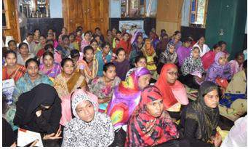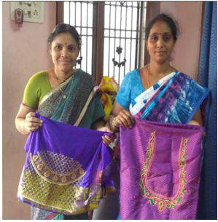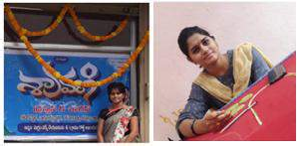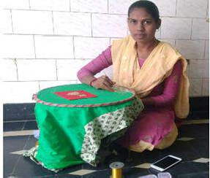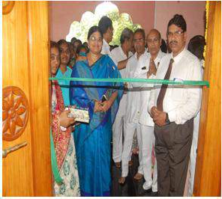

Trainees at Maggam & Zardosi training at Koilakuntla Vocational Training Centre

Mrs. J Jambulamba & Mrs. K V Lakshmi Prasanna were trainined at our Koilakuntla vocational training centre and working jointly at their home and earning around Rs.1000/- per month.

They were very attracted with our Swami’s Love All Serve All

68

Mrs.Pratyusha, Machilipatnam underwent training in Machilipatnam Vocational Training Centre in Tailoring and fashion designing and doing computer embroidery work at her house and purchased a new Usha Janome 450E Computer Embroidery machine at a cost of 90000/- by her own and earning 25,000/- to 30,000/-
Certificates distribution programme at the vale- dictory function of Maggam and zardosi train- ing programme at Kotabommali, Srikakulam District

Mrs. K Durga Bhavani underwent training in Tailoring and fashion designing at our Machilipatnam Vocational Training Centre and doing work in her house and earning 20,000 to 25,000/- per month. With the principles learned in our centre she gave training two mahilas freely. She participated in the Mask seva of ours and stitched so many masks.

Awarding the certificate by Honorable Senior Civil Judge Ms. Anuradha garu at the valedic- tory function of Tailoring & Fashion Designing at Kaikalur, Krishna District.

Seeing with interest the work done by the train- ees of Maggam and zardosi at Kothacheruvu training by Shri K M Rao, NC, RVTC.

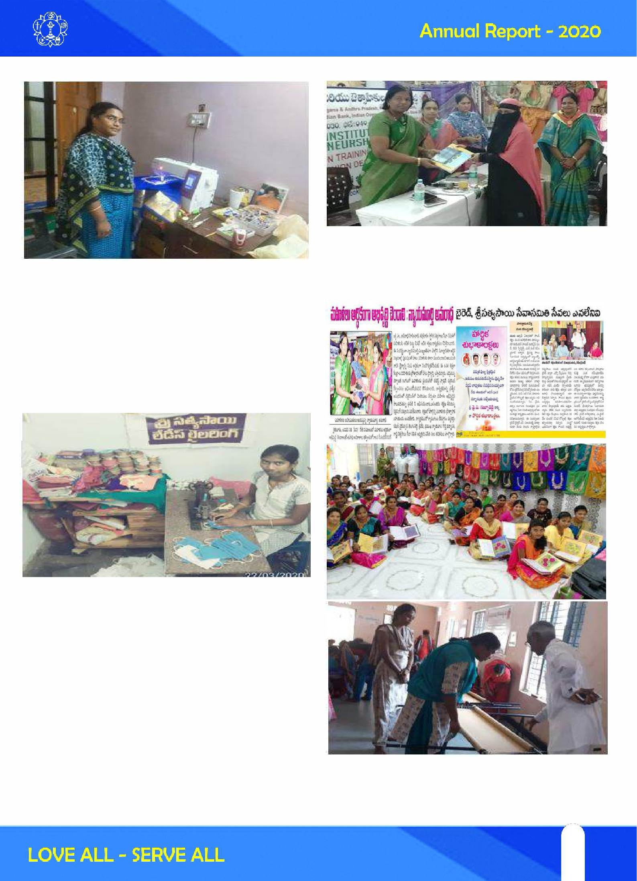

69
69

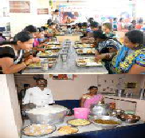
RIMS HOSPITAL SEVA
In the year 2007 on the auspicious occasion of Ugadi ,Bhagawan Sri Satya Sai Baba has started the “Narayana Seva” scheme. The motto of the scheme is to provide food for the people who are in need, at free of cost. In the year 2012 government has come with a proposal to provide food for the patient attendants in Rajiv Institute of Medical Sciences (RIMS) Srikakulam. The then District Collector Sri G Venkataram Reddy garu has given the opportunity to Srikakulam Sri Satya Sai Seva Organization to conduct the same. Following the steps of Bhagawan Sri Satya Sai Baba , Sri Sathya Sai Seva Organisation has taken the responsibilities for providing food for the patient attendants in the afternoon at free of cost. It was extended throughout the State.

70

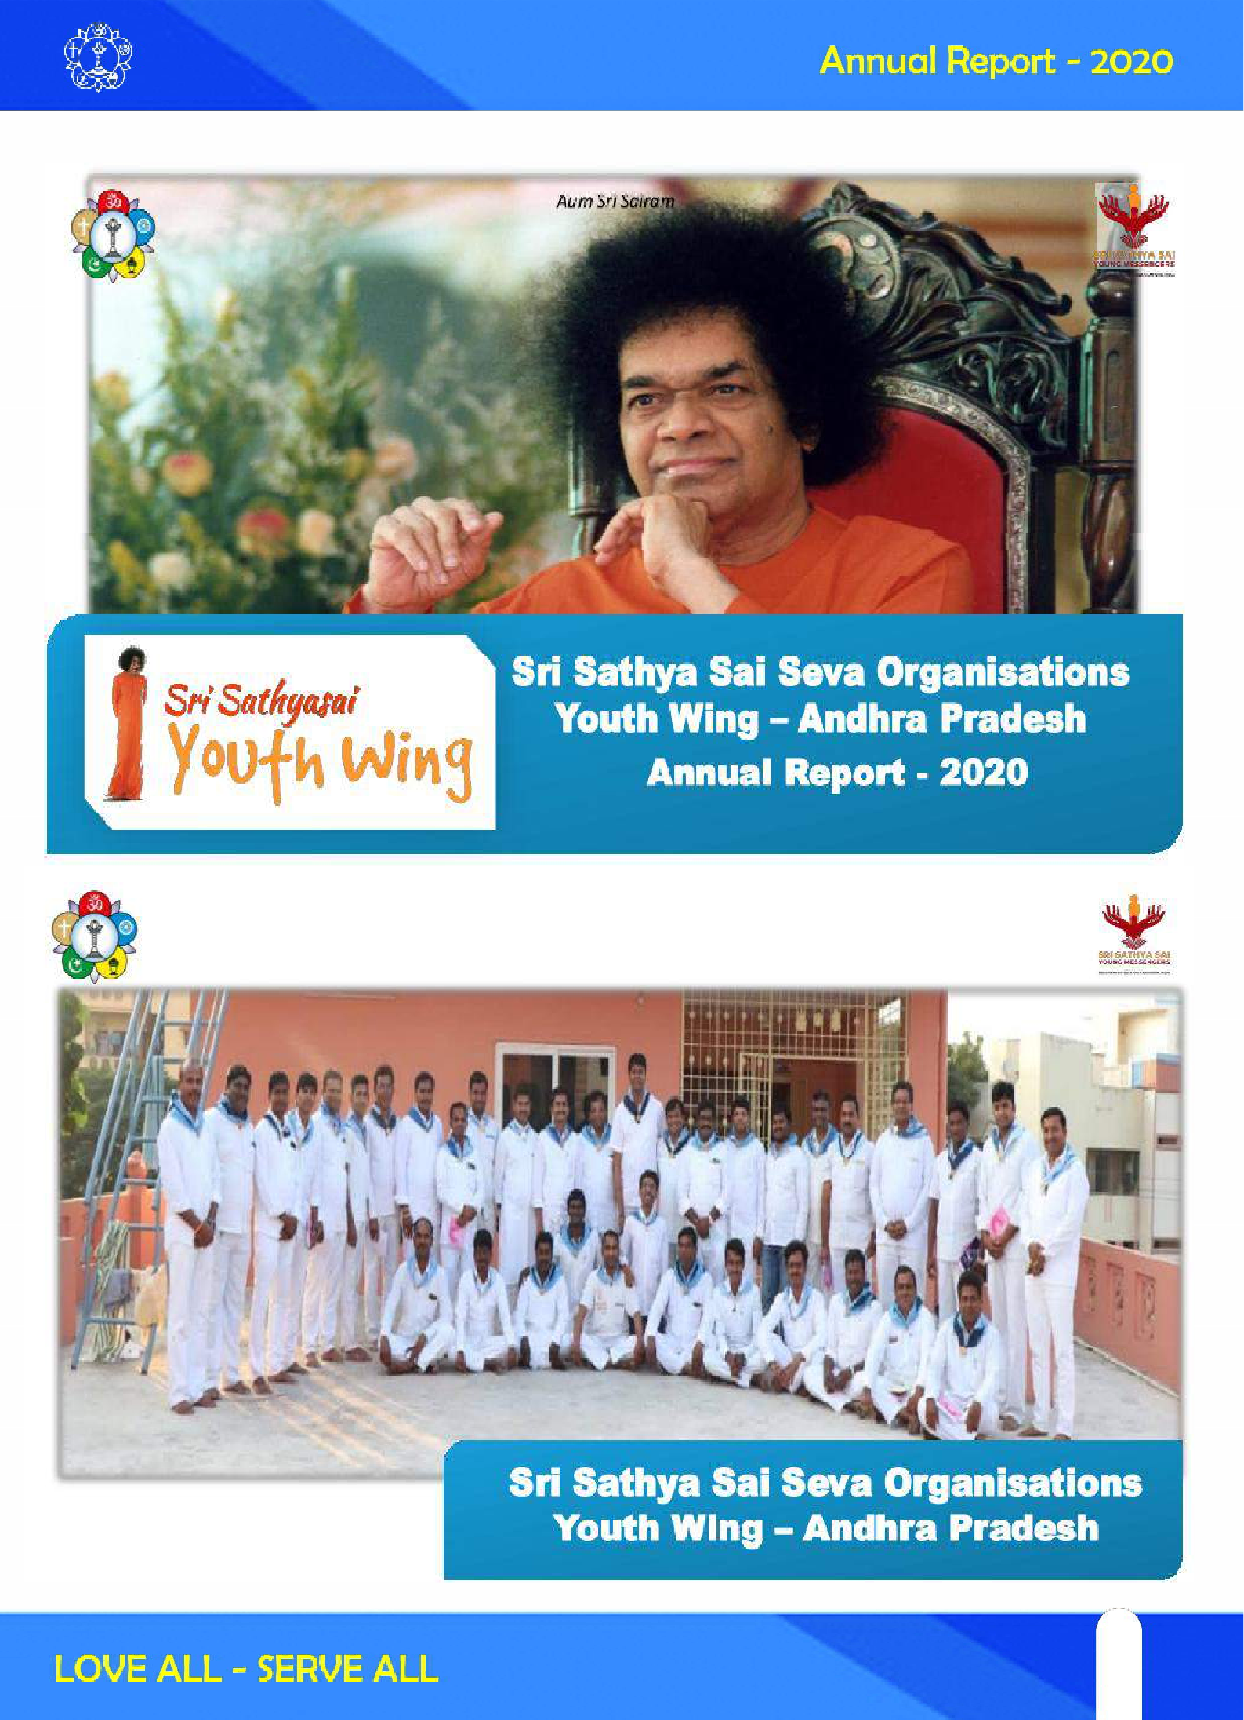

71
71

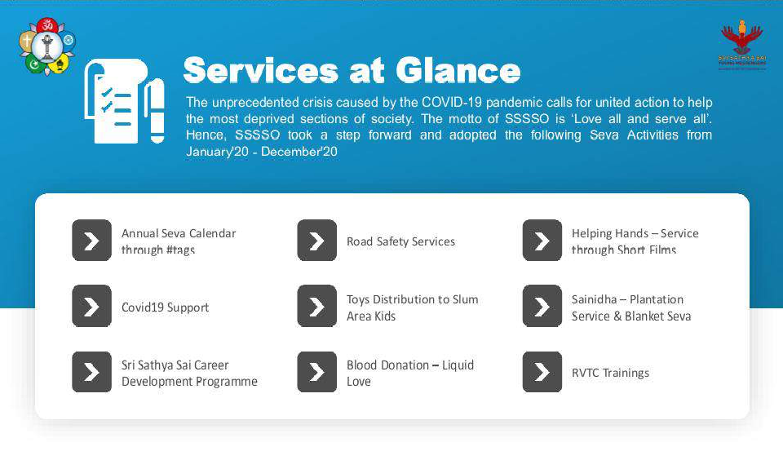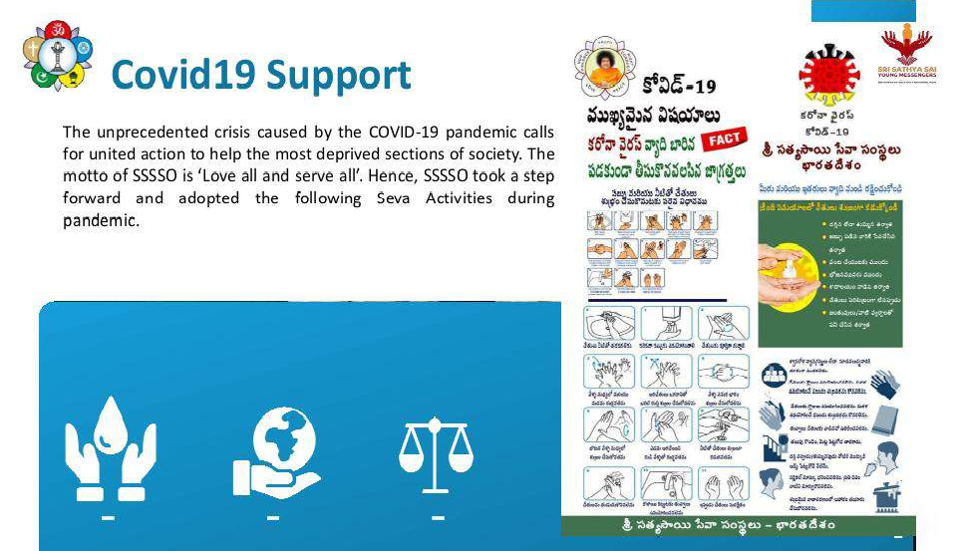

72

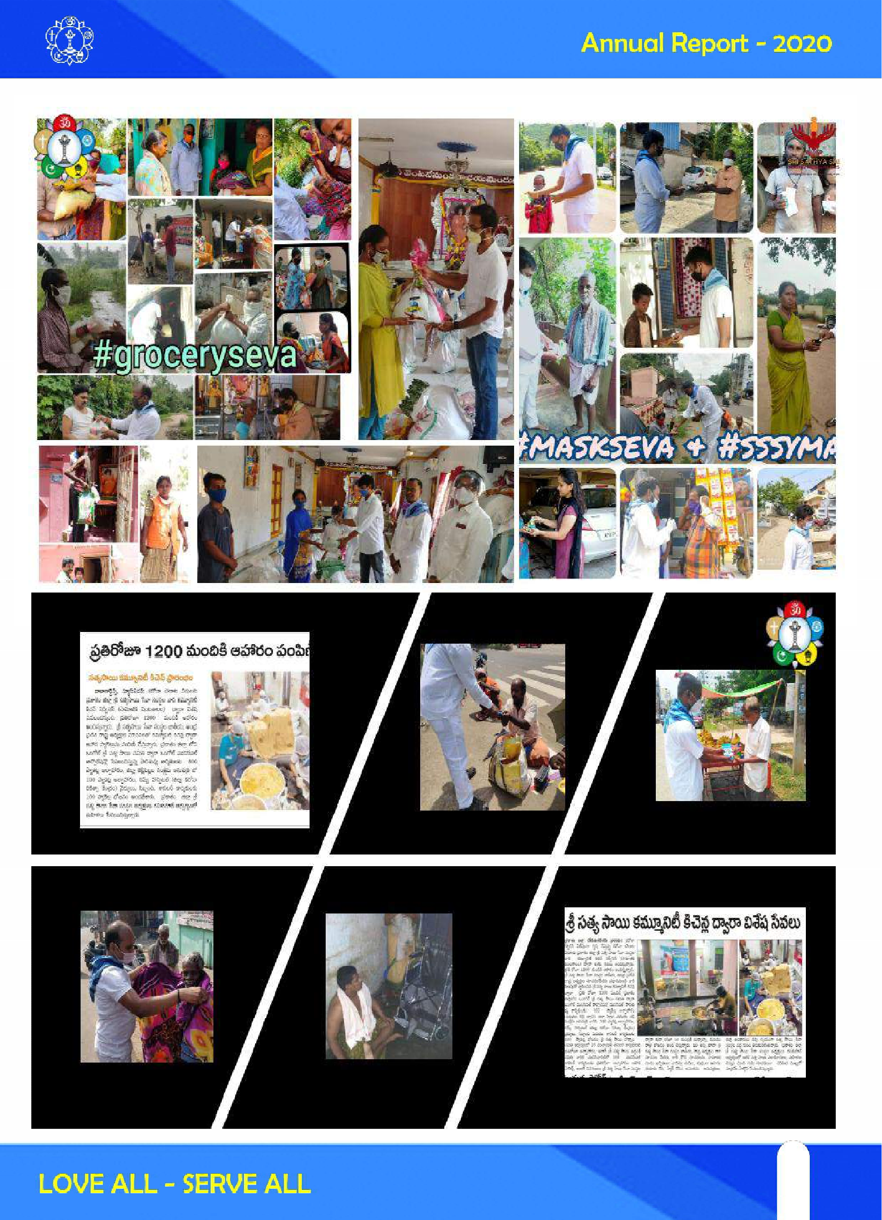

73
73

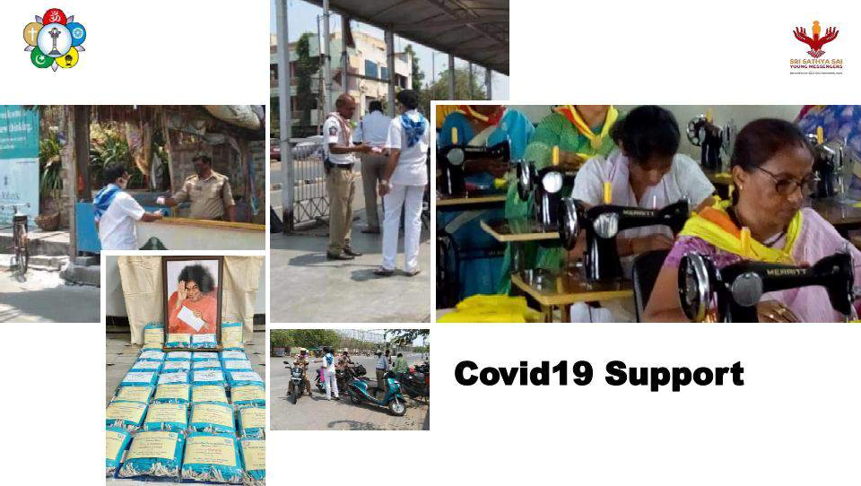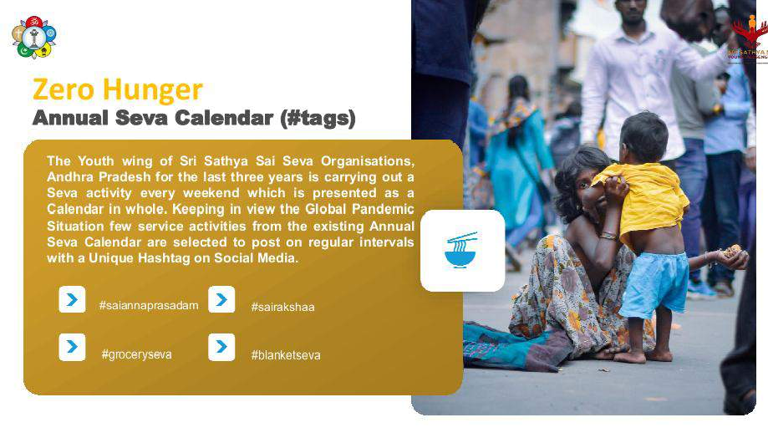

74

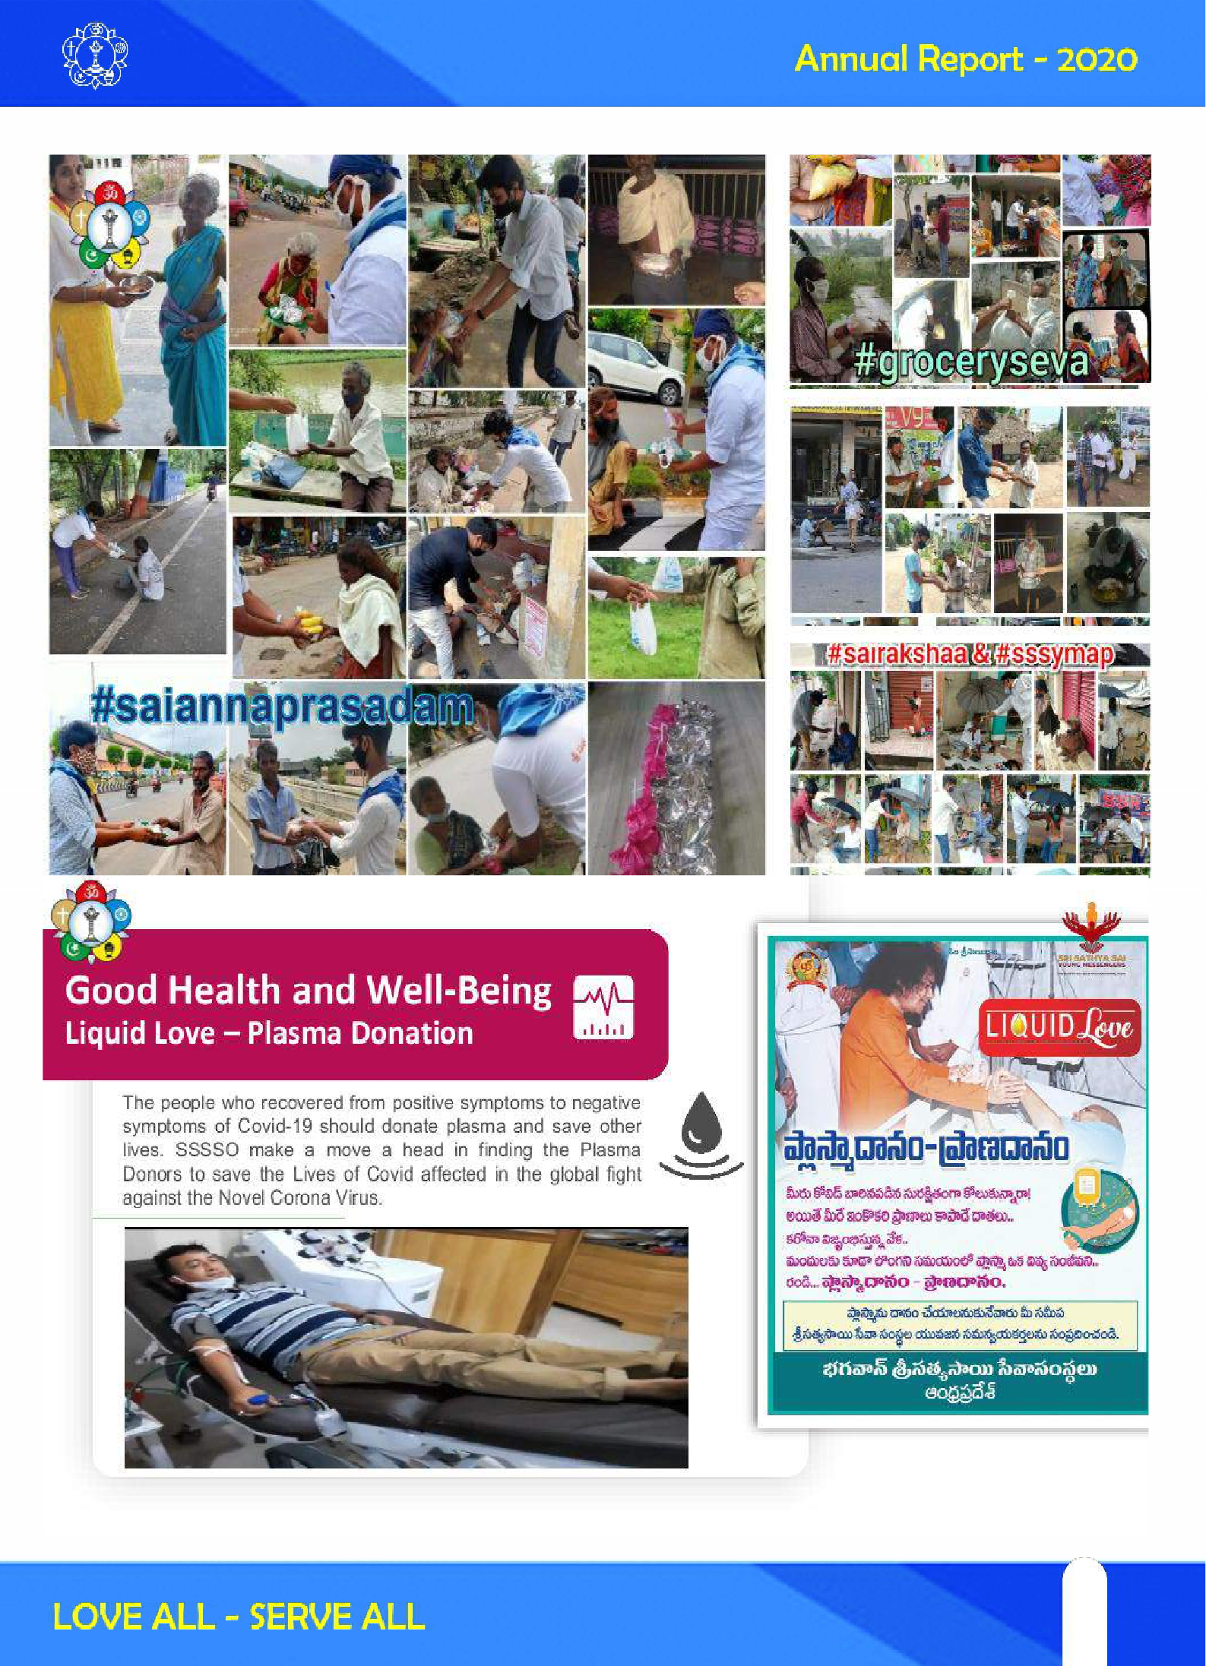

75
75

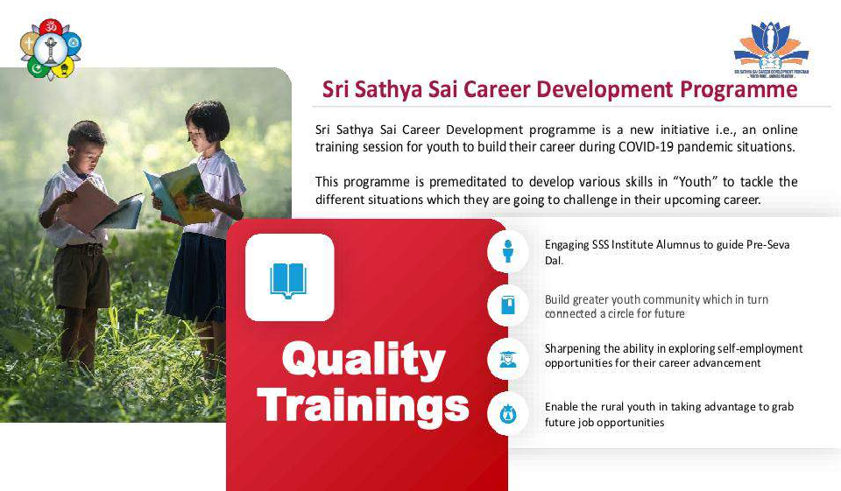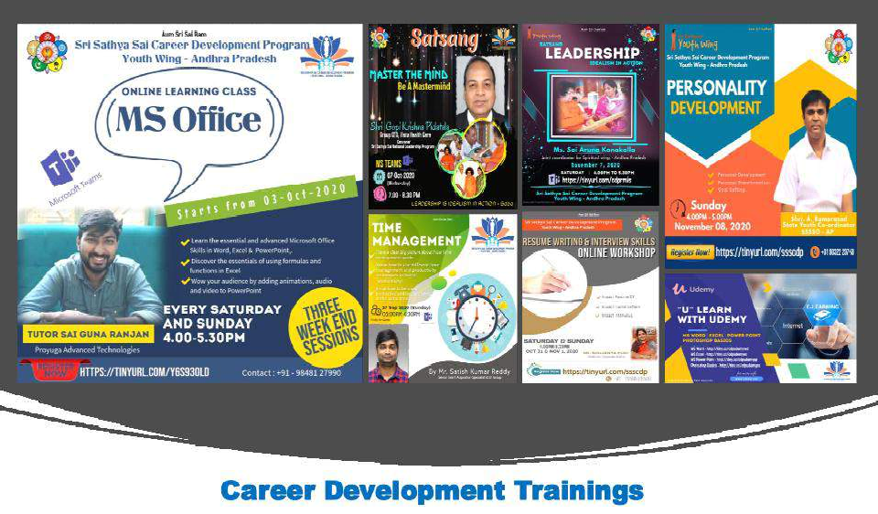

76

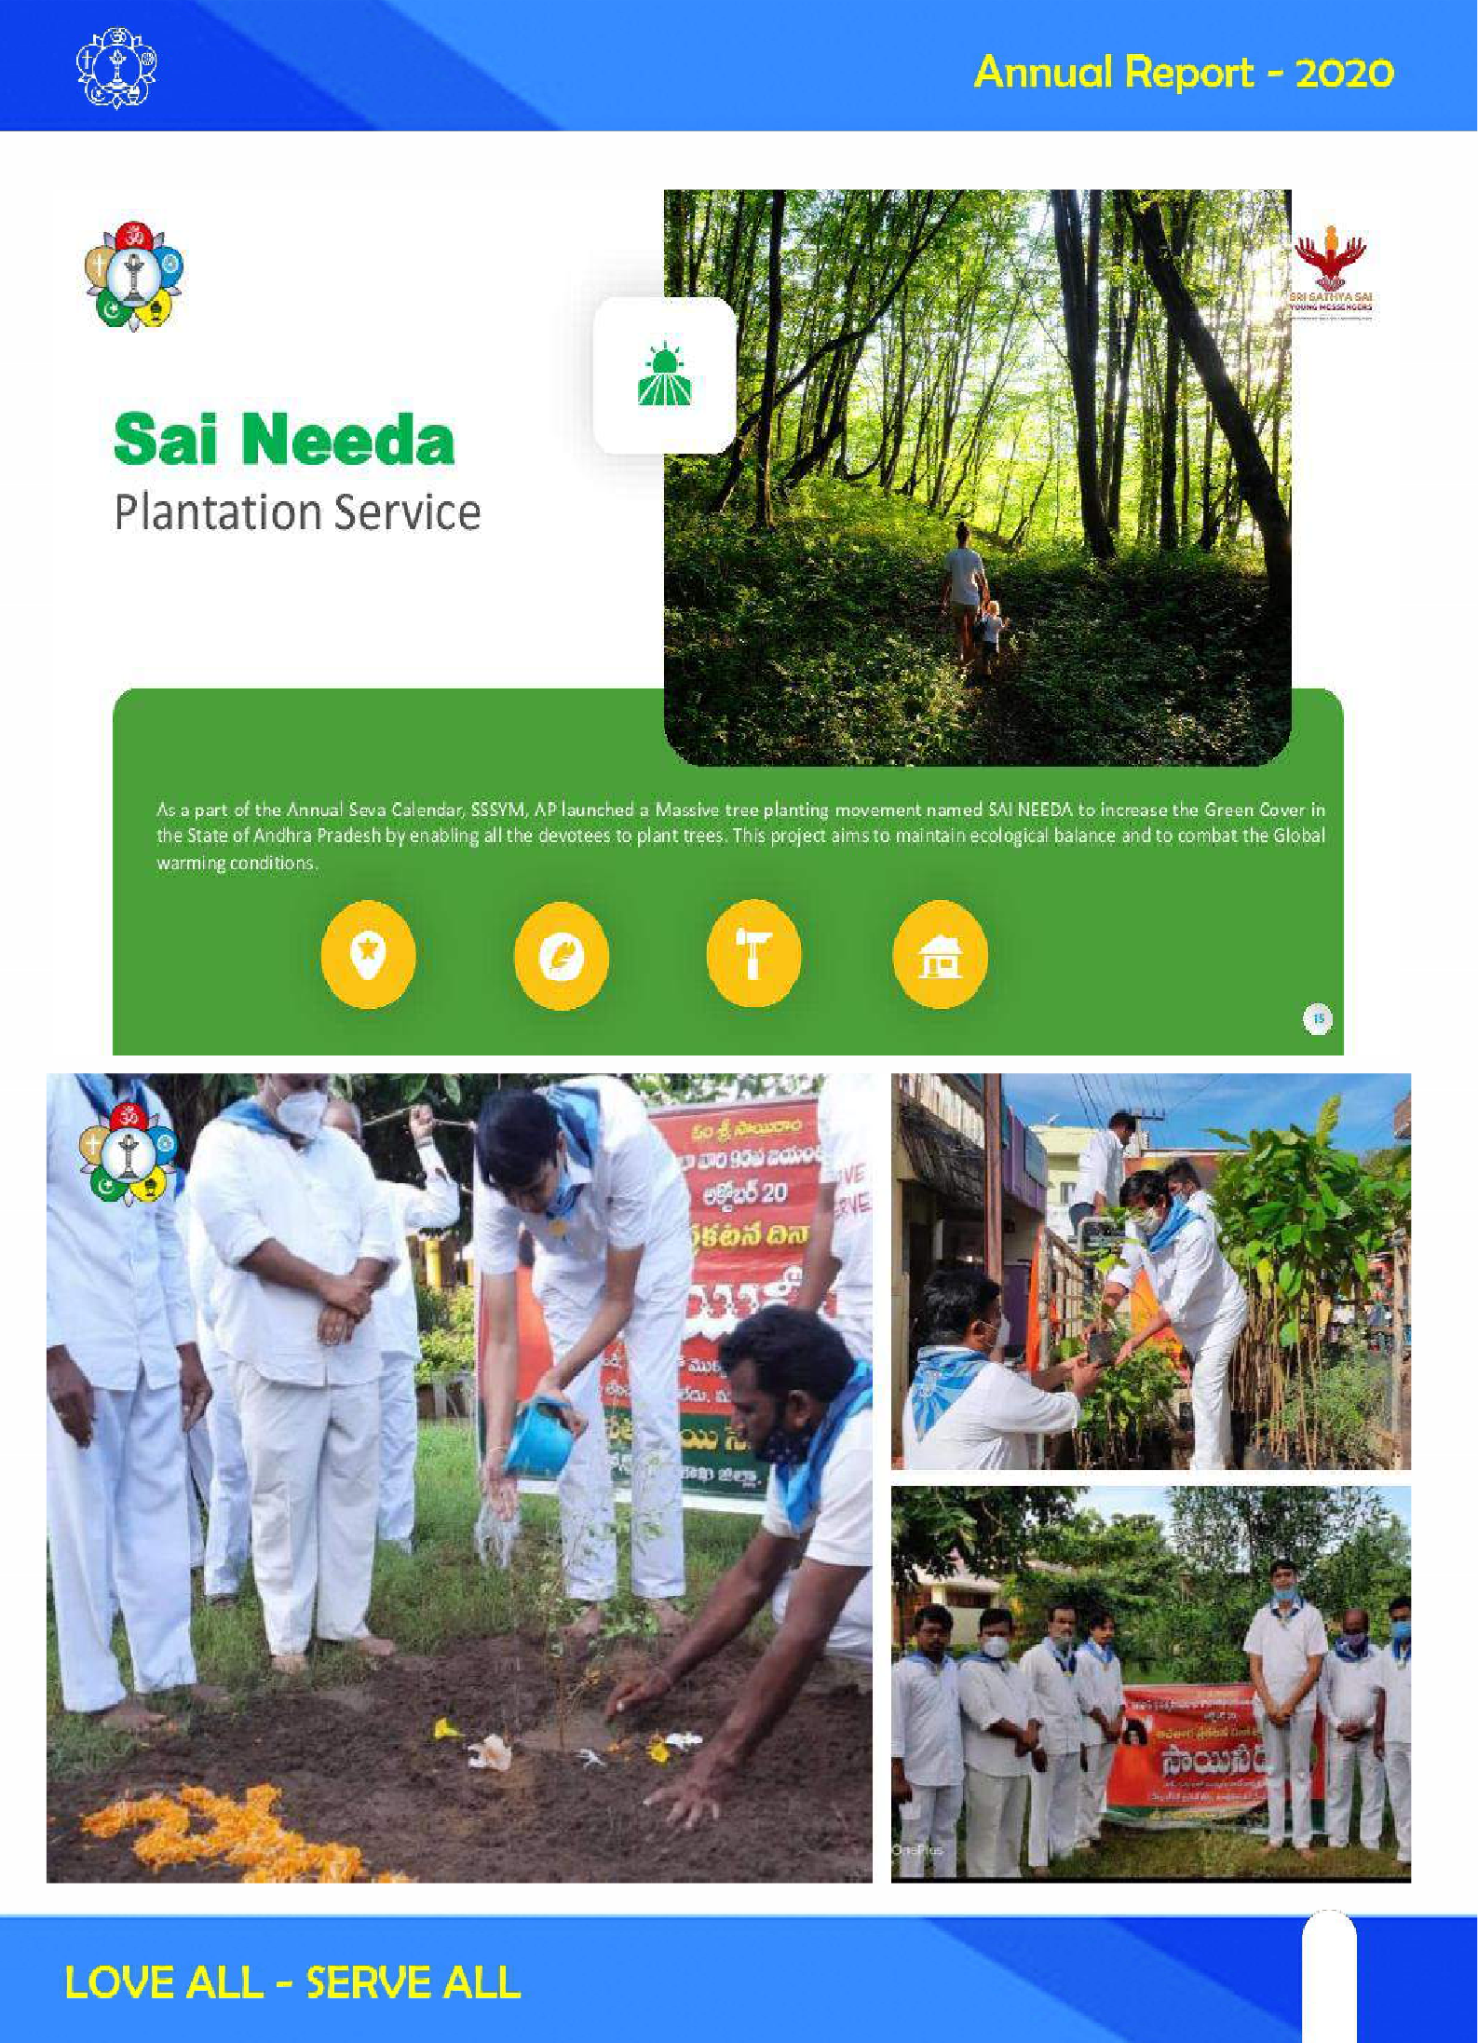

77
77

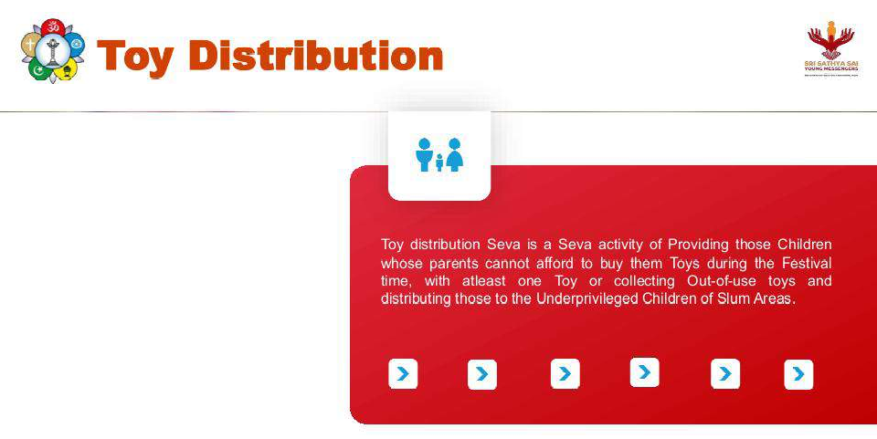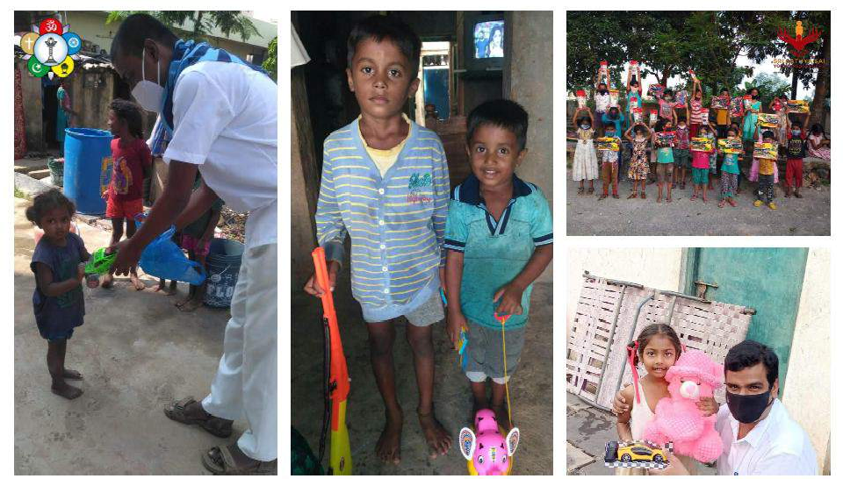

78

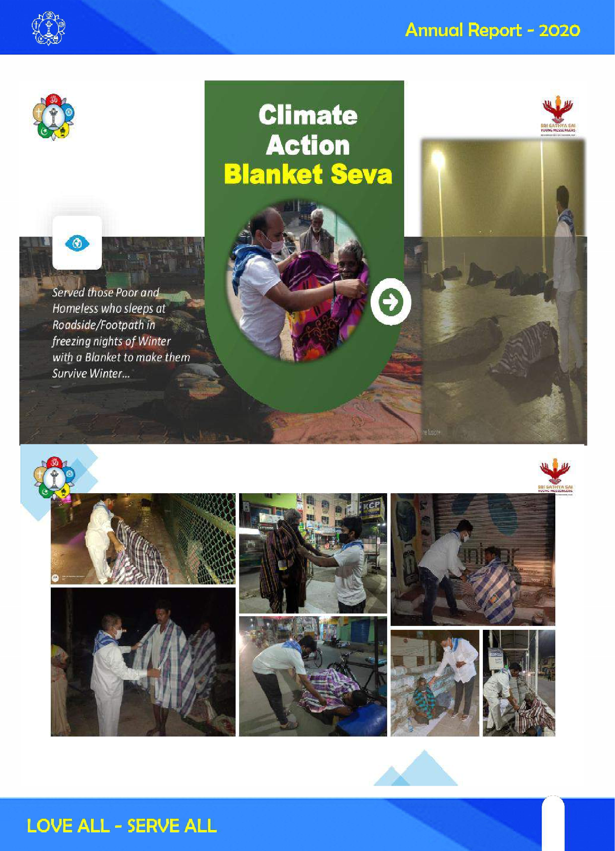

79
79

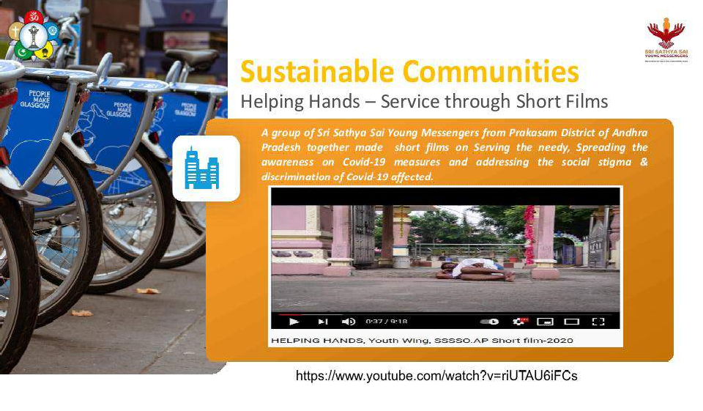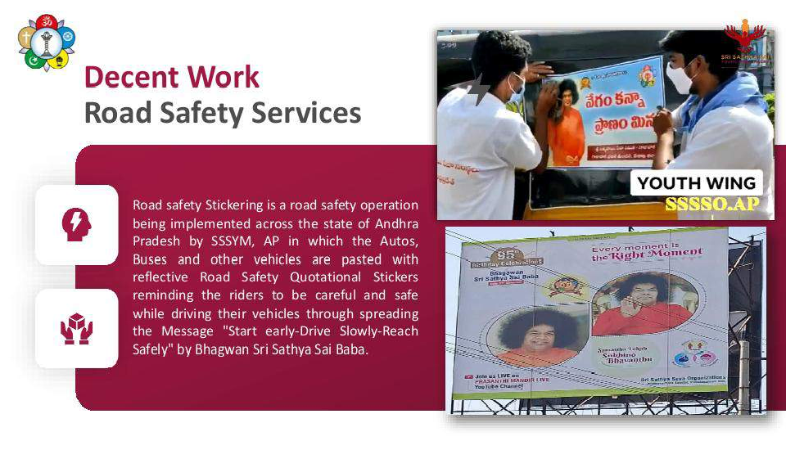

80

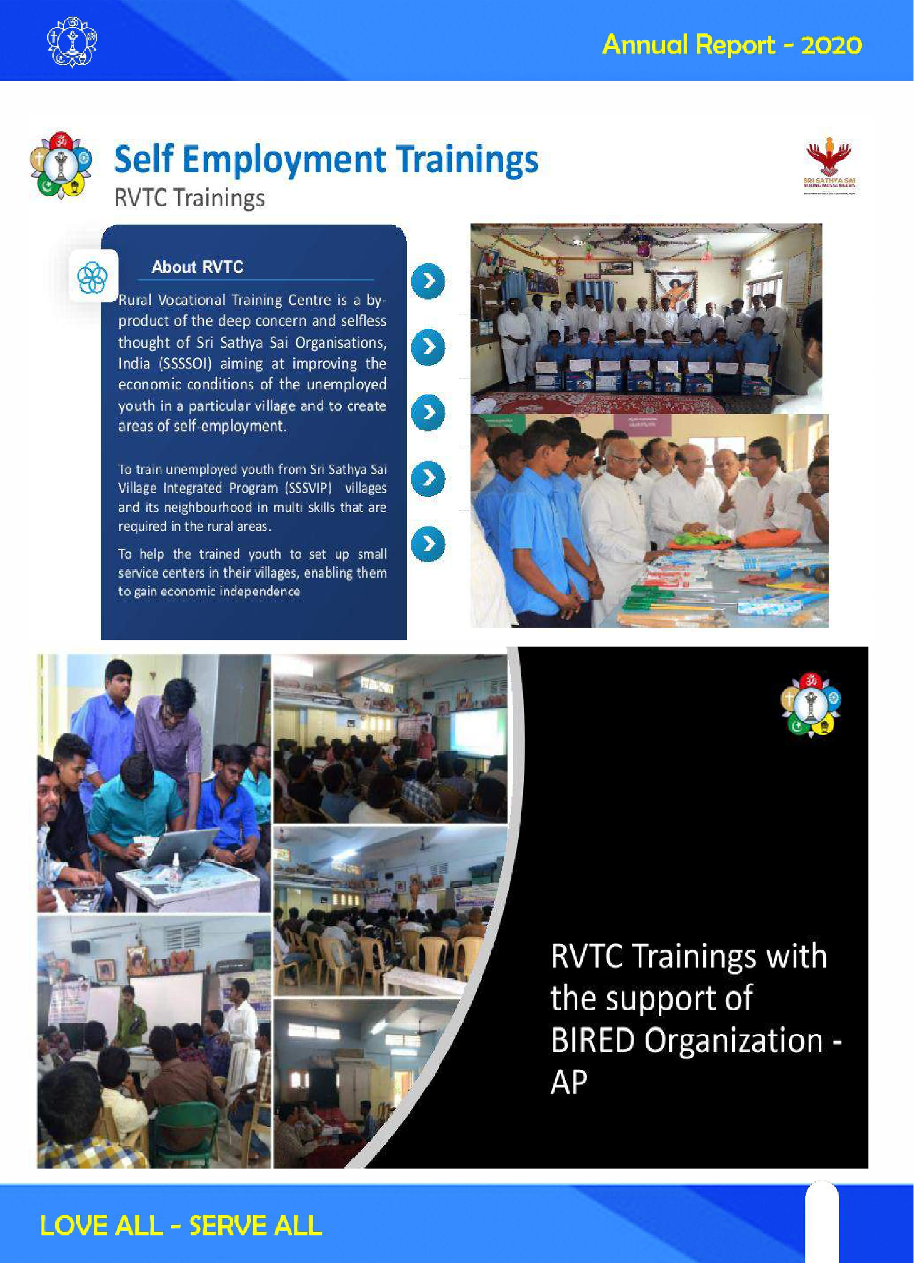

81
81

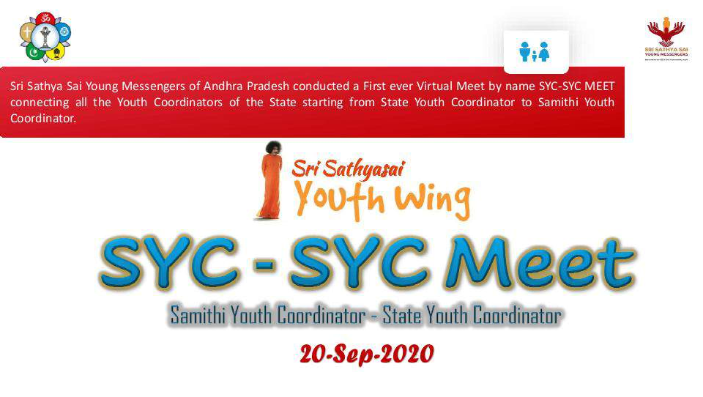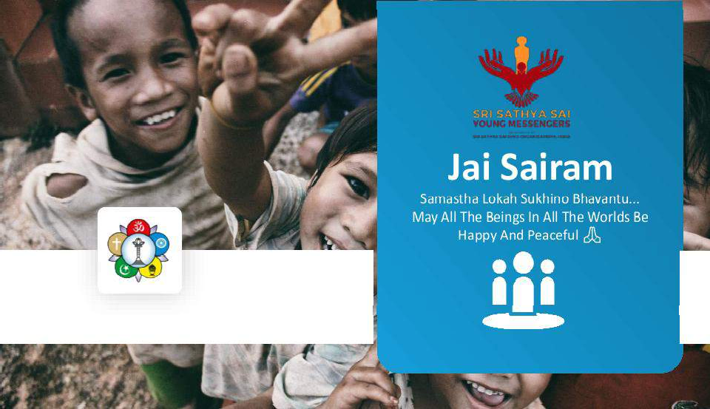

82

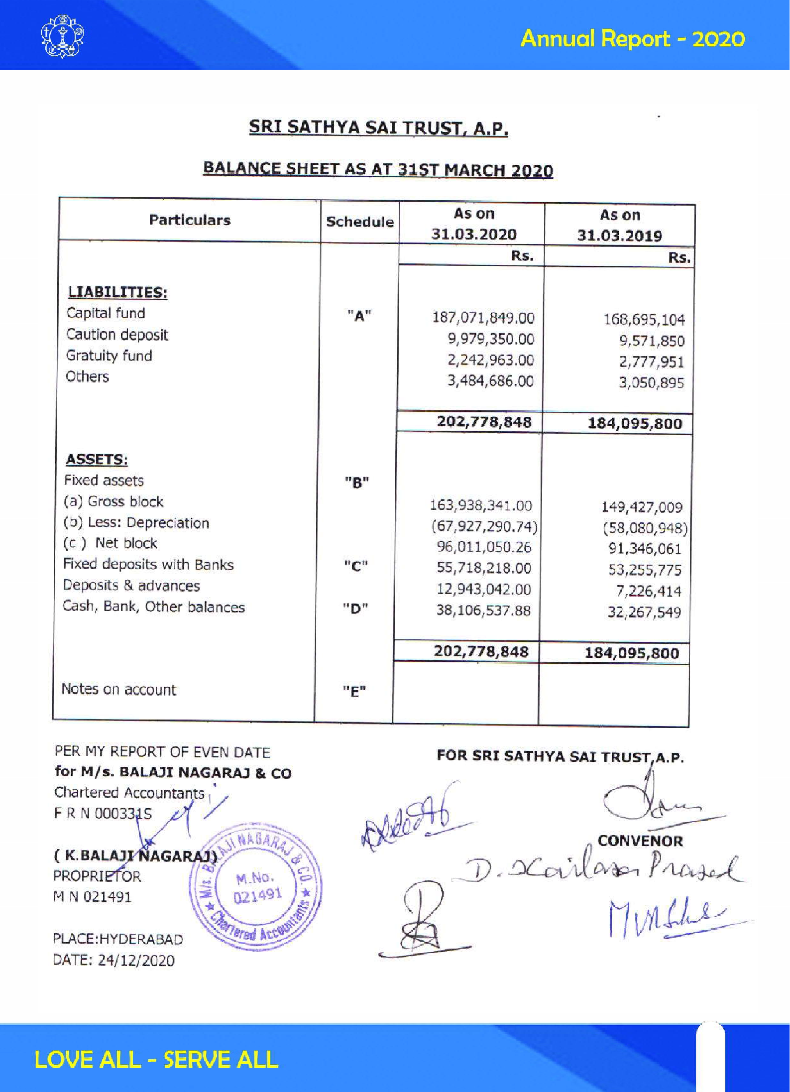

83
83

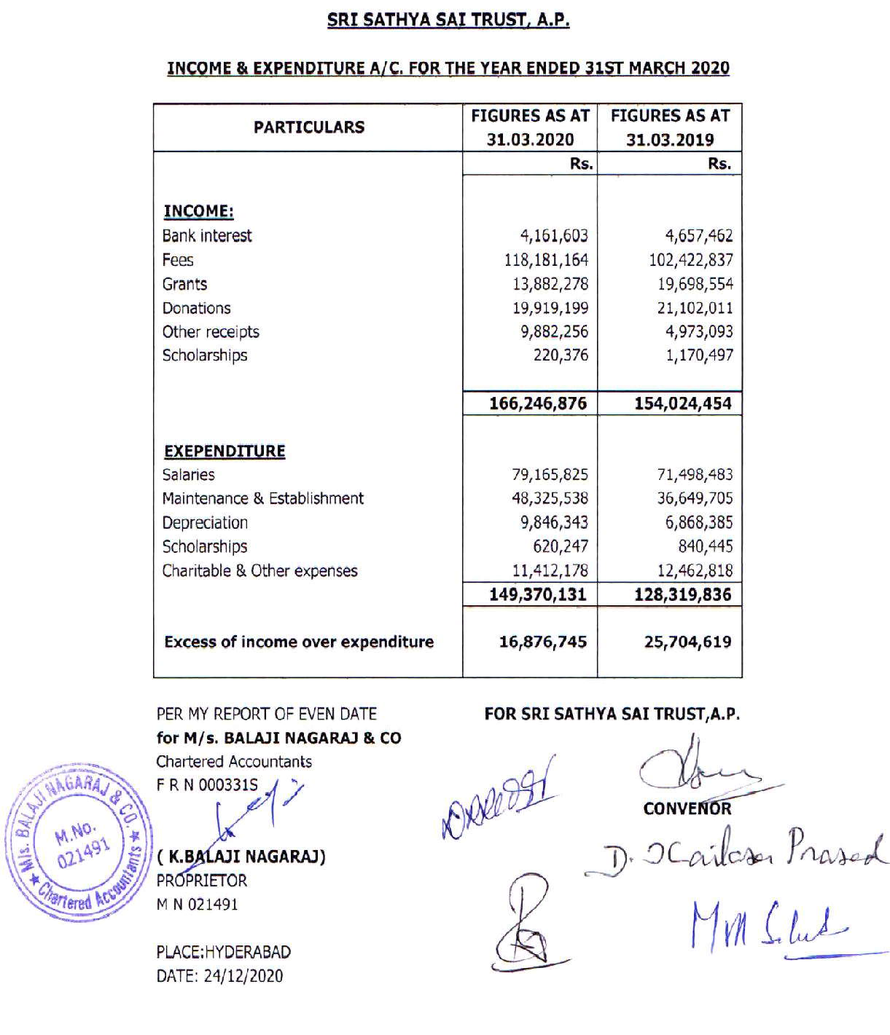

84



85
85

86

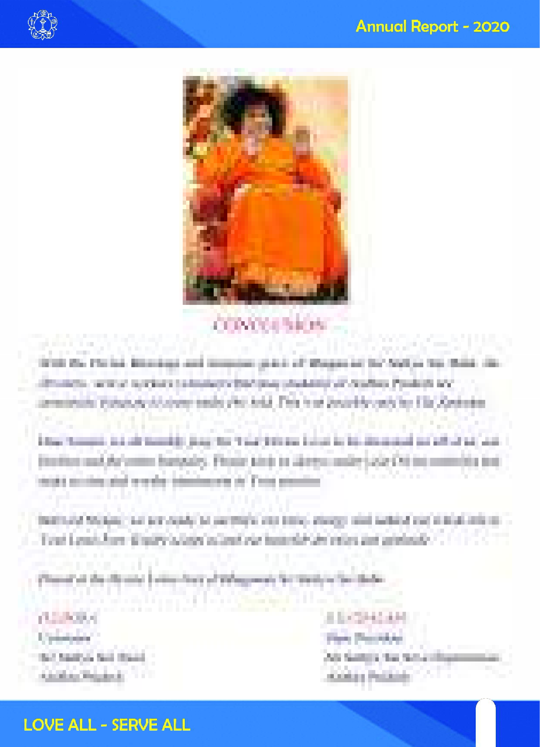

87
87

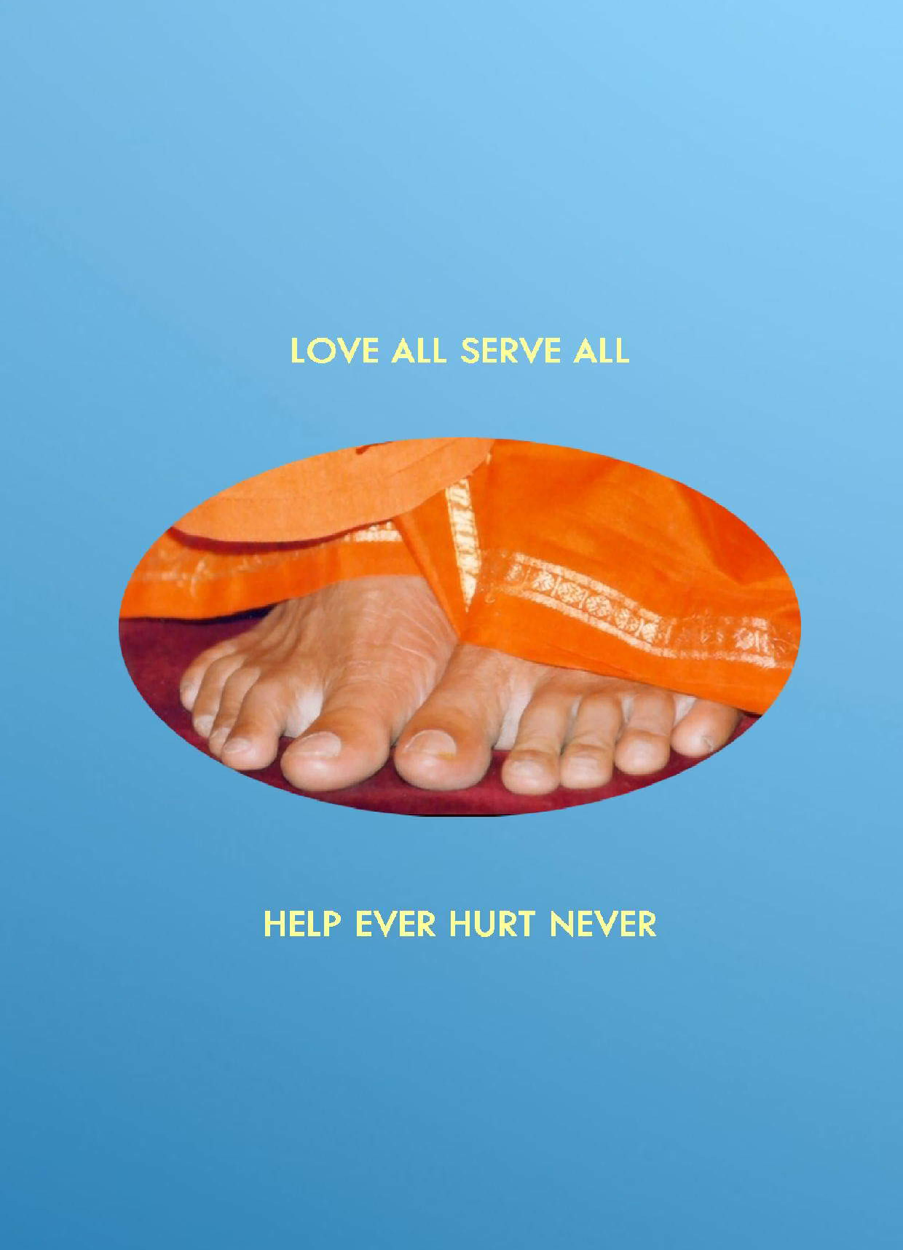

88

